**What is Machine Learning?**

Motivating example

• I am interested in finding out which UTD students get internships (or jobs).

• Think of it as a function: f: X -> Y **(the best function for entire UTD)**

X is an instance (student), Y is Boolean.

X has certain attributes X = <X1, X2, X3, … ,Xn>

X = e.g. X1= GPA, X2=Taken CS 6375?

X3=Years’ experience, …

It’s **a binary classification** problem. You will see lots of such cases in this course.

Learning Scenario

• You are given access to some training data: {(X1, Y1), (X2, Y2), …, (Xn , Yn)}

• Using this training data, you try to approximate the function f. This approximation is also called a **hypothesis** (h).

• Our aim is to design a learning model that can approximate f closely.

• If Y is Boolean (or has a fixed number of values), this is called a **classification** problem.

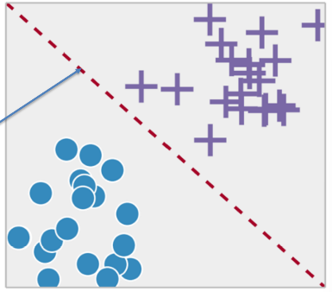Classification

• Learning to differentiate between two or more classes.

• Learning the **separating boundary**

• Most common problem in ML

e.g. classes could be - spam or not spam - family or sports car - apple or orange

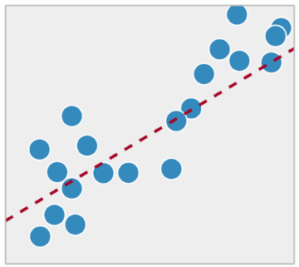Regression

• Classification is different from regression.

• Regression is trying to fit the best model to approximate some real valued data.

• Common in statistics, not ML.

Difference in output type

• If the output was real-valued, this problem can be solved by **statistics**.

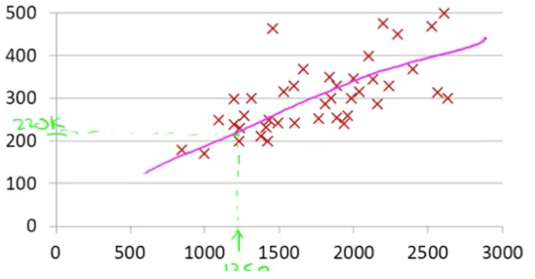Statisticians love regression – linear or non-linear. It can be used to fit a curve to data points.

**Classification**

• Computer scientists love all things Boolean

• So, we have Boolean attributes, Boolean output.

• How do we handle this scenario??

Components of ML (Task, Experience, error)

• What do you for a ML project?

• A well-defined **task** - what are you trying to teach to the machine?

• Training data that will be used by the machine – also called training **experience**.

• A way to check the performance of the machine – called **error** metric.

• A smart machine **learns** from the past errors and improves its performance.

What is ML?

• There is **a task** – generally involving prediction

-e.g.

. Will a student at UTD get internship?

. Will a stock go up?

. Will you play tennis?

. Will a person be approved for credit card?

. What is the price of a house?

. Which digit does a handwritten image represent?

• It has an associated **performance** measure i.e. how close is your prediction to actual value

• Error metric: If your hypothesis doesn’t match the actual value, penalize the model.

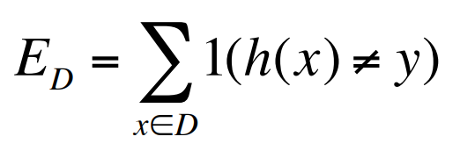The above is the simplest error function.

**h(x)** denotes your hypothesis and

**y** is the actual value.

**D** is the dataset.

• The model learns from **experience** i.e. data.

- More data => Better performance - **Is it always true?** Only if data is meaningful i.e. it’s not **noise**

• If you could see the **entire population** (entire dataset), you would get the best learning model. - **Is it possible?** Can you poll the entire US population? Probably Not!! In this class, we will work with samples of data.

Definition “A computer program is said to learn from **experience E** with respect to some **task T** and some **performance measure P**, if its performance on T, as measured by P, **improves** with experience E.”

-- Tom Mitchell, Carnegie Mellon University

Simpler Definition

• Design of algorithms that **learn from data** and improve performance on a predictive task.

• Development of computational methods **using experience** to improve performance.

Common Theme of this class:

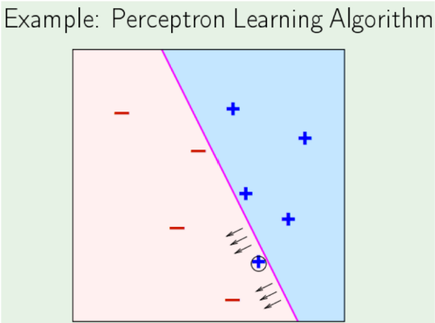- **More training** data is always good Provided data is **meaningful** and is **labeled** (in case of supervised learning). Think: Why does Google work so well?

When is ML a good choice?

• Learning used when

- A pattern exists

- There exists a correlation between predicted variable and features.

- We have data

•Supervised learning

- Unknown target function y = f(x) - You get data & labels (x1, y1) (x2, y2) ,…

- Learning algorithm picks a function g ≈ f (approximation)

Simple, but not obvious

• When can we use ML?

- There is some definite relation/correlation between X and Y.

i.e. there is a deterministic or highly probable function f

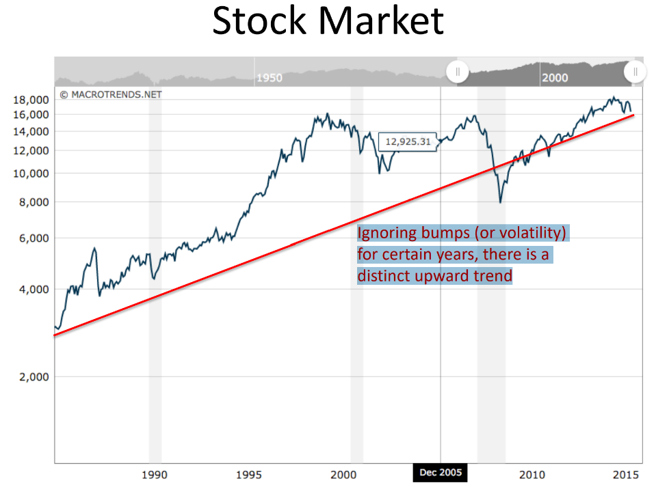- X comes from a well-defined distribution (we don’t need to know the details yet)

**=> X is not a set of random variables**.

Simple, but not obvious

• When can we NOT use ML?

- There is no correlation between X and Y. - There is no clear function f

- X is a set of random variables

=> Can ML predict the lottery? => Can you use it at the casino?

- Can we use it to predict the stock market?

Traditional Programming

. Getting computers to program themselves

. Writing software is the bottleneck, let data do the work

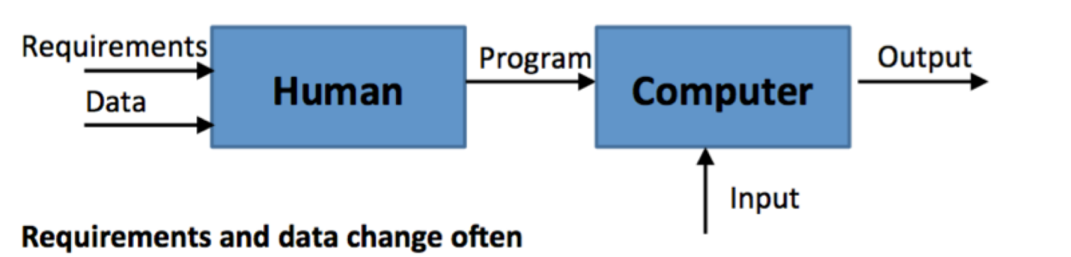

Machine Learning

. In ML, The algorithm learns from data and outputs a program. For example, a self-programming robot.



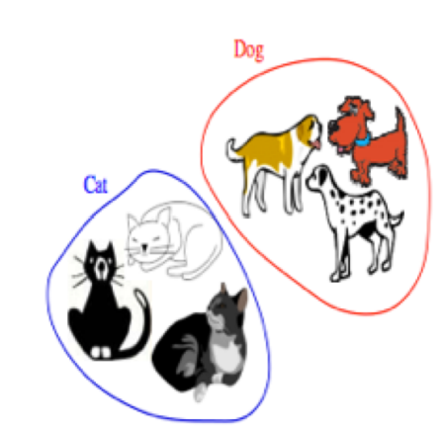Types of Learning

. **Supervised (inductive) learning**

* Training data includes desired outputs

. **Unsupervised learning**

* Training data does not include desired outputs.
* Find hidden/interesting structure in data.

. **Semi – supervised learning**

* Training data includes a few desired outputs

. **Reinforcement learning** (Học tăng cường)

* The learner interacts with world via “actions” and tries to find an optimal policy of behavior with respect to “rewards” it receive from the environment.

Supervised Learning - Inductive

• **Inductive:** Tries to discover general concepts from a limited set of training examples. => Generalization

- Based on search of similar characteristics in different classes of examples. - e.g.

Given labeled examples, you find features that are common within each class.

• **Inductive**: goes from specific to general

- tries to obtain new knowledge. - new data points may force you to change old hypothesis

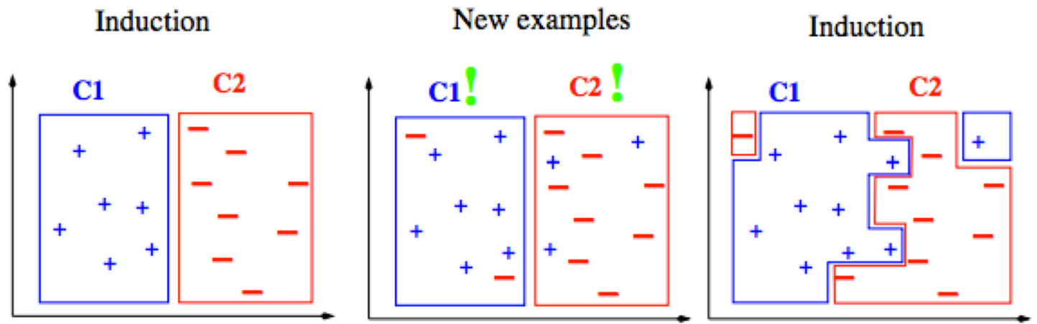

Inductive vs Deductive

• **Deductive**: uses given premises and logical arguments to infer conclusions.

• tries to obtain knowledge that is implicit in original knowledge.

• Classic example:

* All men are mortal. (**major premise**)

* Socrates is a man. (**minor premise**)

* Socrates is mortal. (**conclusion**)

• In this class, we will focus on **inductive** learning.

• Can you see any **issues** with **inductive** approach?

- What do you expect the data to be?

- How do you expect the learner to behave?

- When you make a conclusion, are you 100% sure or are you probably sure?

- Is it even possible to obtain 100% accuracy on training and test data? - …

Learning

• Inductive learning is **supervised learning** because the training data has the **class labels**.

=> That’s what you are trying to learn.

=> So you create an algorithm that separates the two classes based on features.

• What if you just want to find patterns in data i.e. how can you find similar items based on their attributes.

=> **Unsupervised learning**

=> **No labeling provided or you don’t care for labels**.

=> You want to create a natural grouping of people based on shared interests on FB.

Types of Learning task

. **Supervised**: correct output known for each training example

* Learn to predict output when given an input vector

. Classification: 1-of-N output (Speech recognition, object recognition, medical diagnosis)

. Regression: real – valued output (predicting market prices, customer rating)

. **Unsupervised** learning

* Create an internal representation of the input, capturing regularities/structure in data.
* Example: form cluster; extract features

. How do we know if a representation is good?

. **Reinforcement** learning

* Learn action to maximize payoff

Supervised Learning

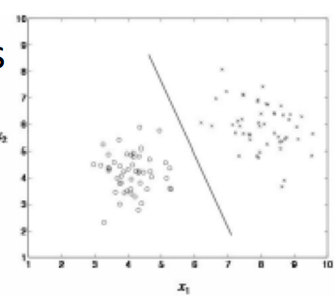. **Classification**

You have N choices for output, learner needs to find best

. Outputs are categorical (1 -of -N)

. Inputs are anything

. Goal: select correct class for new inputs

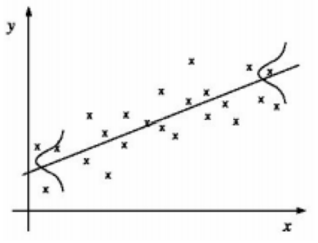. EX: speech, object recognition, medical diagnosis

. **Regression**

You have infinite output choices

. Outputs are continuous

. Inputs are anything (typically continuous)

. Goal: predict output accurately for new inputs

. EX: predicting market prices, customer rating of movie.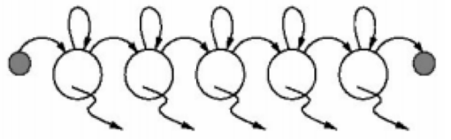

**. Temporal Prediction**:

. Goal: perform classification/ regression on new input sequence values at future time points

. Given input values and corresponding class labels/ output at some previous time points.

Applications of ML

• Pattern Identification: - facial, fingerprint, gene sequence

• Differentiation: spam or non-spam cancerous or non-cancerous cells normal traffic or hacker traffic

• Finding association rules • Recommender Systems • … Many more

The machine learning framework

• Apply a prediction function to a feature representation of the image to get the desired output:

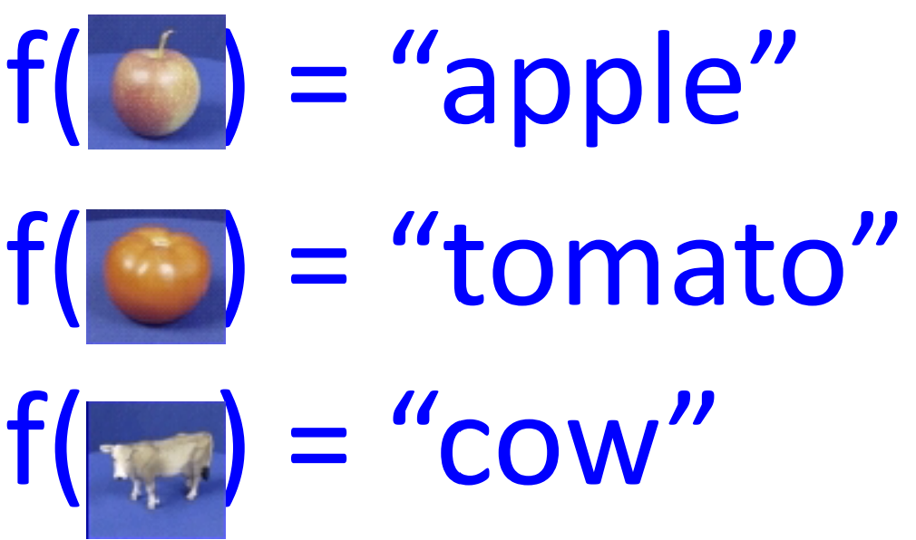

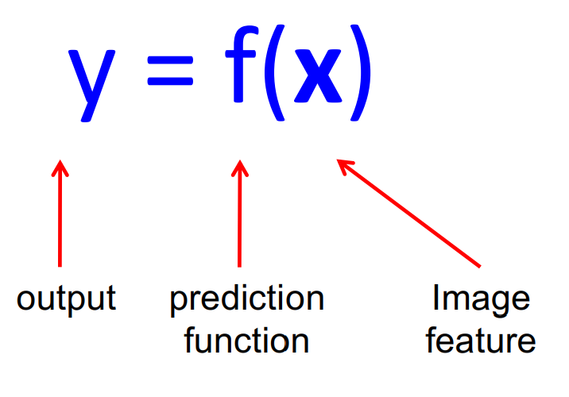The machine learning framework

• **Training**: given a training set of labeled examples **{(x1,y1), …, (xN,yN)},** estimate the prediction function **f** by minimizing the prediction error on the training set

• **Testing**: apply **f** to a never before seen test example **x** and output the predicted value **y = f(x).**

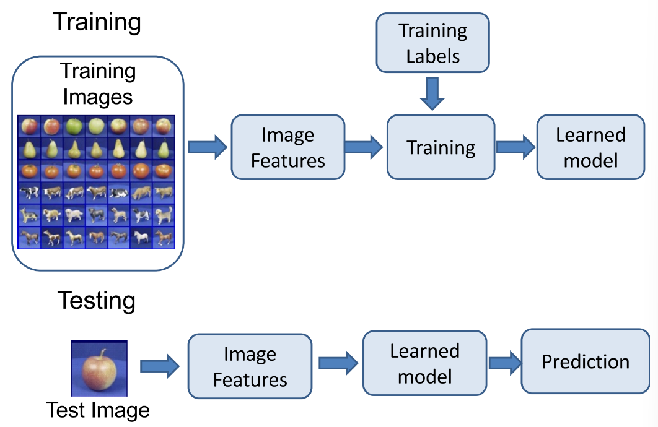

Steps

Formal notation of learning

• You own a credit card company.

• You get a lot of applicants, your job is to design the best classifier for approving them.

• You have some historical data to rely upon.

x j = (x1, x2,..., xn ) T Input vector for customer xj

X = {x 1 , x 2 ,..., xN } set of all customers

y = {0,1} Binary Output

f : X− > Y **Ideal** target function i.e. if you **had entire** data in front of you

(x 1 , y 1 ),(x 2 , y 2 ),...,(xn , yn ) You have this data

H = {h1, h2,..., hN } The set of all possible hypothesis. Doesn’t matter if they are meaningful or not

g : X− > Y,

g ∈ H The best hypothesis you can come up with given the data

Can you really know f?

- **No**, you can only try to approximate it by **g**

- Your approximation is only as good as the data that you see.

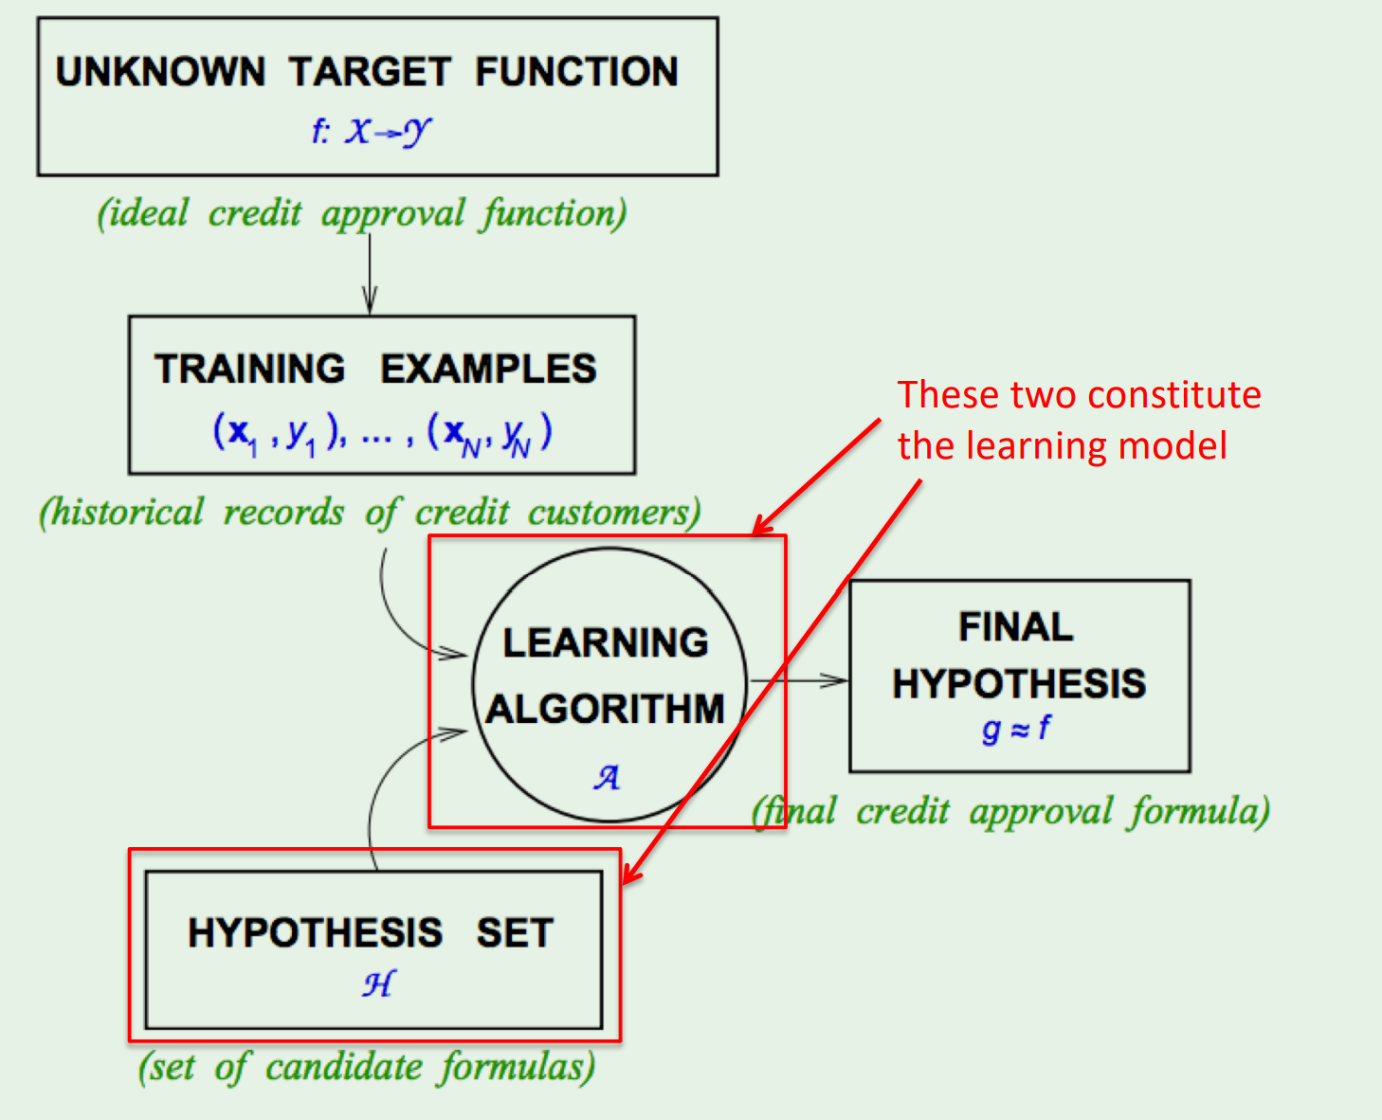

Really simple, right?

• All you have to worry about is the type of learning model and how to generate (and eliminate hypotheses)

• In this class, we will focus on these types:

- Linear separators (**Perceptron**:a computer model devised to represent the ability of the brain to recognize and discriminate.)

- Extension of linear to non-linear (**SVM, ANN, etc**)

- Tree-based classifiers (**Starting with decision trees**)

Linearly Separable Data

• Suppose you have following data: (This is a toy example J )

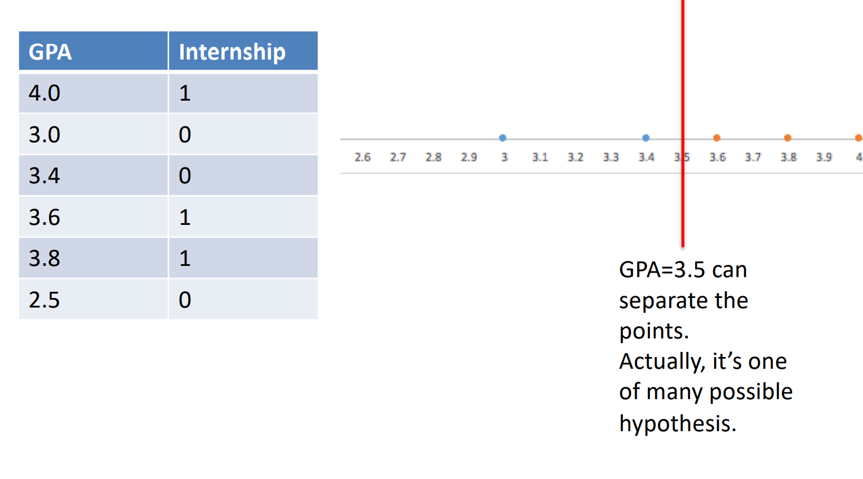

• 2-D case

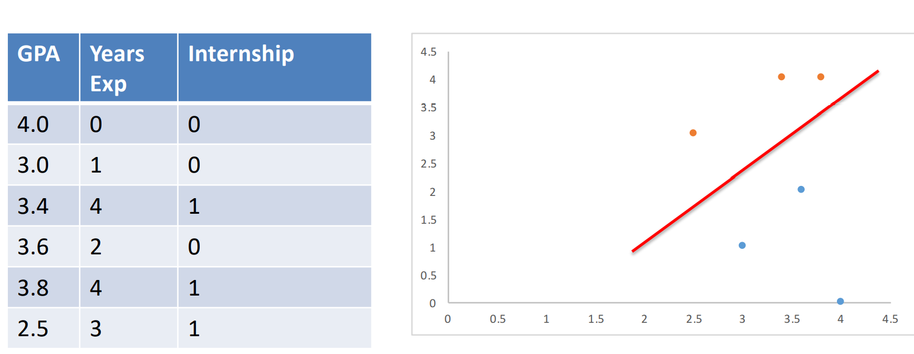

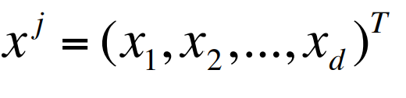Perceptron

• It’s a simple linear classifier -> straight line in 2-D and a plane in higher dimensions.

• Suppose each instance is represented by the vector xj

Example of instance can be a student, a customer, etc. Attributes are x1, x2, …, xd

• Each attribute can have different weights w1, w2, …, wd.

• Equation of separator is:

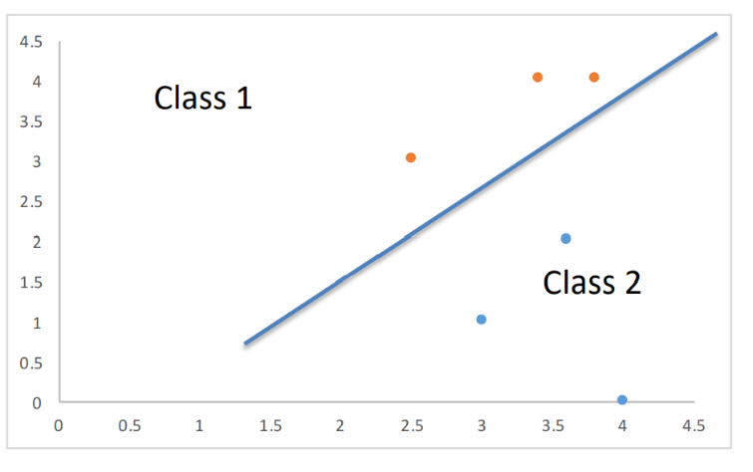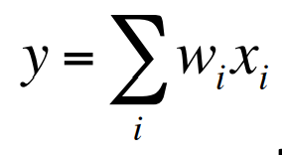

An easy way to separate classes is:

If 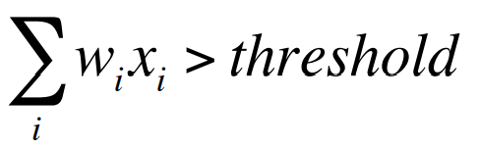assign class1

else assign class 2.

**Perceptron** : a computer model or computerized machine devised to represent or simulate the ability of the brain to recognize and discriminate.

• An easier way to present this is:

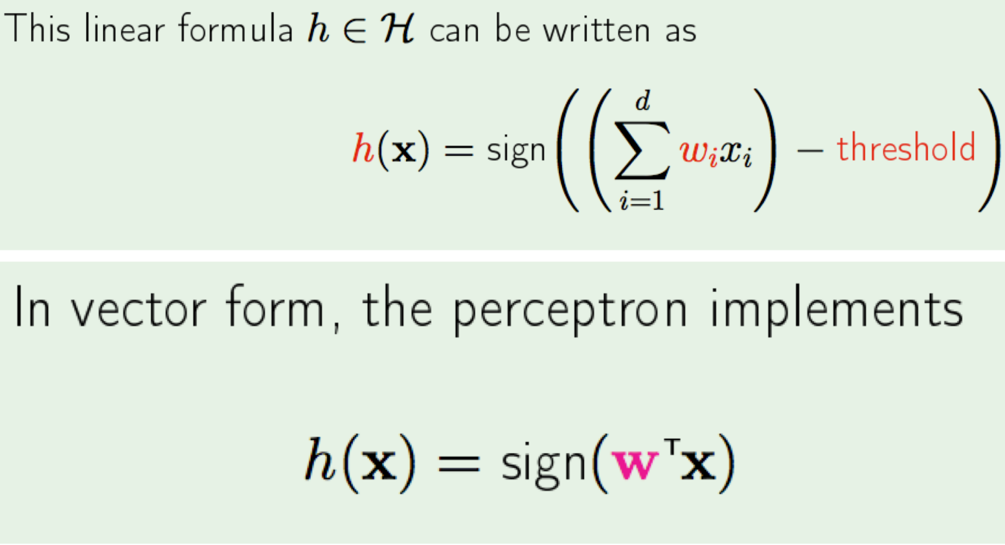

Learning

• Let us look at another way of classification. • Decision Trees.

Decision Tree

• Toy example again

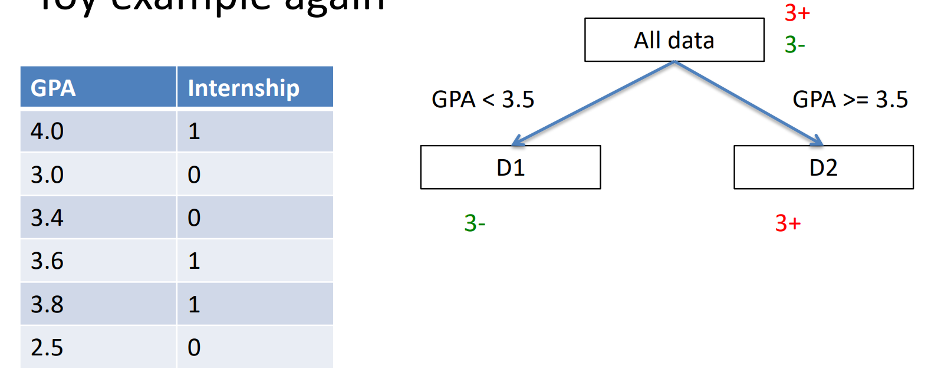

• 2-D case

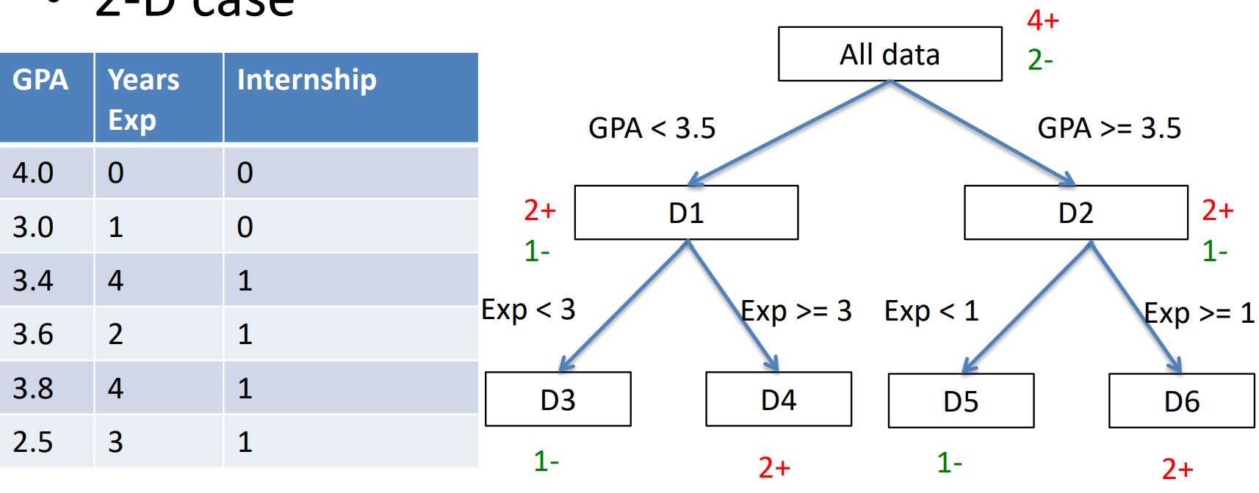

• What can you infer?

• Think about decision trees as a way to learn **classification** function.

• Can also be thought of as rules:

eg: X1 ^ X2 -> 0 where x1 is Boolean GPA and x2 is Boolean exp<3

• OK…but which attribute should I choose to be at the top i.e. how do I choose attibutes??

Sounds great, but …

•Can you make some guarantee about the **unknown** data / parameters?

Let’s do an experiment. You have a bin and want to estimate the **probability of** **red marbles (μ)**. You draw **N samples** and observe **fraction of red marbles = ν** Is there any relation between μ, ν, and N?

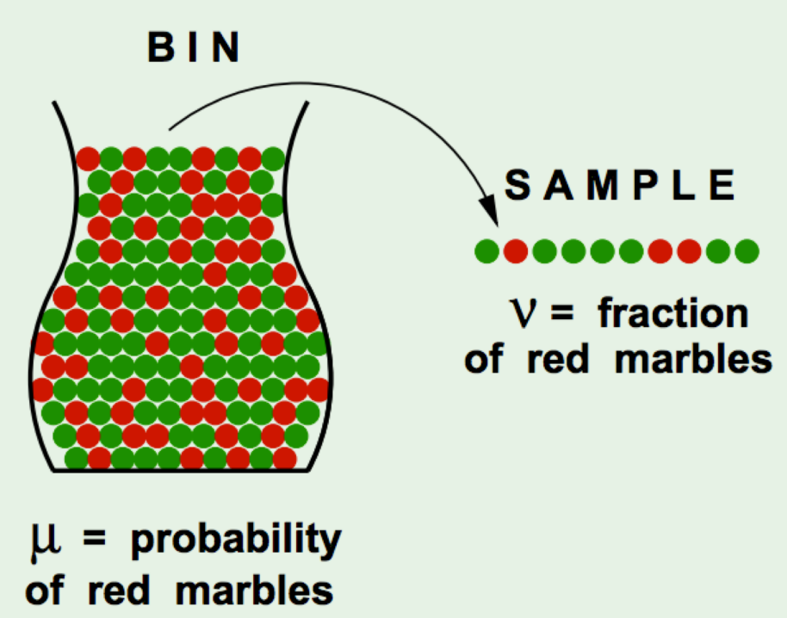

Hoeffding's Inequality

• It turns out there is a relation: For **large values of N**, the **probability of large error (difference)** between **ν and μ is bounded**.

Think: What happens when N becomes large, and when N is small?

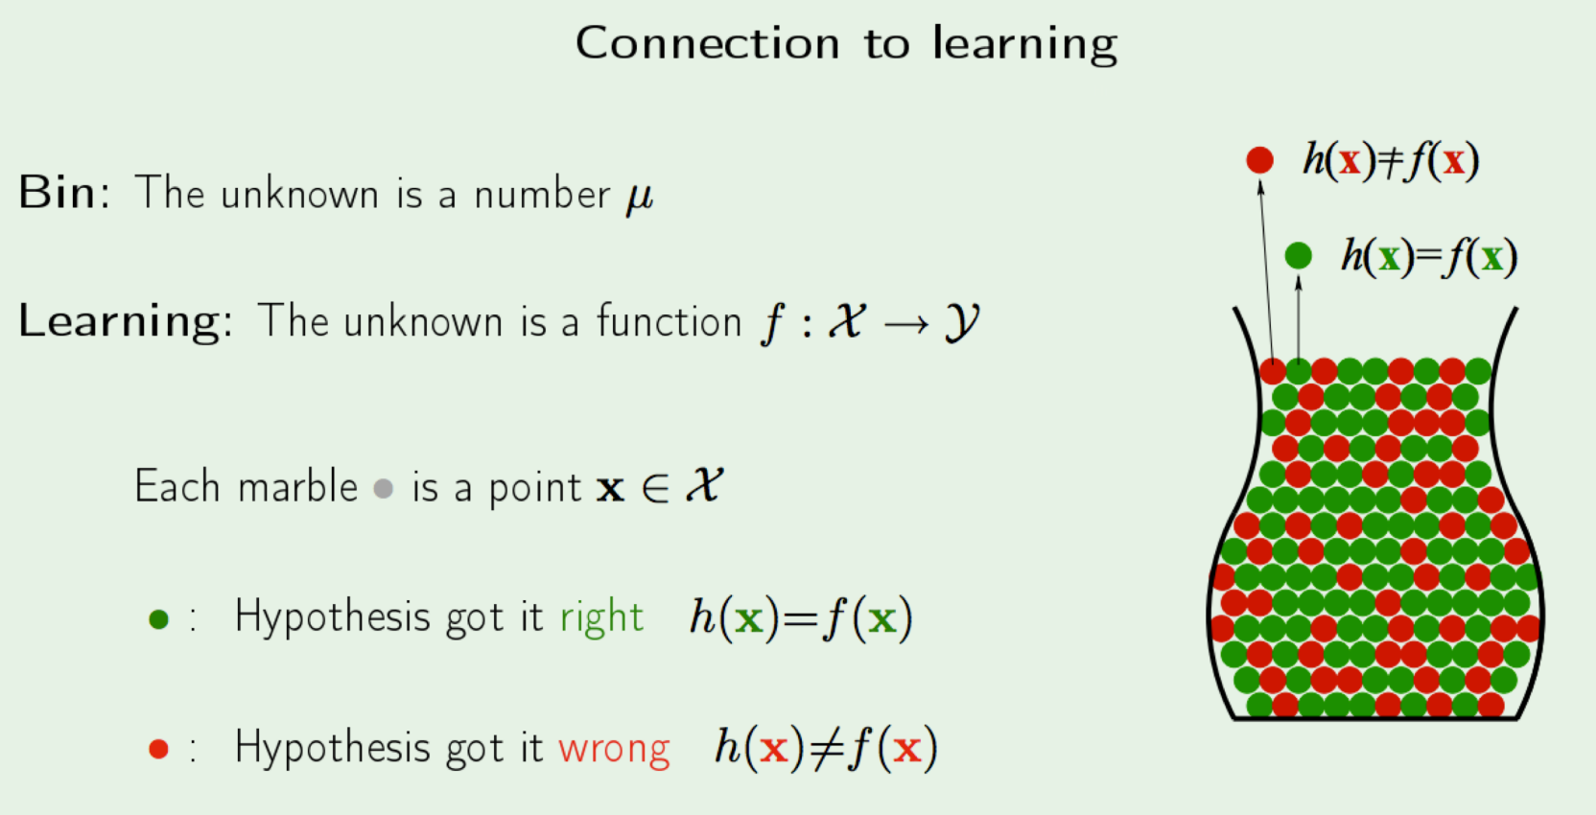

**Inductive Learning**

• Inductive learning - **generalize** from a limited set of training data

• Training data is labeled

• You would like to estimate true separating function f

• Attributes of data (i.e. features) are important.

Learning from data

• Given: a set of labeled training examples: <x,f(x)>

Global f(x) is unknown to us - Distribution of x is unknown to us

• Find: An approximation of f(x)

Appropriate situations

• **Credit risk assessment**

x:properties of the customer and proposed purchase

f(x): approve purchase or not

• **Disease diagnosis**

x: Properties of patient (symptoms, lab, tests)

f(x): Disease (or maybe, recommended therapy)

• **Face recognition**

x: bitmap picture of person’s face

f(x): Name of the person.

Learning

• Improving with experience (E) at some task (T) with respect to some performance measure (P).

• **Experience** = Training data

**Task** = Any classification task (for this class, at least)

**Performance Measure** = Error value -> difference between true value and predicted value.

Model Representation

**What are you given in supervised learning?** A set of training examples and their labels (x(i) , y(i) )

** It is assumed y(i) is generated by a true function f(x) **

**What do you do with the training data?** Feed it to a learning algorithm that learns a function h, that is an approximation to f

Learning Process

use it as a guide After each training instance, refine h so that value of error metric goes down.

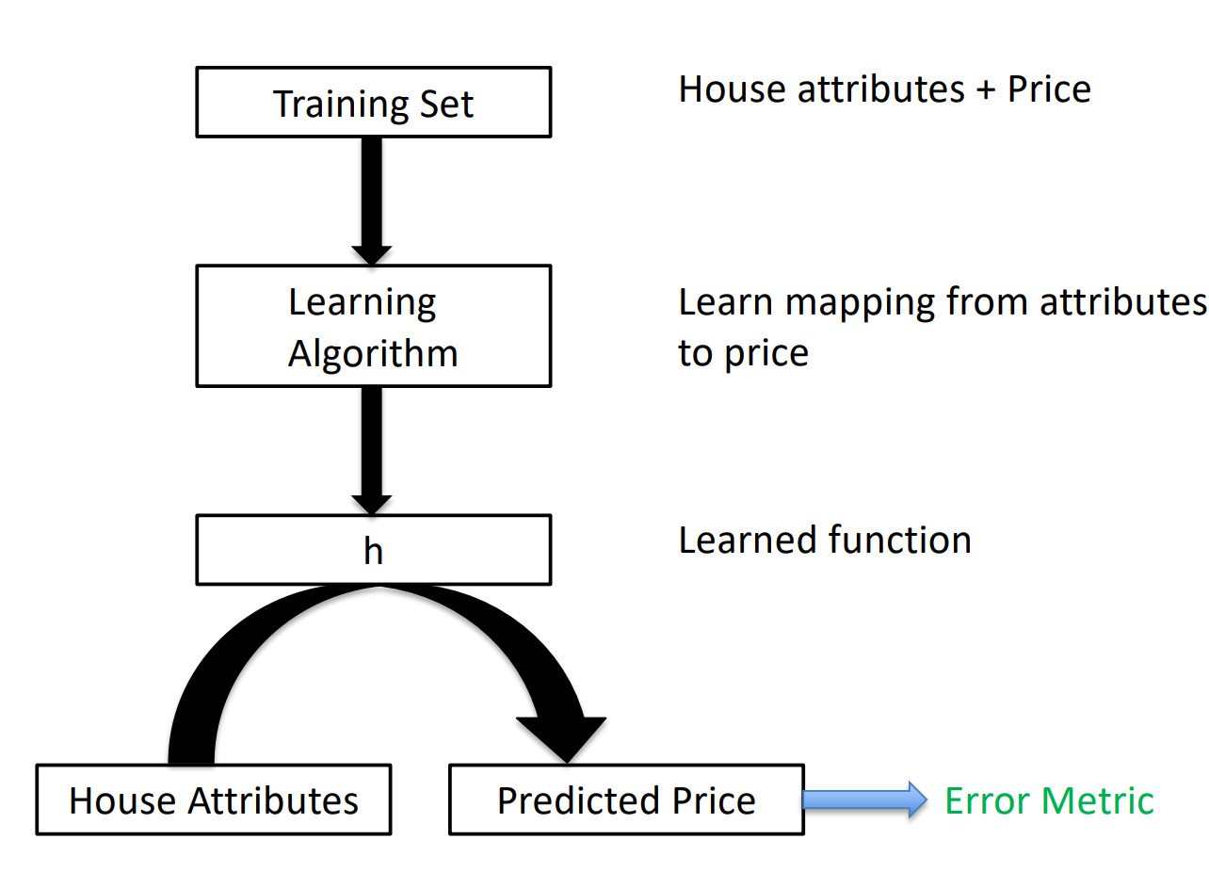

Model Representation

**How do you know if h is good?**

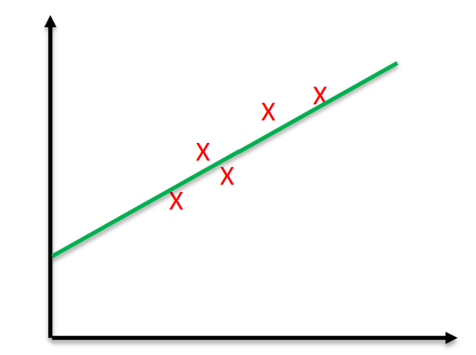We measure the error (overall) by using h Example:

Error = | f(x) – h(x) | or Error = 1/(2m)* (f(x) – h(x))2 Think: Is more training data good? Always?

**LINEAR REGRESSION**

Learning a linear function

• Suppose we want to learn a function of the form:

ℎ θ (x) = θ0 + θ1x

to represent house price. Let's say it's a one-D problem and only independent attribute is house size x.

Linear Regression

• Linear Regression – find best model that fits a continuous (i.e. real valued) output

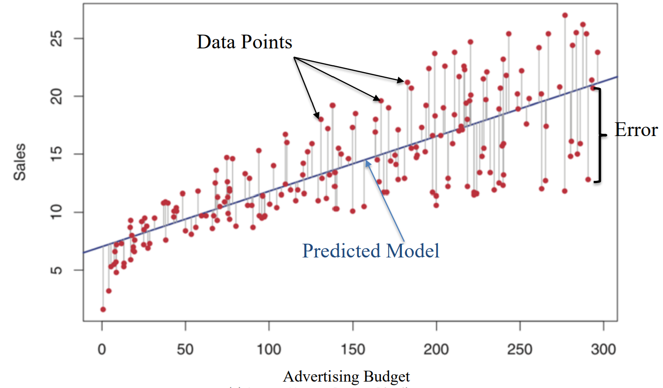

Error Function

• Our aim can be stated as: Choose parameters θ0& θ­1 ( such that our hypothesis ℎ θ (x) is as close to y for our training examples.

• Mathematically, choose parameters such that the following is minimized (called error or cost function). m is the number of training instance

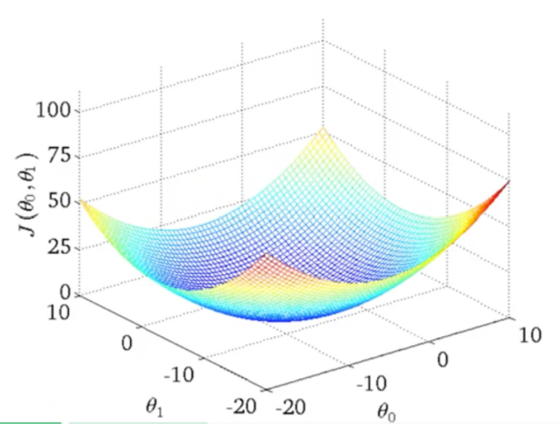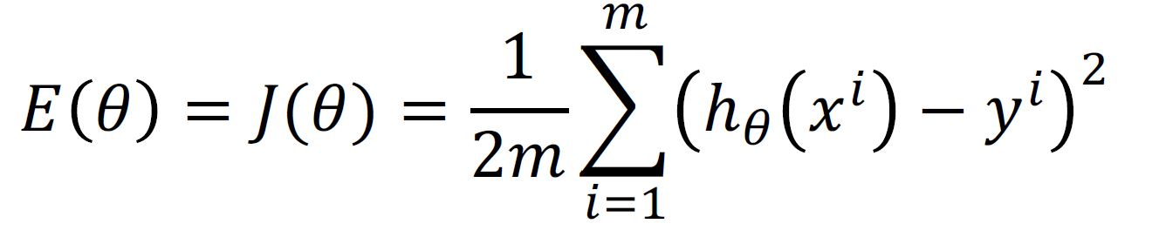

Error function

• How does J vary wrt the parameters

• Contour plot

• We are looking for the minima

• How do we get there?

Gradient Descent

• Given a function J of parameters ϴ, how do we find its minimum or maximum.

• Gradient Descent is a very powerful and popular algorithm.

• Widely used in machine learning

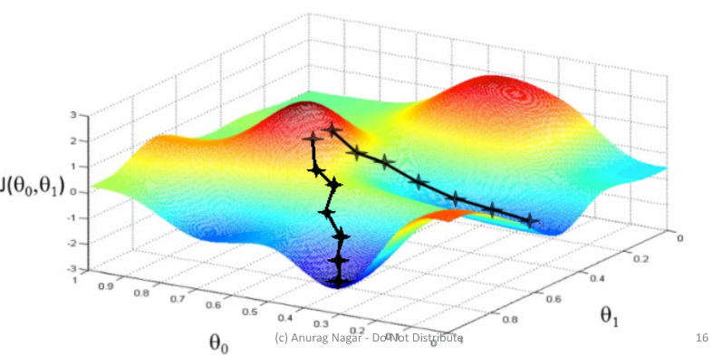• In many cases, analytical solution is not possible, so we have to randomly take steps in search of minimum.

• Aim: We have a function 𝐽 (𝜃0, 𝜃1) , and we want

argmin 𝐽( 𝜃0 , 𝜃1)

𝜃0 𝜃1

**STEPS:**

• Start with some random values

• Keep changing these values such that you achieve a reduction in J

• Imagine a man at a random point on the mountains.

• He needs to reach the city by walking randomly

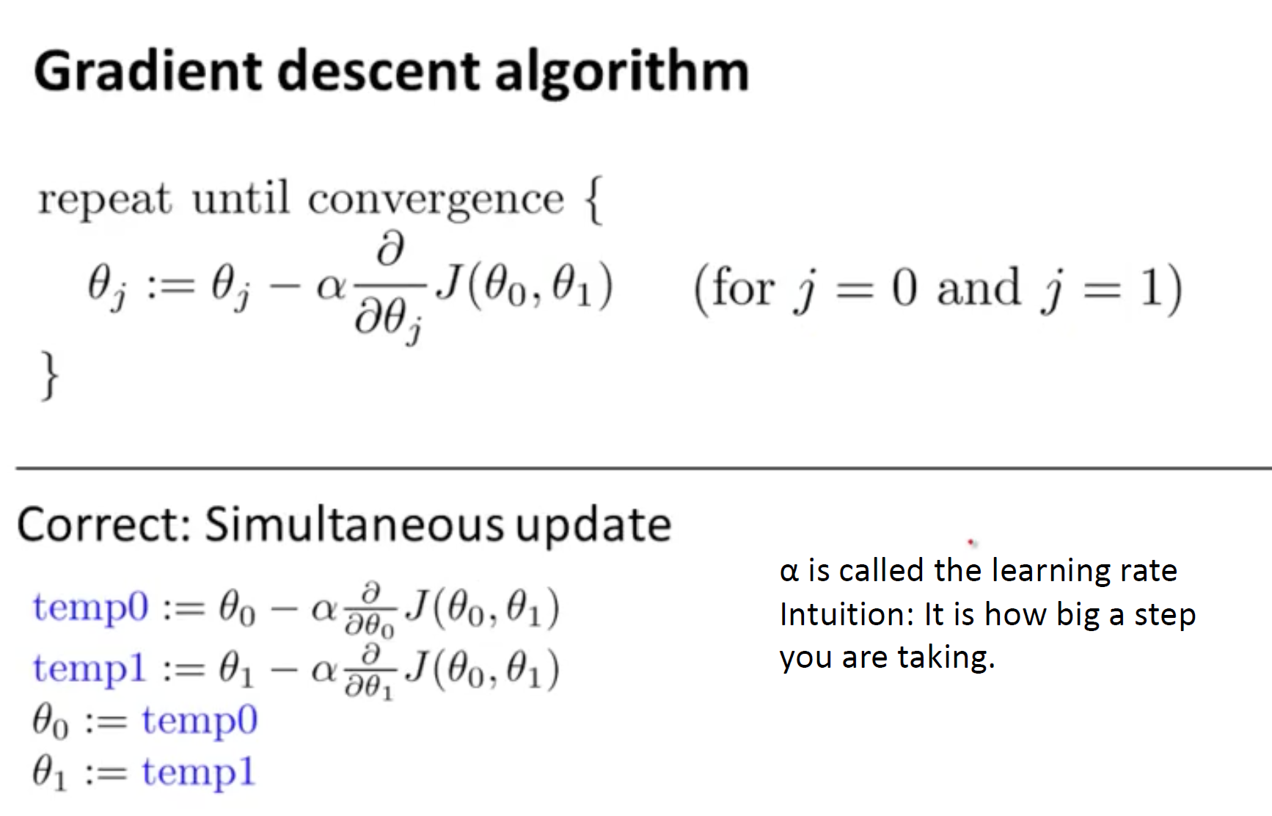

α is called the learning rate Intuition: It is how big a step you are taking.

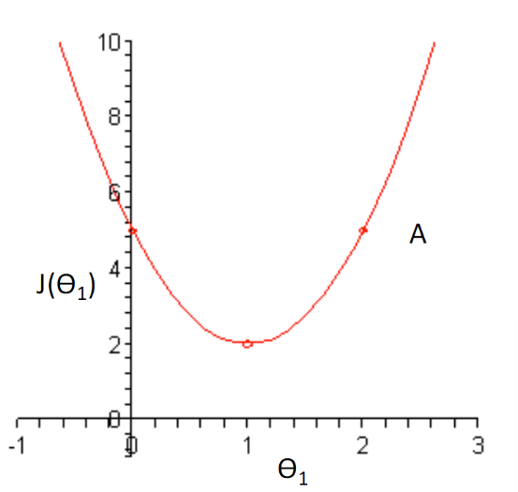Illustration

• In the curve on the right, imagine you are at point A

• The slope there is positive

• Update rule:

𝜃1 = 𝜃1 – 𝛼* 𝜕𝐽/𝜕𝜃1

since 𝜕𝐽/𝜕𝜃1 is positive and α is always positive, we would move towards left.

Local Minima can be a problem

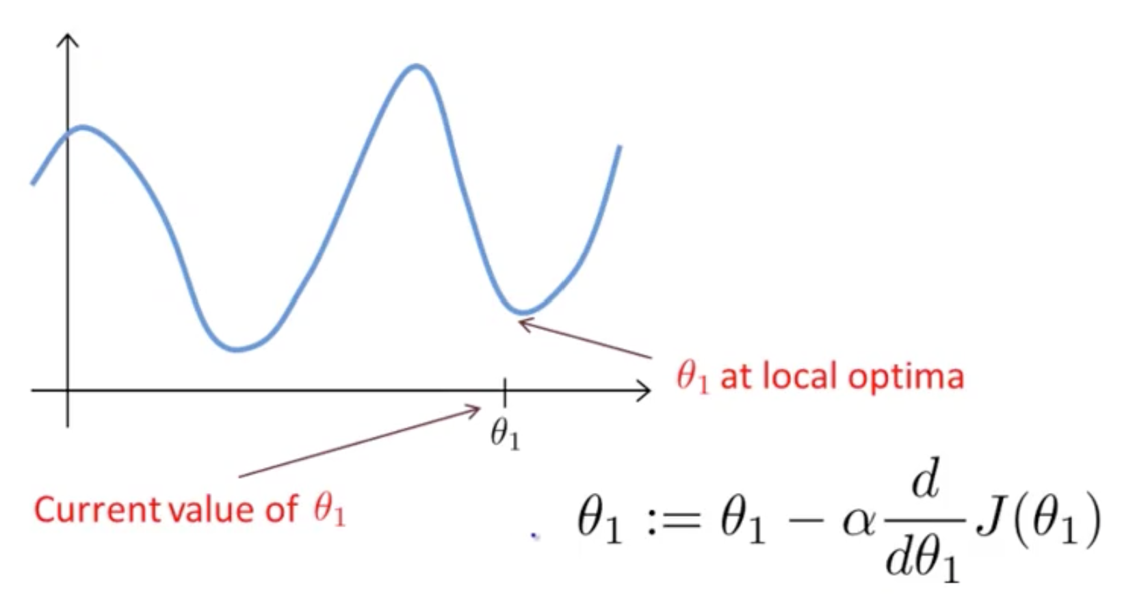

Gradient Descent for Linear Regression

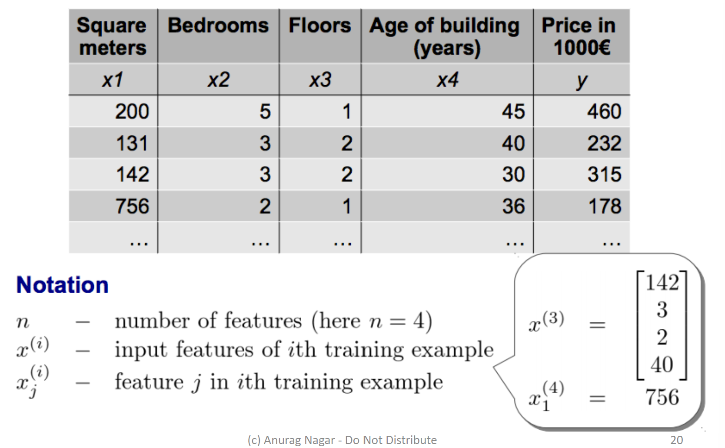

Gradient Descent for Linear Regression

**Hypothesis representation**

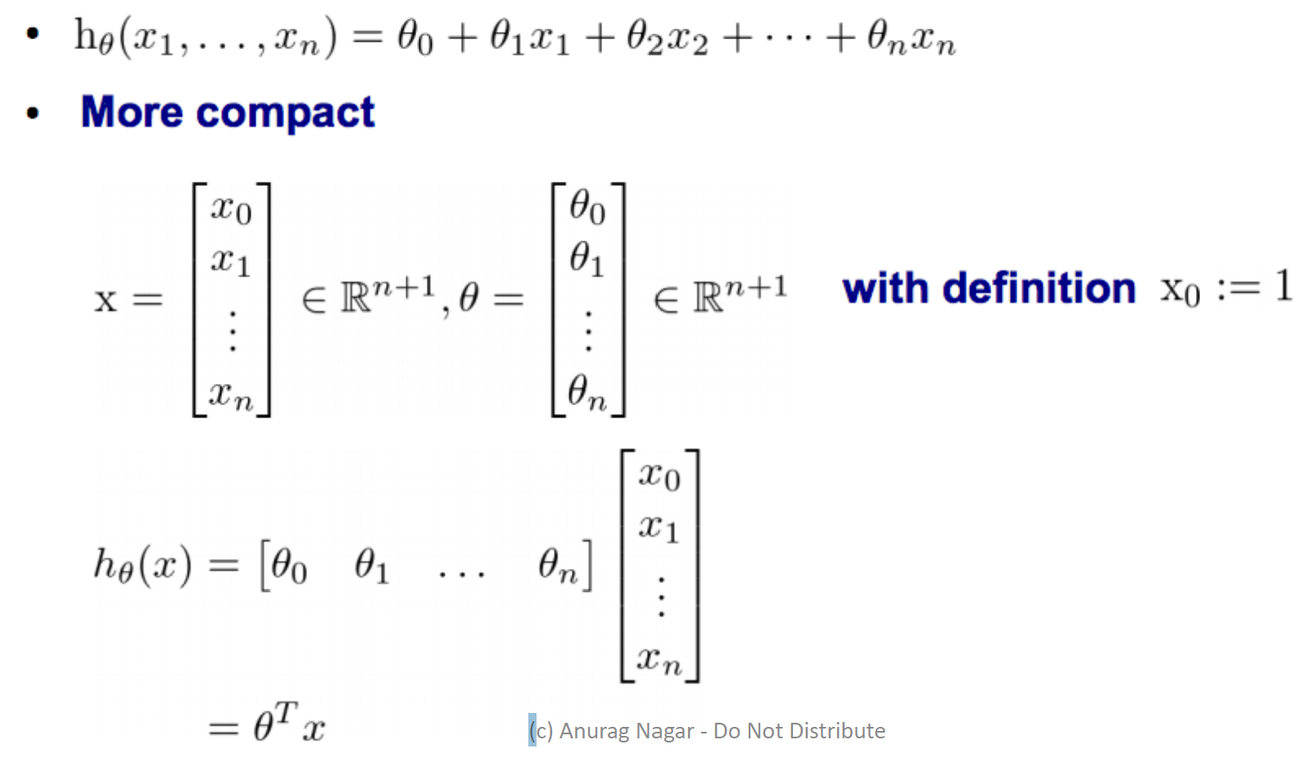

**Gradient Descent for multiple variables**

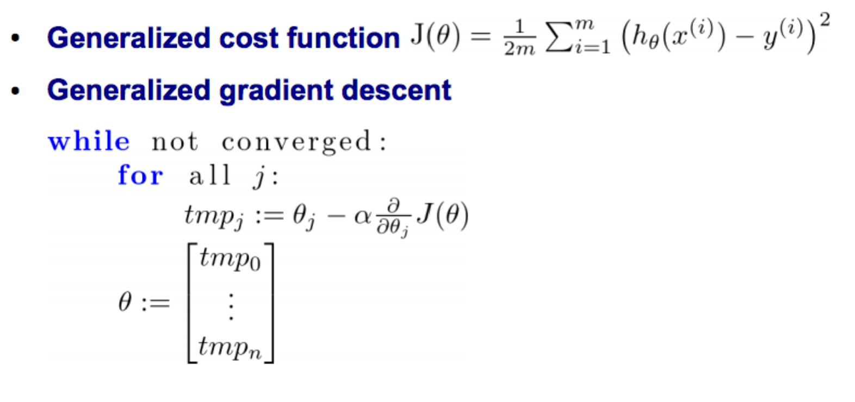

**Partial derivative of cost function for multiple variables**

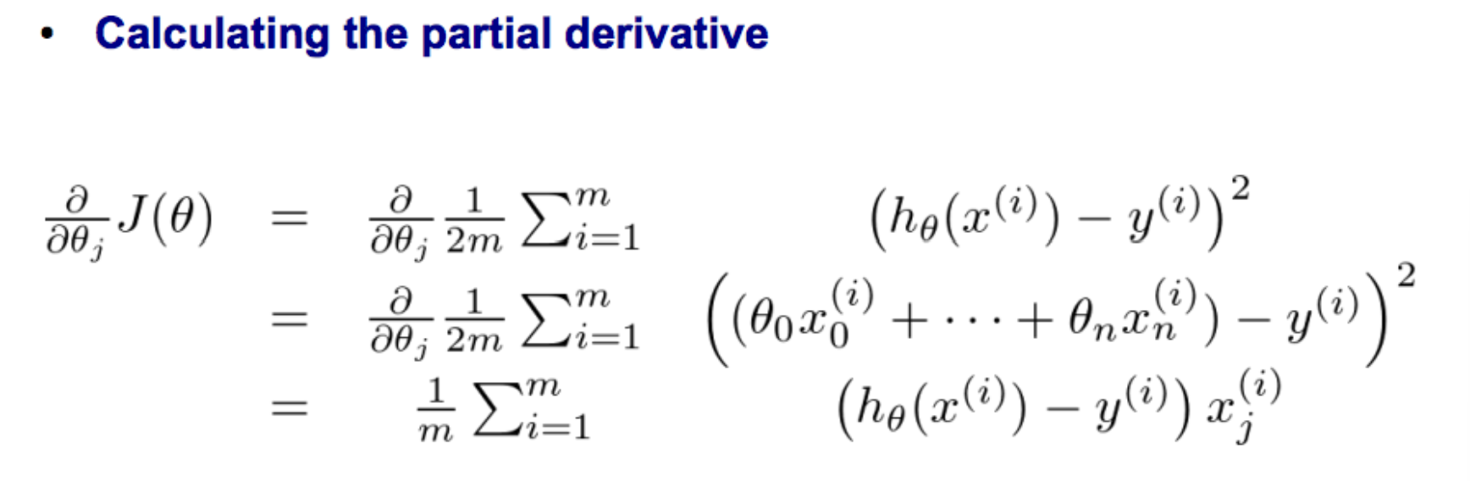

**Gradient descent for multiple variables**

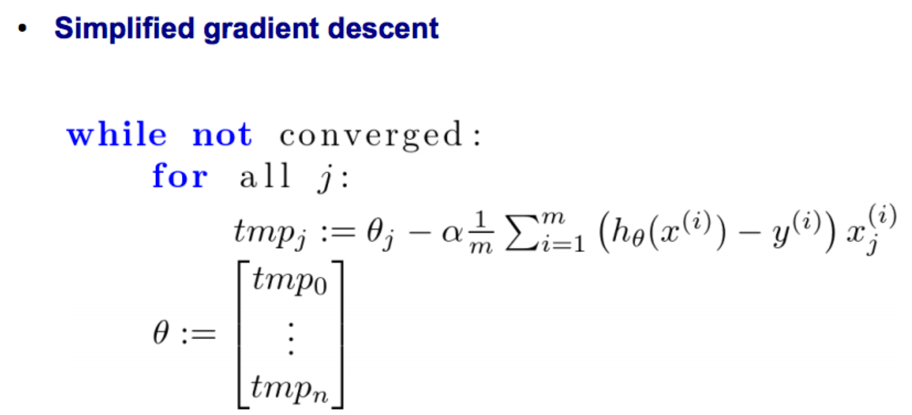

Regression Evaluation Metrics

• Suppose we propose a linear model:

𝑌 = 𝛽0 + 𝛽1X + ϵ where 𝜖 represents the error.

• The coefficients 𝛽0 and 𝛽1 need to be estimated from the data (using gradient descent or other computational techniques).

• Let’s suppose our estimates are ^𝛽0 and ^𝛽1 ( , then the predicted value would be: ^𝑦 = ^𝛽0 + ^𝛽1 𝑋

• 𝑒i = ^y­i − yi represents the residual or error for the ith data point.

• Residual sum of square (RSS) is defined as:

𝑅𝑆𝑆 = e12 + e22 + …. + en2,

• By minimizing the RSS, we can arrive at the estimates ^𝛽0 and ^𝛽1.

Another evaluation metric

• We would like to check what fraction of data variance is explained by the model.

• R2 statistic measures this:

R2 = 1 – RSS/TSS

where **RSS** is the **residual sum of squares** (defined earlier) and **TSS** is **the total sum of squares**:

𝑇𝑆𝑆 = 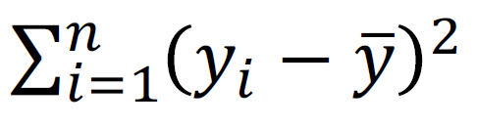

Practice question:

. Consider the problem of predicting the number of A grades that a student a UTD will obtain in second year of M.S. based on the number of A grades obtained in the first year of M.S. course.

Below is the data:

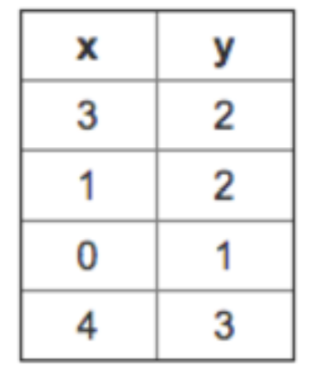

x represents the number of A grades in 1st year

y represents the number of A grades in 2nd year

You decide to use a hypothesis of the form ℎ θ (x) = θ0 + θ1x where θ0 = 0 and θ1 = 1 . Find the value of the square error? <https://www.coursehero.com/qa/wait/43823259/>

**DECISION TREE**

**What is a DT?**

.

Decision Tree

■ 2-D case

Of course, you could start with Exp as the first sorting or splitting criteria and get a different tree.

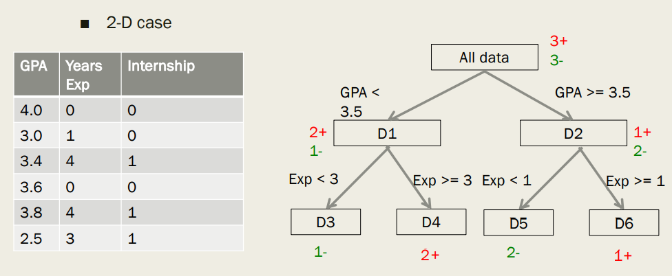

Decision Tree - Representation

■ In this class, DT is a way to represent concepts & hypothesis about a target concept

■ Can be written in form of rules

IF exp > 3 and GPA > 3.5 THEN internship = 1

■ **Leaf nodes** decide values of output variable

■ **Internal nodes & edges** represent splitting (sorting) criteria.

■ We will consider Boolean attributes and output.

■ Given instances with n Boolean attributes i.e. each Xi is of the form:

Xi = (x1, x2, …, xn) e.g. Xi = (0, 1, …, 0)

How will you represent one hypothesis => A binary tree

Properties of Binary Trees

■ A complete binary tree of height h has 2h+1 -1 nodes

■ Number of nodes at depth d is 2d

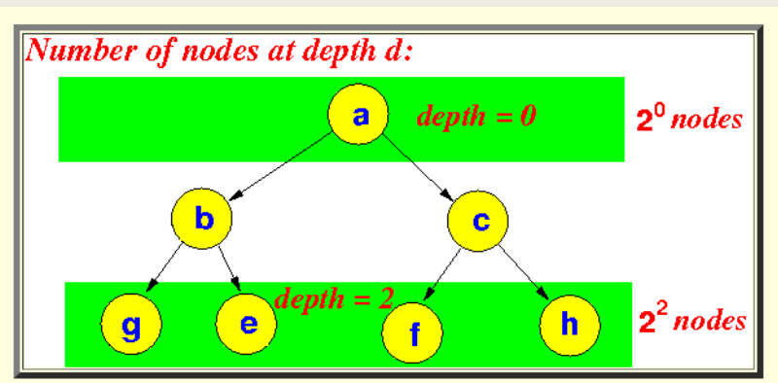

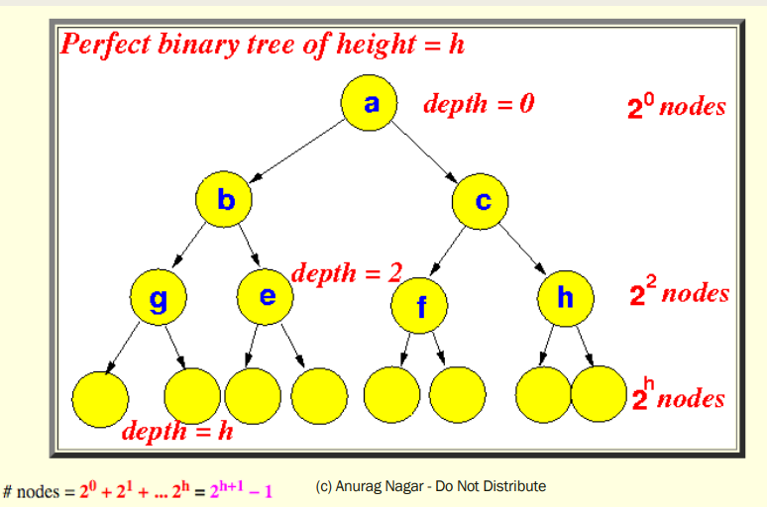

**Learning a DT.**

Use of DT in learning

■ Use the training examples and their labels to construct decision tree

■ For example, (X1, y1) could be ((0, 0, 0), 1)

■ You can use DT to model knowledge from training data.

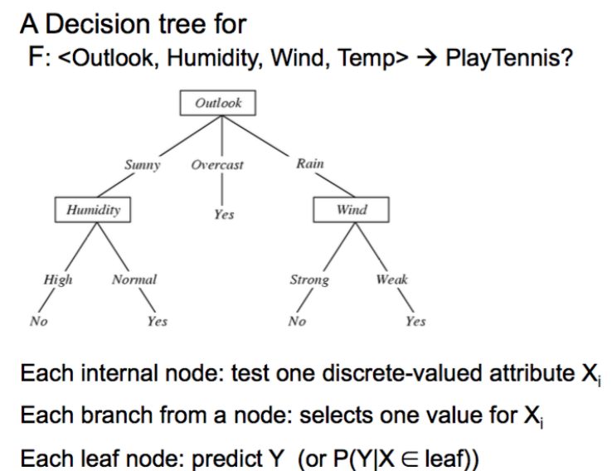

Using DT to represent hypotheses

.

.

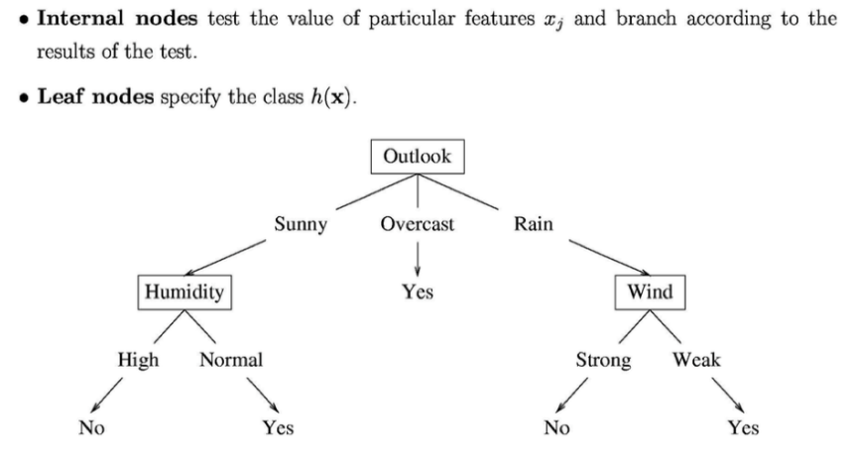

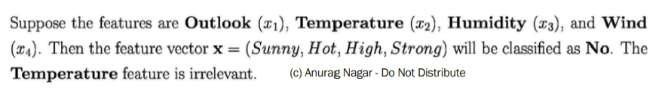

Classification Boundary of a DT

.

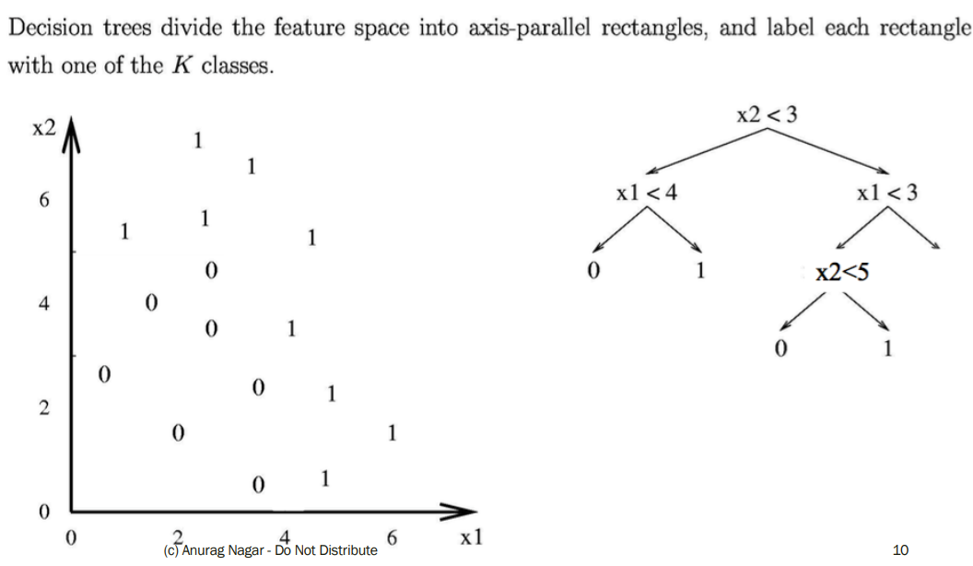

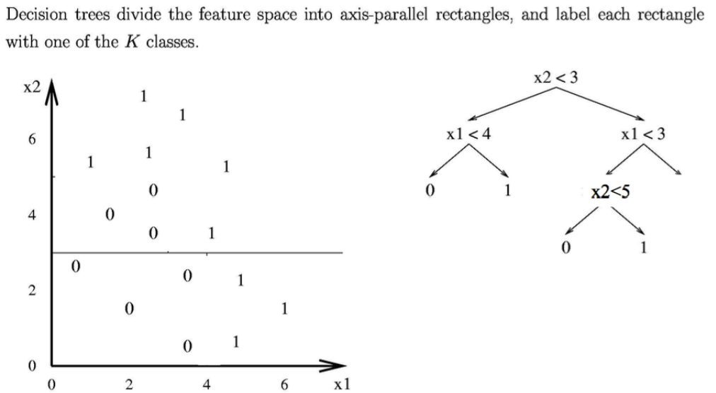

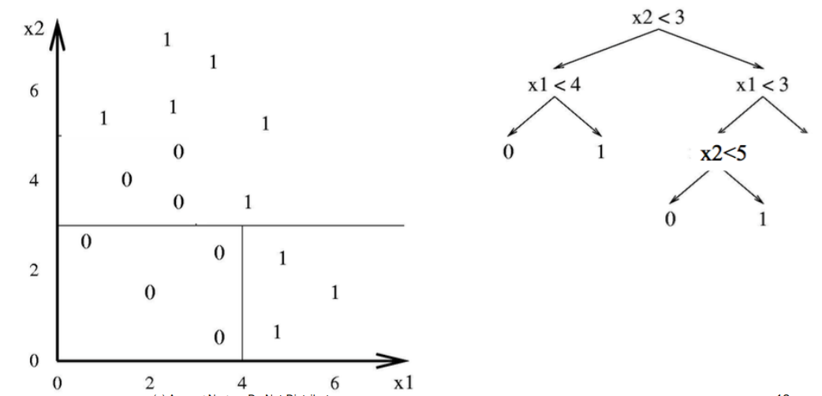

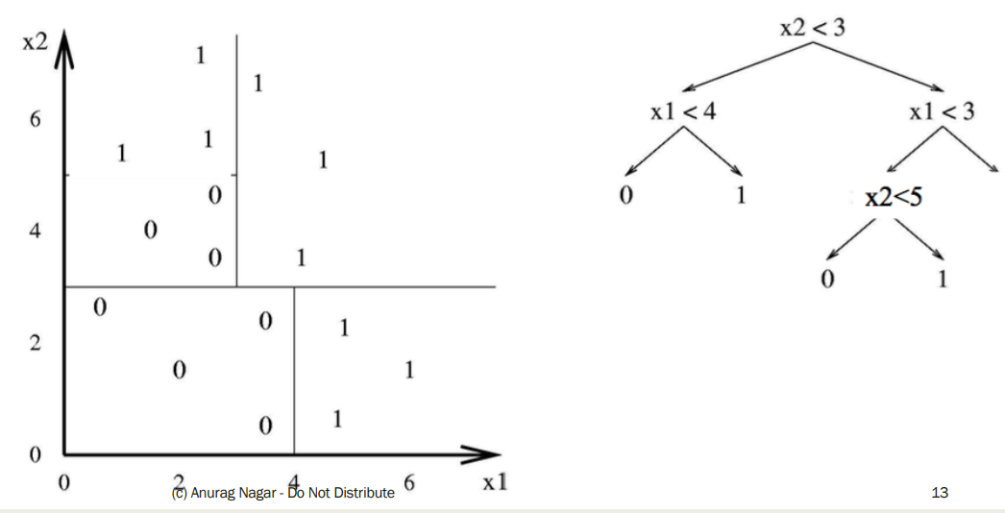

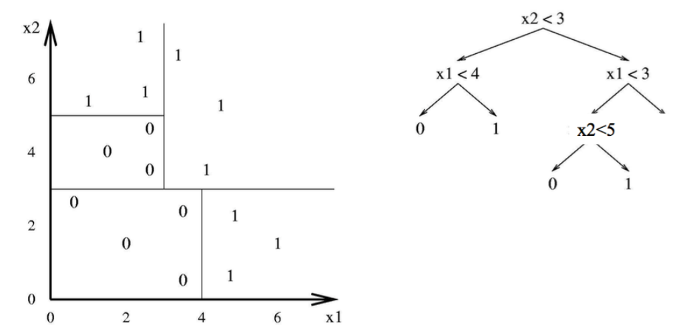

Hypothesis Space of DT

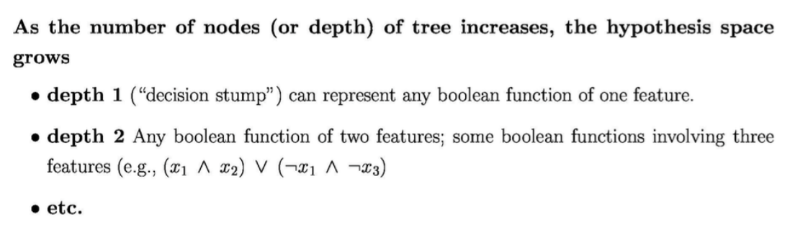

**Finding the best split (also called sort)**

DT – How to find best sorting?

■ Which attribute should I sort (split) on first? - It DOES make a difference.

■ Informally, we want that split that gives maximum purity at each node i.e. split such that all instances are of a single class (or close to it).

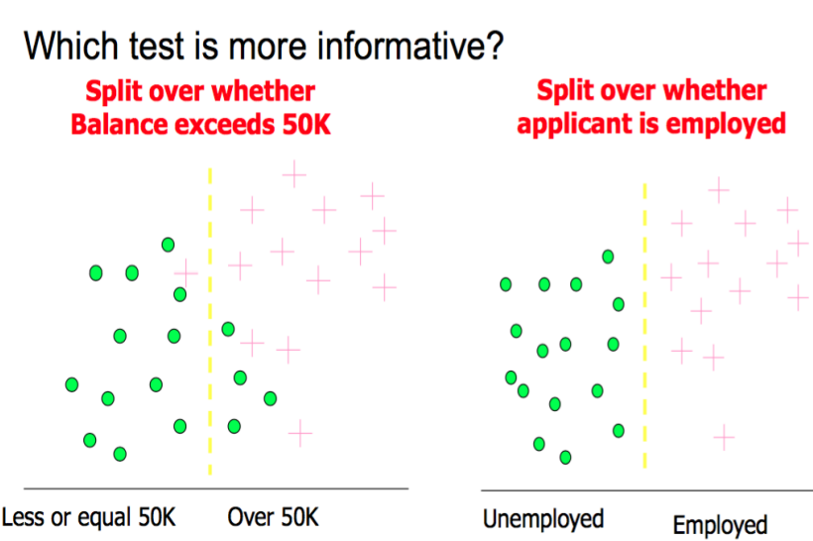

Entropy

Entropy is a measure of Information Content (IC)

. 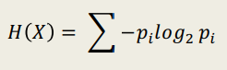

where pi is the probability of the i th class. If you think deeply, it is the **expected value** of –log 2 pi or log(1/p i )

. This quantity is also known as information of an attribute. Also, H(x) can be thought of as the number of bits needed to encode a dataset

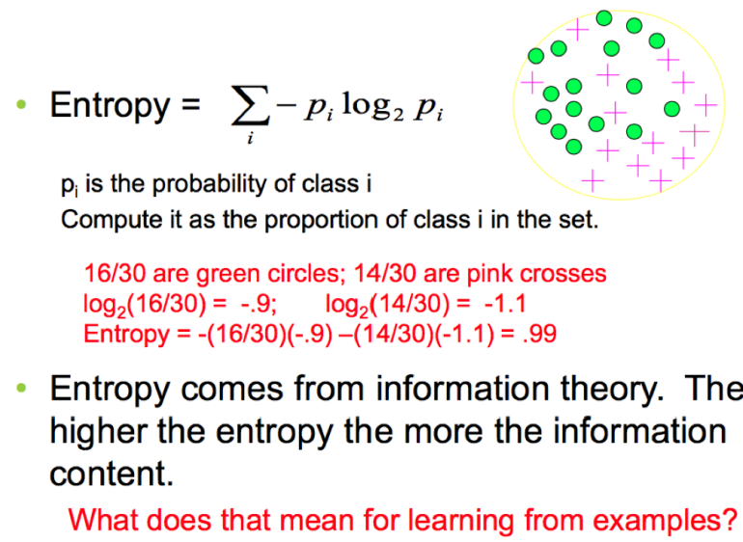

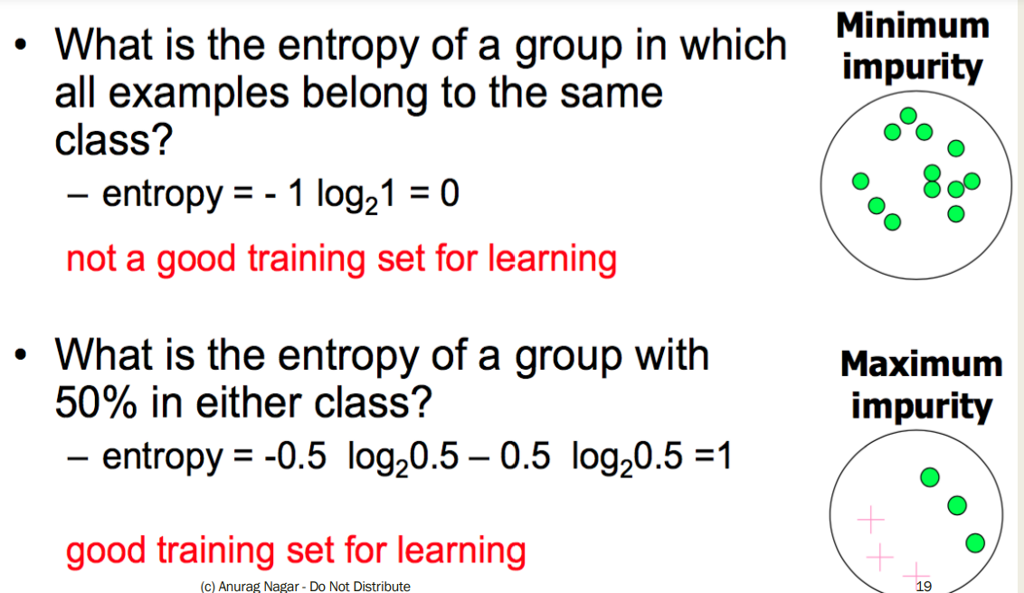

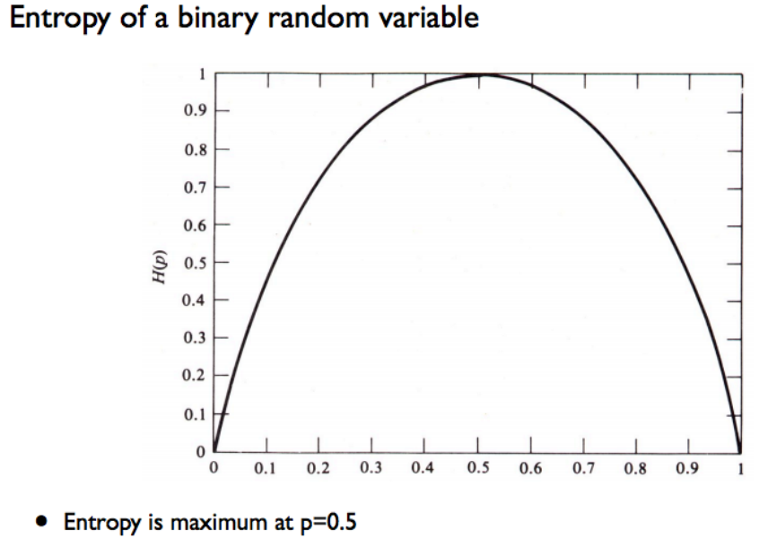

Information Gain

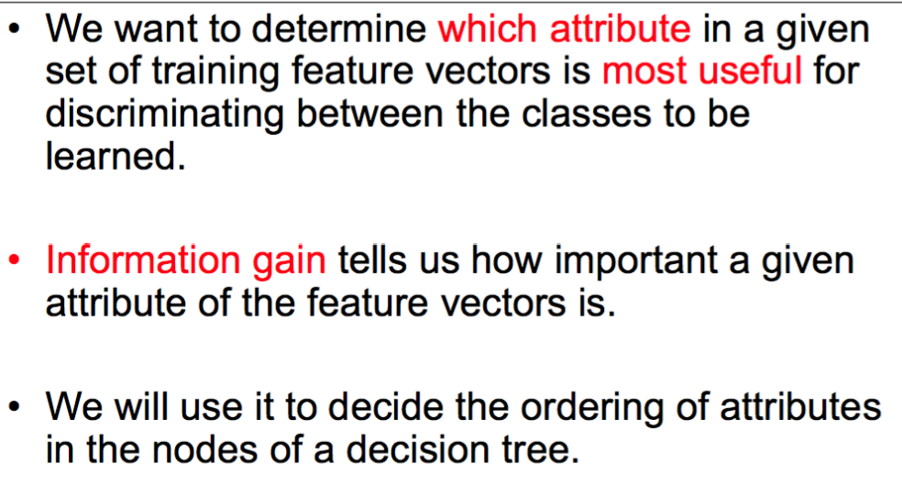

Information Gain

■ Suppose you just know the class labels initially.

■ Then you know one of the attributes. (Mean the same thing)

=> Does it really help you?

=> Do you get any information gain or reduction in entropy?

=> Do you get any increase in purity of the classes by knowing an attribute?

Information Gain

■ Information Gain (IG) is defined as: IG = Parent Entropy – Average Entropy of children

■ Average entropy of children: Probability weighted entropy of all the child nodes

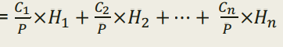

■ Information Gain (IG) =

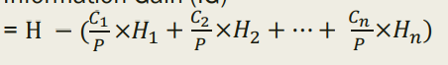

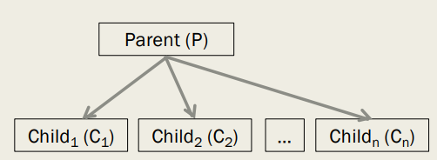

Parent has P data instances and entropy of H After splitting into n child nodes:

Child1 has C1 data instances and entropy of H1

Child2 has C2 data instances and entropy of H2 ….

Child­n has Cn data instances and entropy of Hn.

Example

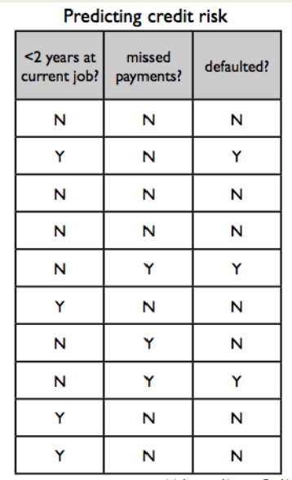

of IG Class attribute is **defaulted**?

Independent Attributes - **the first two**.

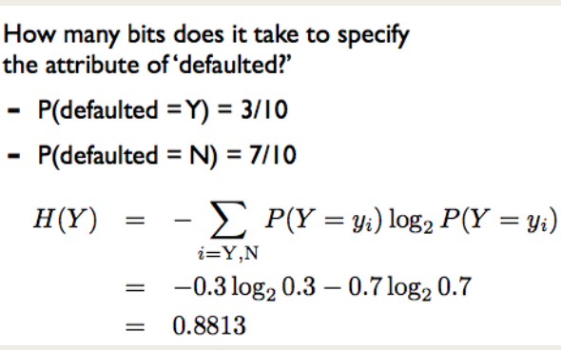

IG

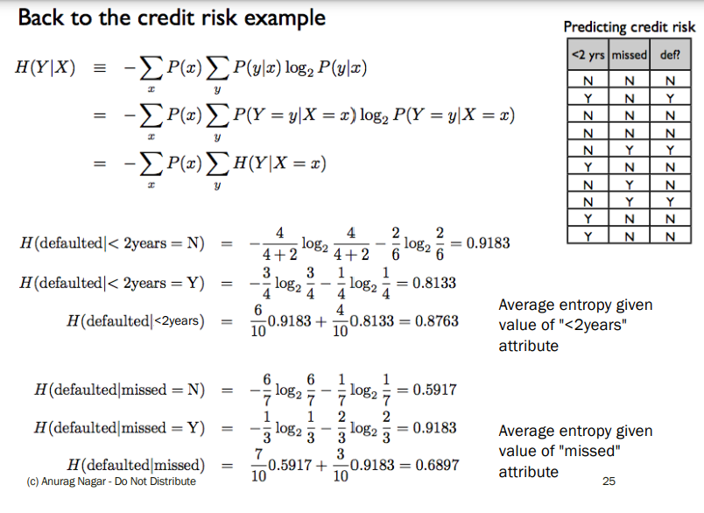

So… which attribute should I split on?

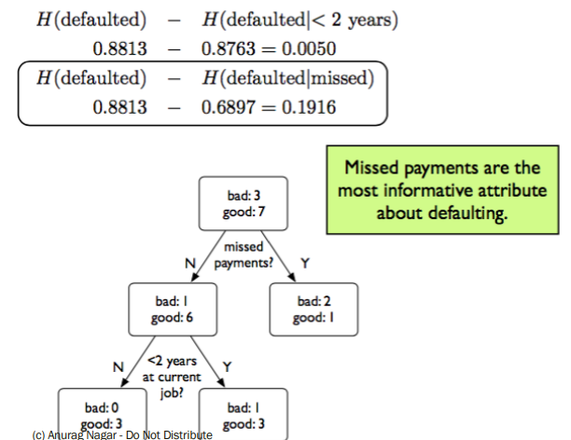

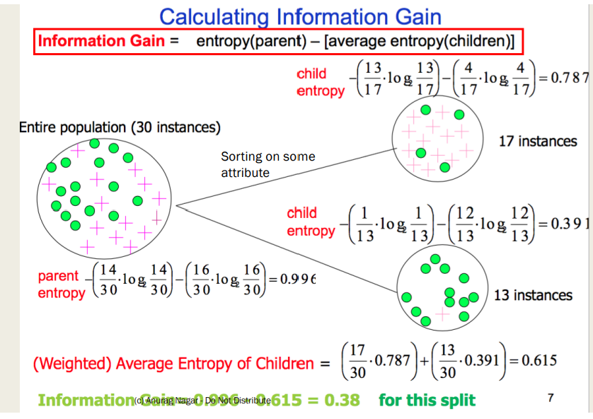

Calculating IG E(S) = E(29, 35) E(X1) = E(21, 5) E(X2) = E(30, 8) IG = E(S) – [26/64 * E(X1) + 38/64 * E(X2)]

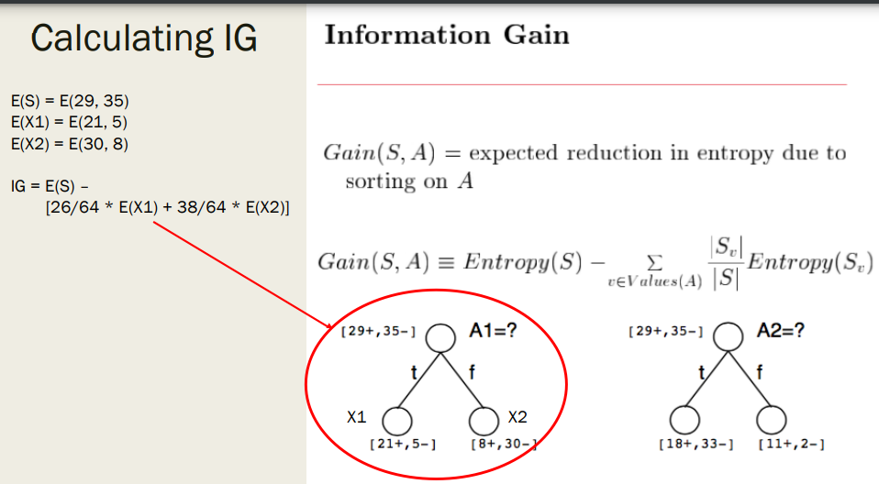

Use IG to build a tree

■ Start at the root of the tree (N1) and choose the best attribute according to IG. Let's say it is a1

■ Create its children according to possible values of a1. If a1 is Boolean, it will have 2 values 0 and 1.

■ These two nodes will be the leaf nodes for now -> since we haven't constructed whole tree yet.

■ Also, these two nodes will have only less attribute to choose from. Their available choices will be {a2, …, an}

■ Similarly create the rest of the tree, choosing the best attribute at each step.

■ Terminating Condition: - The node is pure in terms of class label. - There are no more attributes remaining.

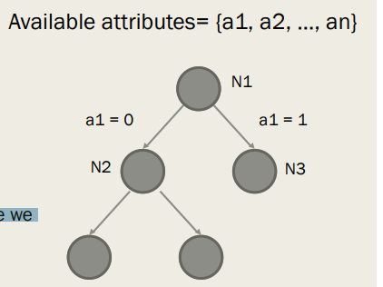

ID3 algorithm

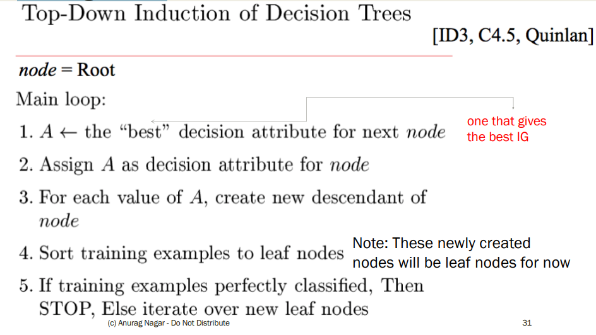

ID3 algorithm

■ Simpler version ID3 (node, {attributes})

1. Let A = best attribute among {attributes} according to IG

2. Sort according to A and create child nodes (which will be leaf nodes for now)

3. For all the child nodes

If it is pure or {attributes} is empty,

STOP

else call ID3(childNode, {attributes} – A) /* Recursive Call */

Worked out example

■ Please see the handout/notes for a worked out example using ID3

■ Remember:

- For each node, you have to find the best attribute

- You can only use an attribute once along a path. So, a node needs to inherit a list of attributes from its parent class -> You have to program this. J

- At the leaf node, find the majority class (by count). Use that for the prediction rule

Does it really matter which attribute comes first?

■ ID3 helps us in selecting the shortest i.e. most compact tree

ID3 is a greedy algorithm Top-down induction of trees.

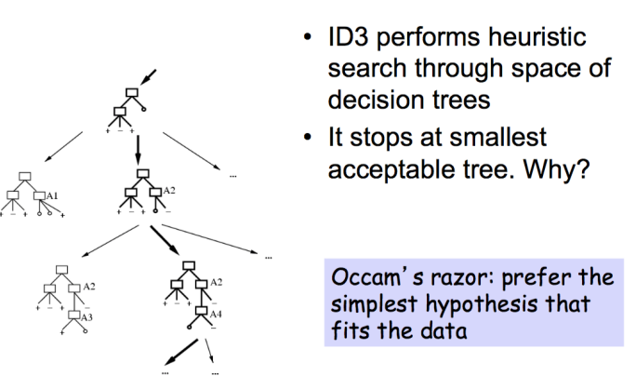

Problem with DT

■ Over-zealous learner -> learns all features

■ What if there is noise?

■ DT will try to change everything??

■ Consider tree below: What would happen if you get noisy data point

Sunny, Hot, nOrmal, Strong, Play Tennis = no

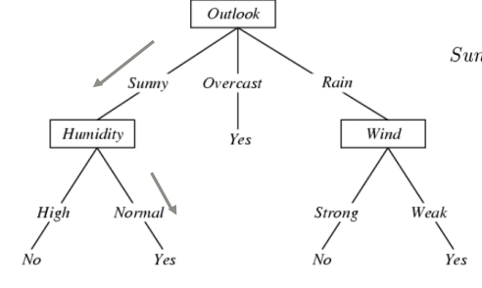

Overfitting

■ You train on the training dataset The data that the learner trains with. => It is possible to design a DT that gives 100% accuracy on training data. Think how?? e.g. each instance gets its own leaf node

■ But is that a good thing? => NO! Because you are in fact memorizing (rote learning) the training data => No room for generalization, it's a case of Overfitting

■ So, you have to find a balance between underfitting (learning very little) and overfitting.

■ Notation: Training error of hypothesis h = etrain(h) True error (on unseen data) of hypothesis h = etrue(h)

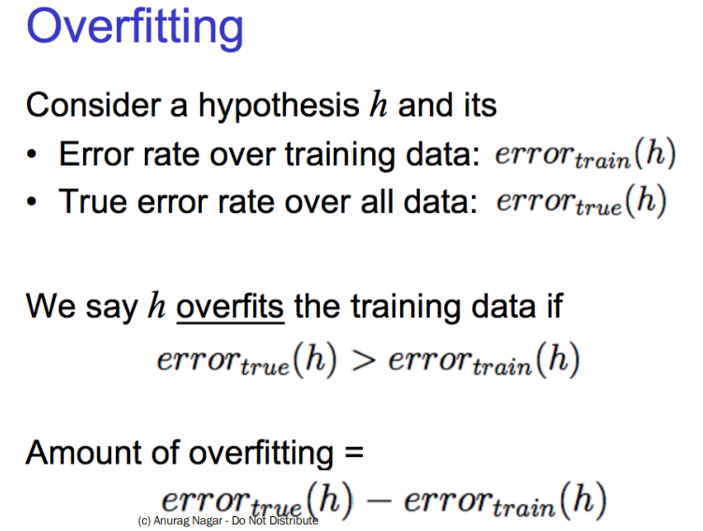

Overfitting in decision Tree Learning.

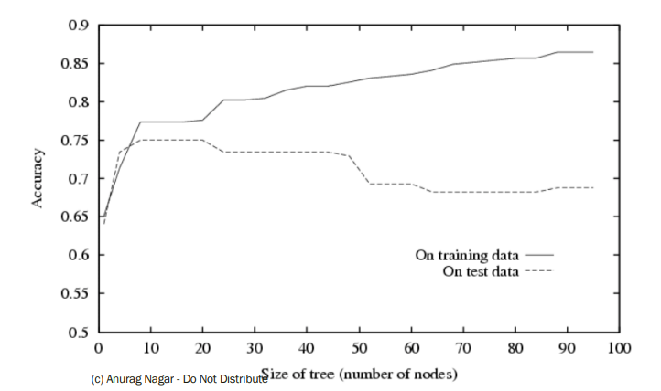

How to avoid overfitting?

1. Stop growing when splits are not statistically significant (TOUGHER PROBLEM)

OR

1. Grow full tree then post-prune i.e. remove nodes and see if true error decreases (EASIER PROBLEM)

How to avoid overfitting?

■ Keep another dataset -> validation dataset

■ Build model on training, test accuracy on validation

■ Learn model from training dataset.

■ Randomly remove nodes and see if validation accuracy improves

Reduced- error Pruning

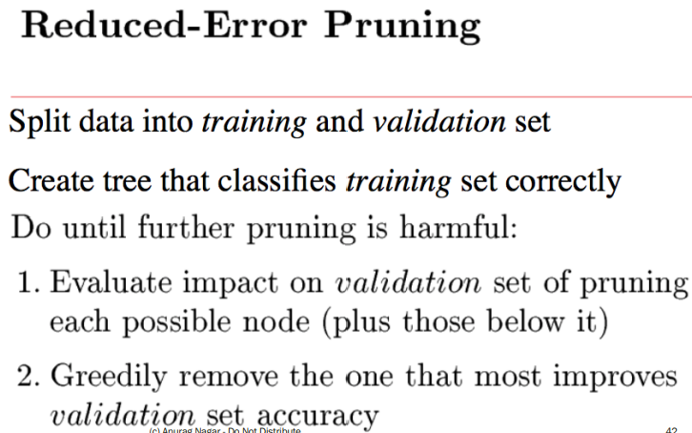

Post-pruning

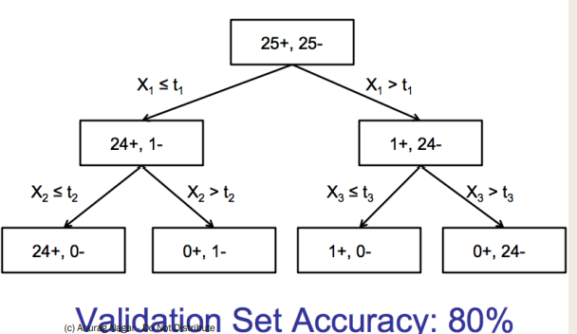

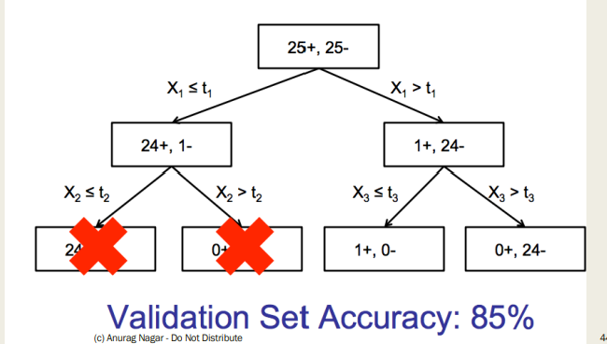

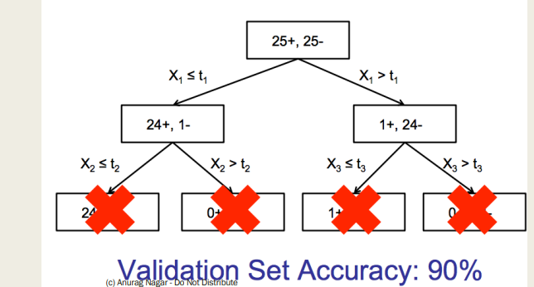

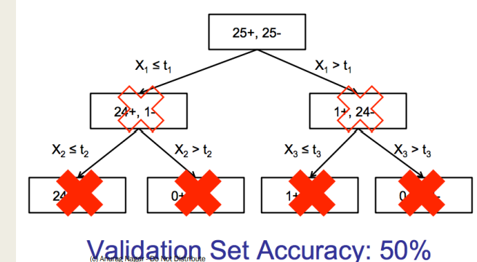

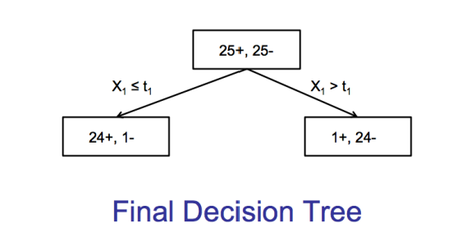

What have we learnt?

■ Idea of DT

■ Number of instances (leaf nodes) and hypotheses

■ How to choose best sorting attribute for each node

■ How to induce top-down tree using ID3

■ What is overfitting

■ Avoiding overfitting

Linear Classification Perceptron

. Imagine you have data as shown on the right and you want to propose a class separating hypothesis

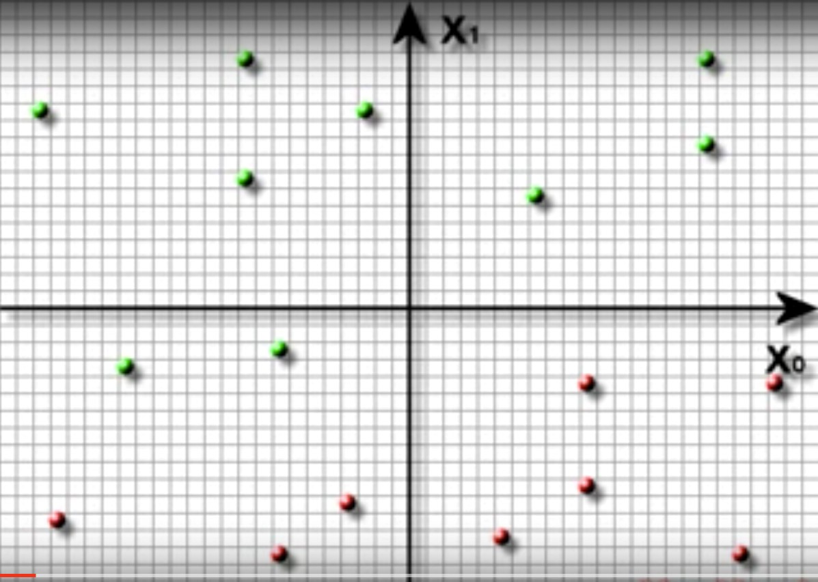

Your hypothesis

(

h

)

• Since data is linearly separable, you can propose a straight line

• Your hypothesis divides the plane into two parts

• Aim: Get those parts as pure as possible

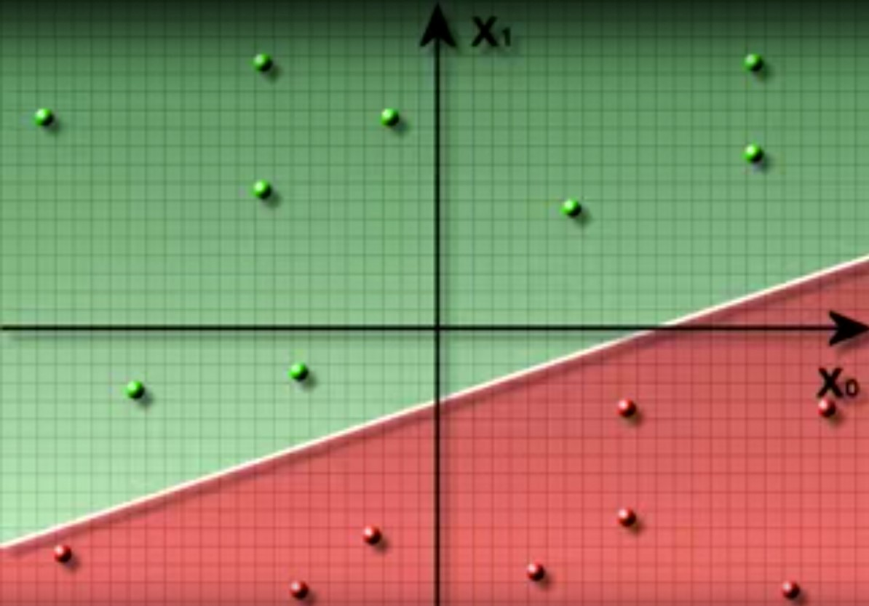

• OK, sounds simple enough

•Just draw a straight line and partition the plane into two parts.

• Limitations:

- Works with linearly separable data only.

•I can draw many lines that separate the data perfectly, which one do I choose?

•Good Question

Let's do some Math

• Equation of a straight line in a plane with two dimensions x1 and x2:

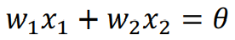

• There are three parameters in the equation above w1, w2 and ϴ.

• By changing these, you can get a different line.

• Let's call the hypothesis as:

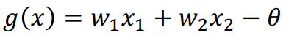

• What's the value of g for points that lie on the separating line? 0

Math

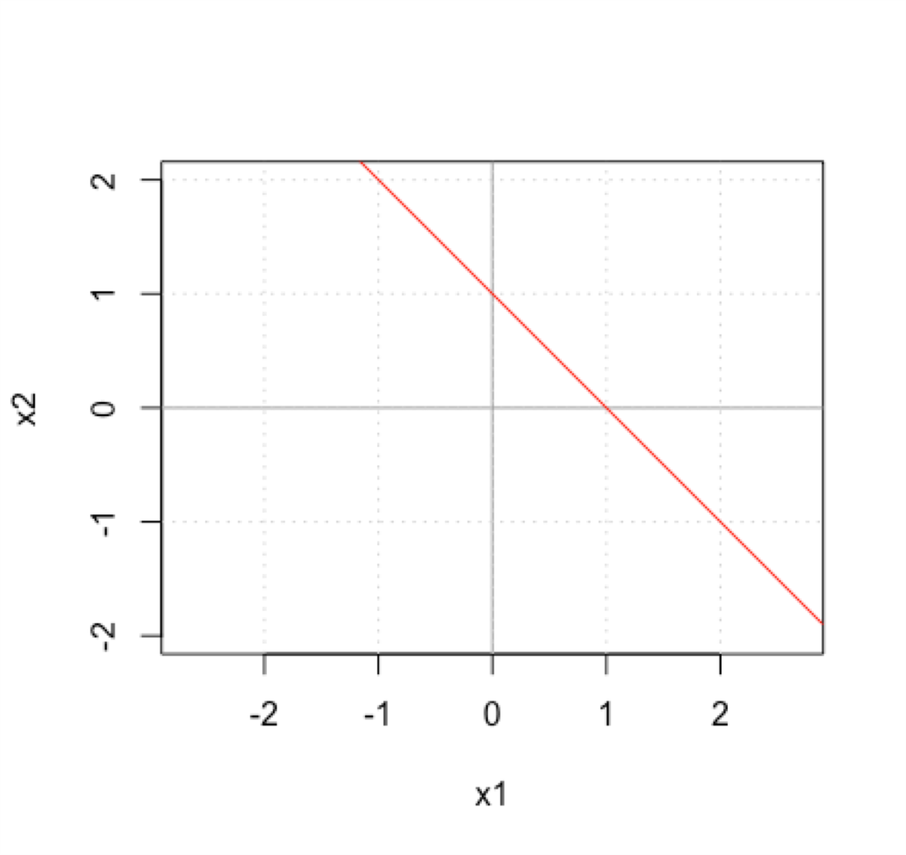

• Let's draw a line with w1 = 1, w2 = 1 and ϴ = 1.

• We are trying to draw: x1 +x2 =1

• Thus, g(x) = x1 + x2 - 1

• What are some points on this line: (1, 0), (0, 1), (½, ½), (-1, 2), …

• All the above points satisfy g(x) > 0

• Let's see what happens to points in green area.

• What is g(2, 1) ? g(2, 1) = 2 + 1 – 1 = 2

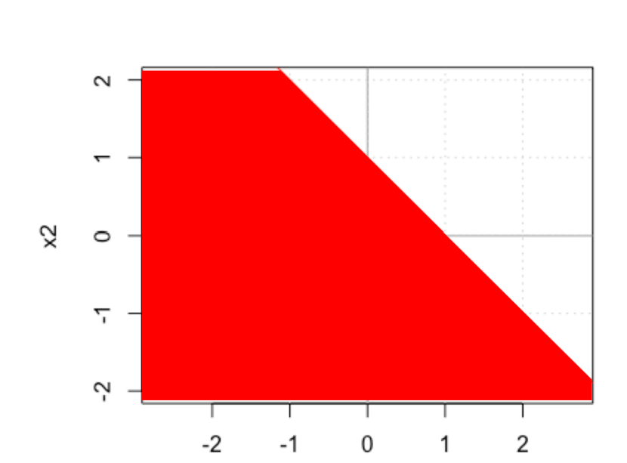

• Let's see what happens to points in red area.

• What is g(-1, -1) ?

g(-1, -1) = -1 - 1 – 1 = -3

• So, what can we use as a classification rule:

• Check sign of hypothesis for test data point:

if sign(g(xtest)) > 0 call it class +1 else if sign(g(xtest)) < 0 call it class -1

Classification Rule

• Let h(x) denote the sign of g(x) h(x) = sign(g(x))

sign(x) function is defined as +1 for x >= 0 and -1 for x < 0

• Predicted class label:

Class = h(x)

Linear Classification

• If there are n input attributes x1, x2, …, xn, our task is to find appropriate set of weights w1, w2, …, wn, such that correct classification can be performed.

We would like if 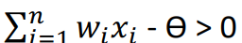 then class = +1 otherwise class = -1.

for some threshold value ϴ.

• This can be states as: If wTx > ϴ then class= +1 otherwise class = -1 where w is the weights vector and x is the attributes vector.

**Note: i starts from 1 => We don't have any artificial attributes**

Linear Classification

• Can be written as: w1x1 + w2x2 + … + wnxn > ϴ for class +1

Or - ϴ + w1x1 + w2x2 + … + wnxn> 0 for class +1

or w0 + w1x1 + w2x2 + … + wnxn> 0 for class +1

where w0 is referred to as the bias term.

**You will find both these form used in textbooks.**

Linear Classification

• Two equivalent ways:

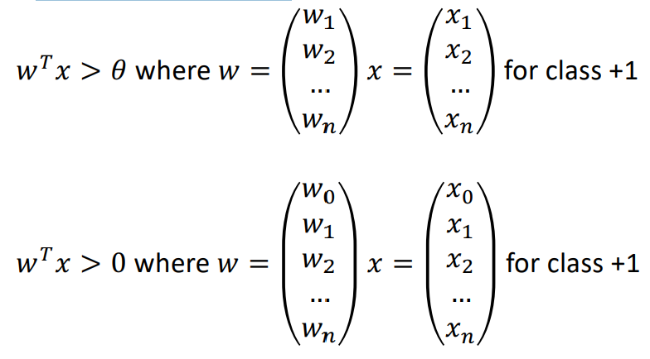

Graphical Meaning of Terms

• What do the terms (w1, w2, ..) and ϴ mean graphically.

• w's correspond to the slope and ϴ is a measure of intercept of the line.

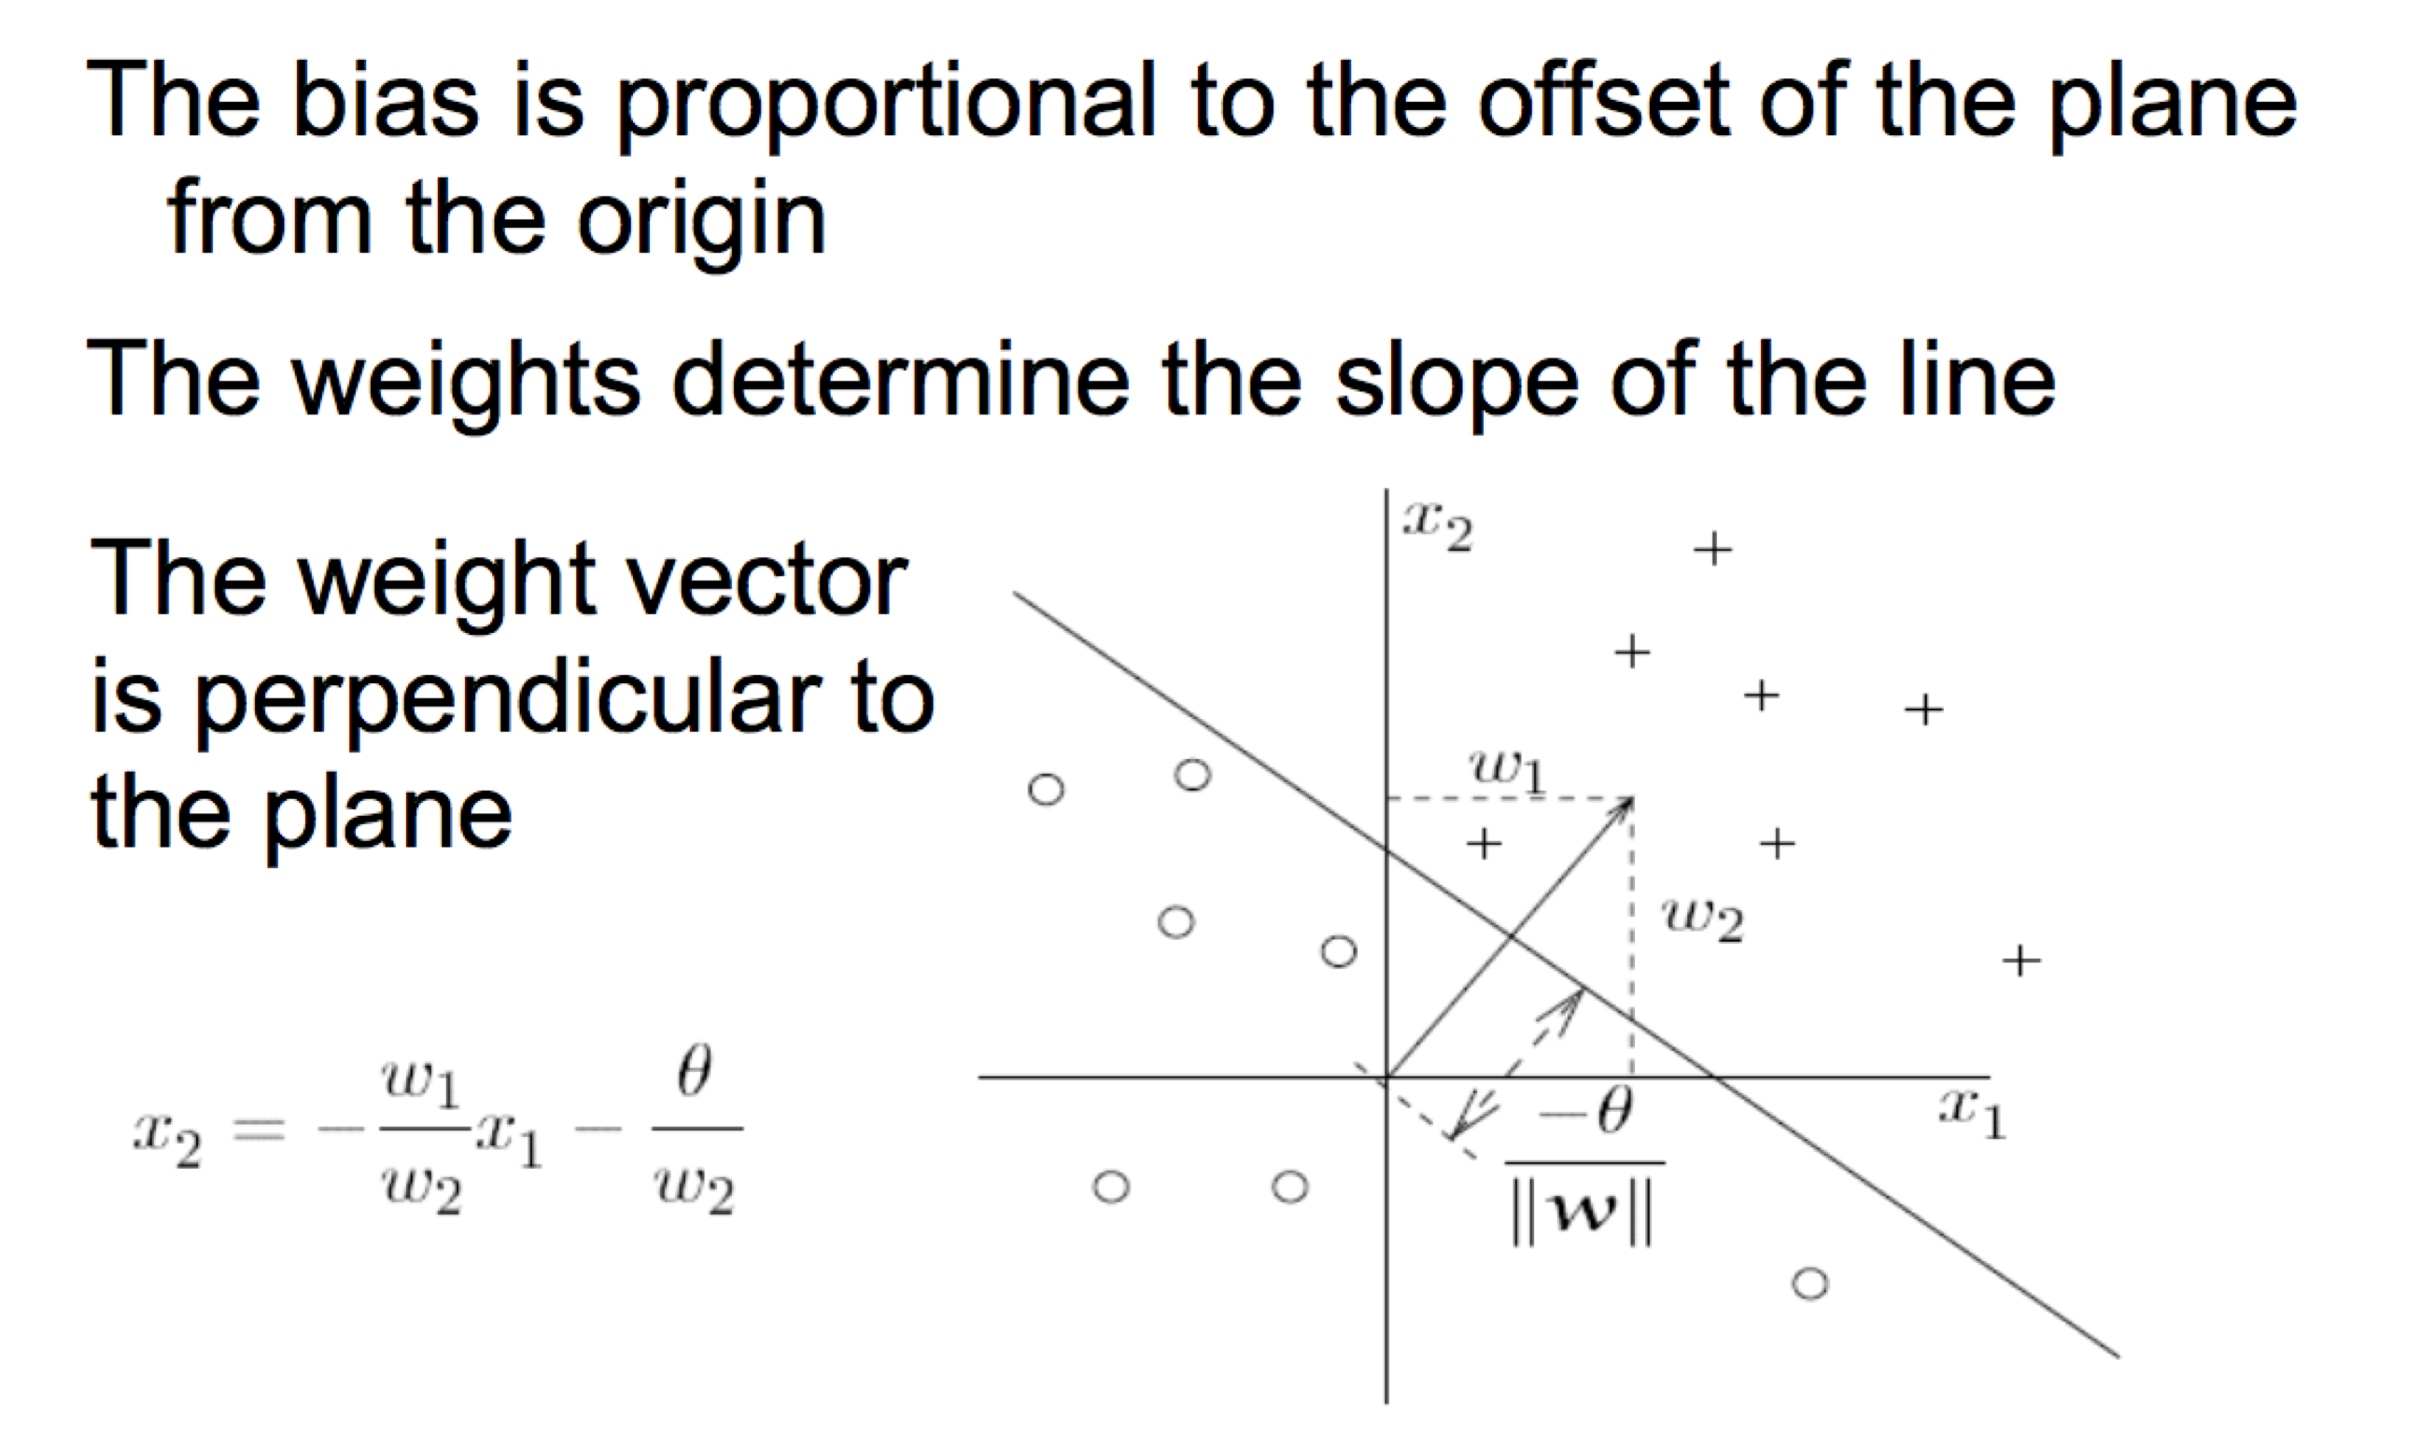

Perceptron

• The idea of linear threshold classifier is used in the model of a perceptron.

• Inspired by bio-computing model of a neuron in brain

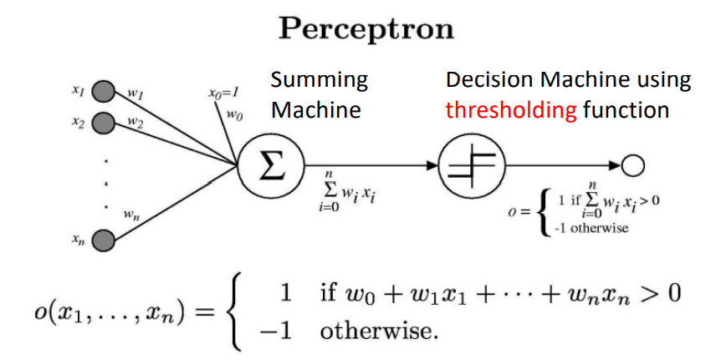

Sometime we’ll use simpler vector notation:

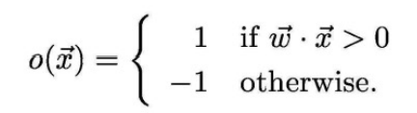

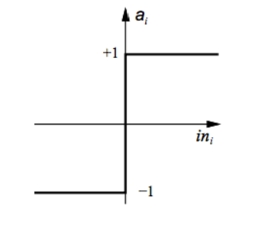Linear Classification

• The hypothesis can be represented as: h(x) = s(g(wT x))

where s is a function that outputs -1 or +1

What can s be?

s(x) = +1 if x >= 0

-1 if x < 0 It's called the sign function

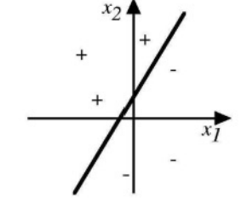Types of problems Perceptron can solve

• Linearly separable dataset only.

• If you use it with non-linear data, you will not get 0% training error. => You will not get a consistent hypothesis on non-linear dataset

• Let's see some examples of its representational power

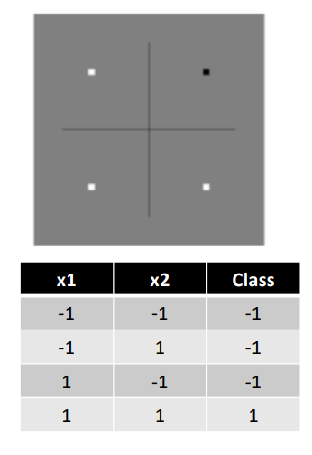Representative power

• Let's see if we can represent the AND function.

• Perceptron model:

if w1x1 + w2x2 > ϴ then Class = +1 else class = -1

• Let's assume w1 = w2 = 1. You can vary ϴ.

if x1 + x2 > ϴ then Class +1 else class = -1

• Find the value of ϴ

• Any number greater than 0 and less than 2 e.g. 1.5

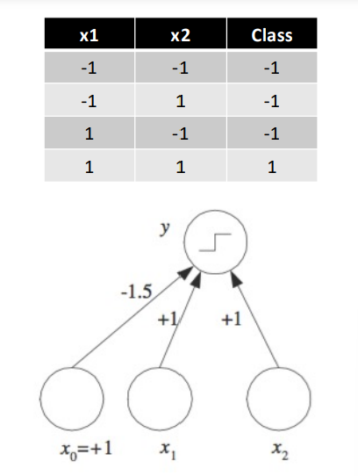Representative power

• Another way of representing AND.

• Perceptron model: if w 0 + w 1 x 1 + w 2 x 2 > 0 then Class = +1 else class = - 1 Notice: w 0 = - ϴ

• Let's assume w 1 = w 2 = 1. You are looking for w 0 such that : if w0 + x 1 + x 2 > 0 then Class +1 else class = - 1 • What is w 0 ? Any number less than 0 and greater than -2 e.g. -1.5 or -0.5

Representative power

• Let's see if we can represent the **OR** function.

• Perceptron model: if w 1 x 1 + w 2 x 2 > ϴ then Class = +1 else class = - 1

• Let's assume w 1 = w 2 = 1. You can vary ϴ. if x 1 + x 2 > ϴ then Class +1 else class = - 1.

• What is ϴ ?

• Any number less than 0, but greater than -2. Example: -0.5

Representative power

• Another way of representing OR.

• Perceptron model: if w 0 + w 1 x 1 + w 2 x 2 > 0 then Class = +1 else class = - 1 Notice: w 0 = - ϴ

• Let's assume w 1 = w 2 = 1. You are looking for w 0 such that : if w0 + x 1 + x 2 > 0 then Class +1 else class = - 1

• What is w 0 ? Any number greater than 0, but less than 2. Example: 0.5 or 1.5

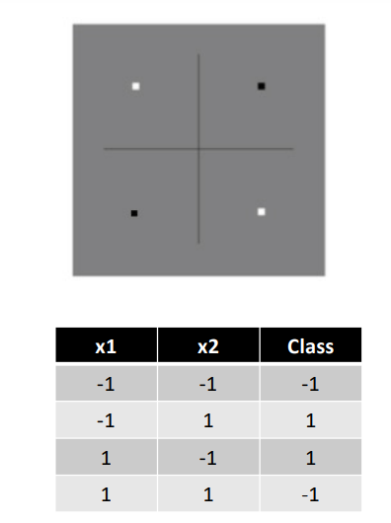Representative power

• Let's see if we can represent the XOR function.

• Perceptron model: if w1x1 + w2x2 > ϴ then Class = +1 else class = -1

• Let's assume w1 = w2 = 1. You can vary ϴ. if x1 + x2 > ϴ then Class +1 else class = -1

• What is ϴ ? Can't find any such value

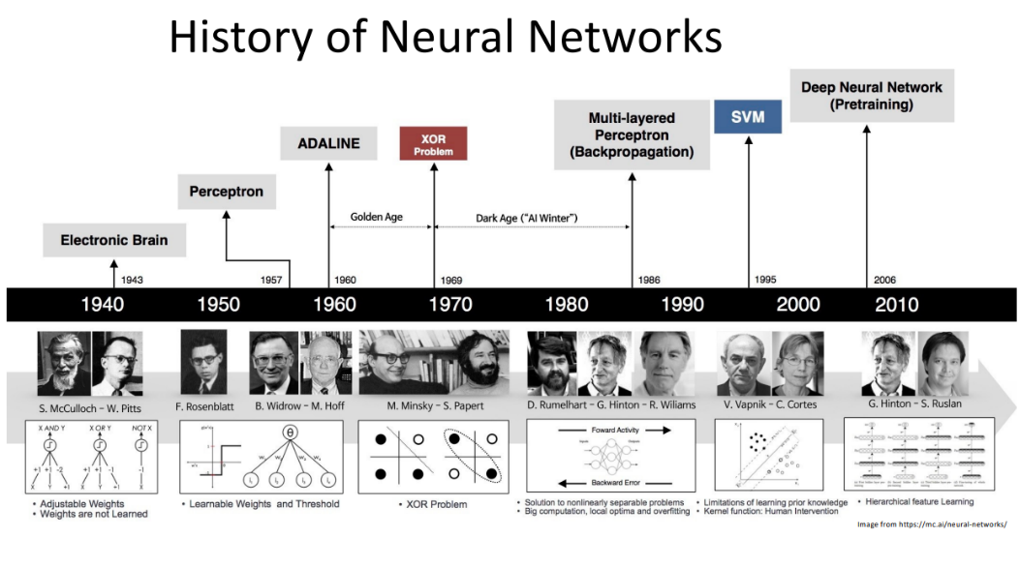

Canonical Representation

• In our framework, when do our hypothesis and actual value agree?

• Sign function plays a big role.

• Let's consider possible cases:

So, what do you conclude: (h * y) should be > 0 for correct prediction

Some textbooks write it as: g = wT x h = sign(w) Check sign(h * y) for correct prediction

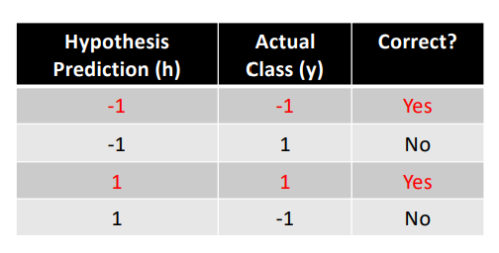

Perceptron

• So, the functional form of the hypothesis is given to you: g(x) = wT x • You classify a point based on sign(g) • But the big question: How do you find weights? • That's why companies are looking for you.

Learning Weights of a Perceptron

Perceptron Training Rule only works for linearly separable data.

• Two techniques available: (Tom Mitchell 4.4.2 and 4.4.3)

**1. Perceptron Training Rule – Change training weights according** to: 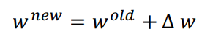

where 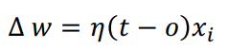

Start with random weights and apply above rule to each training example and modify each weight wi according to above rule.

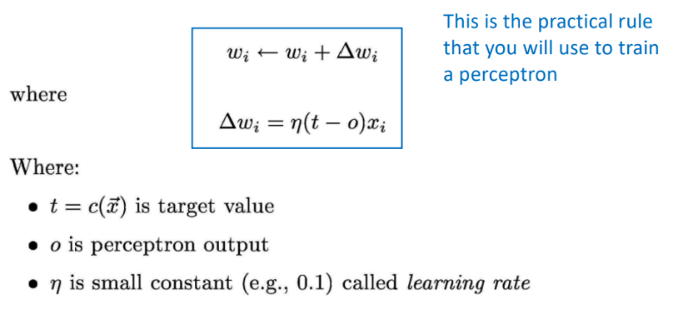 is the learning rate



t is the target value that you want (given for training examples)

o is the current output of the perceptron.

Note: t and o can only have values in the set {-1, +1}

Learning Weights of a Perceptron

This works even if the data is not linearly separable

Two techniques available: (Tom Mitchell 4.4.2 and 4.4.3)

**Gradient Descent Rule – First consider unthresholded output of the perceptron**:

o = w . x

Specify an error function: 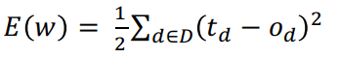where D is the set of all training examples.

Just like before, run the gradient descent algorithm on this function by starting with random weights.

Perceptron Training Rule

**Example:**

• Given: - A set of instances X1, X2, …, XD each containing n attributes i.e. Xi = * For LC, we assume the binary attributes can take values of +1 or -1 * - Labels for each instance y1, y2, …, yD (can be +1 or -1)

• Example: UTD Internship Problem

Can each attribute have different weight? I want to give twice the weight to work experience as GPA.

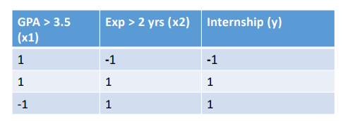

**Perceptron Training Algorithm**

Perceptron_Training_Algorithm(training_examples, ) {

Initialize weights vector w to some random value

Until convergence do {

For each training example {

Compute output o using activation function

For each linear unit (attribute) i, update using

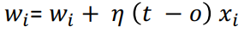

} } }

Convergence

Will it converge? Yes, provided: • Data is linearly separable. • The learning rate is small enough.

Example

• You initialize the weights vector as: w= −2 1 2 Assume a learning rate  = 0.5. You are given following data points and target values:

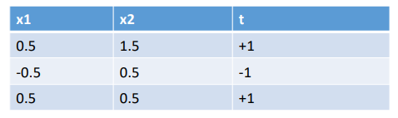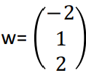

**Example**

• For first point, g(x) = sign(w.x) = sign(-2 + 0.5 +3) = +1 => no change needed since t(x) = g(x)

• For second point, g(x) = sign(w.x) = sign(-2-0.5+1.0) = -1 => no change needed since t(x) = g(x)

• For third point, g(x) = sign(w.x) = sign(-2+0.5+1.0) = -1 => Need to update weights

**Example**

• Updating weights. Start with Δw = 0; t - o = 1 - (-1) = 2

Δw0= 0.5 * 2 * 1 = 1

Δw1= 0.5 * 2 * 0.5 = 0.5

Δw2= 0.5 * 2 * 0.5 = 0.5

So new values will be:

w0 = -2 + 1 = -1.0

w1 = 1 + 0.5 = 1.5

w2 = 2 + 0.5 = 2.5

You can verify that this value of the weights vector will classify points correctly.

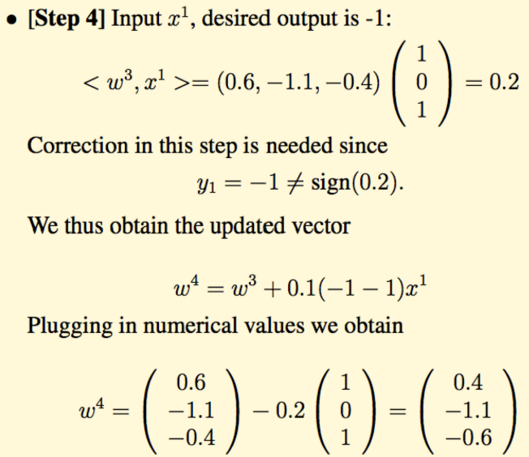**Example 2**

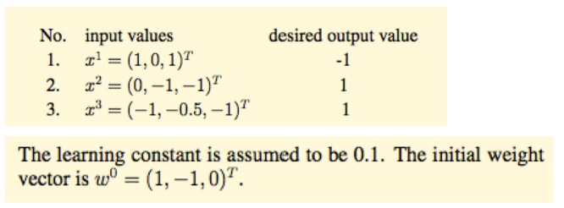

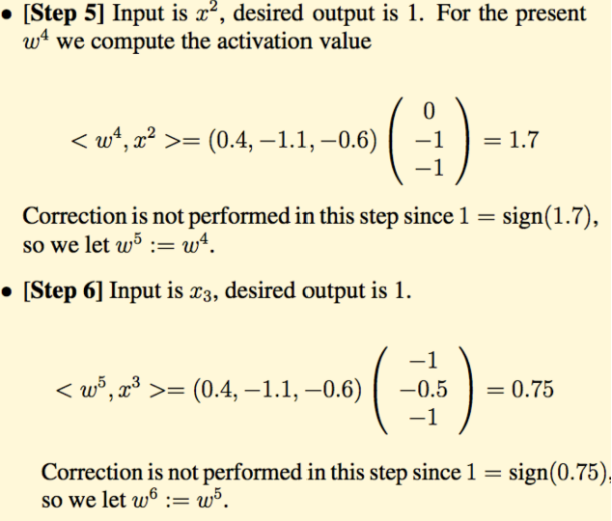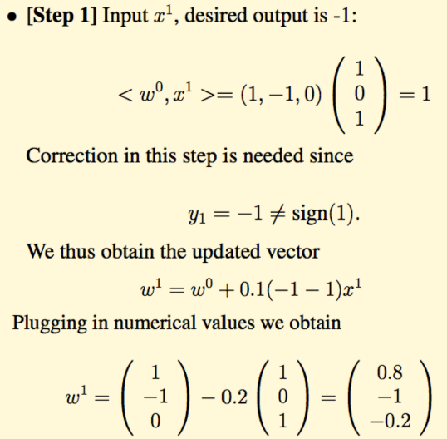

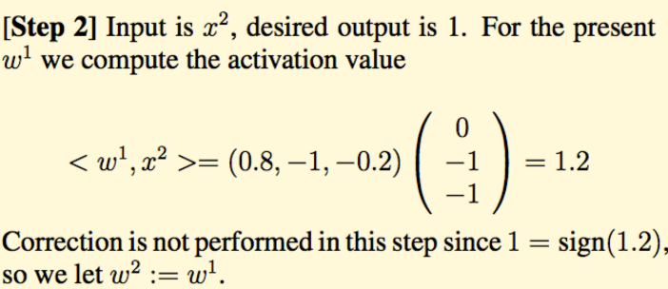

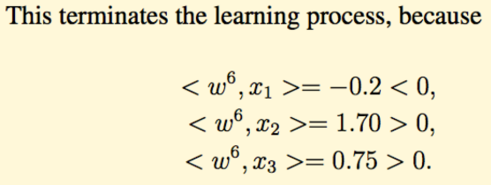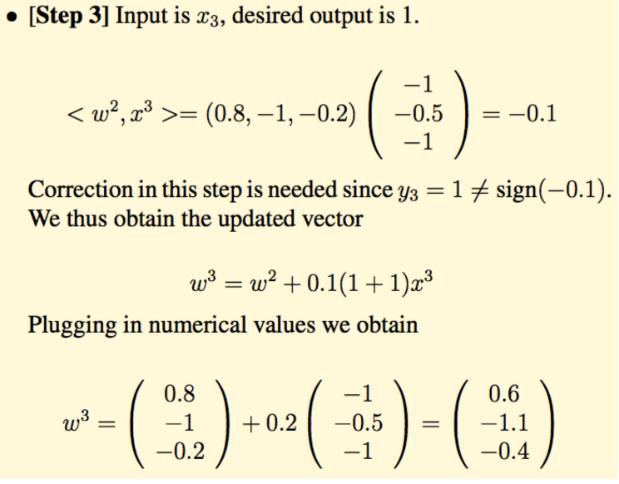

2. Gradient Descent

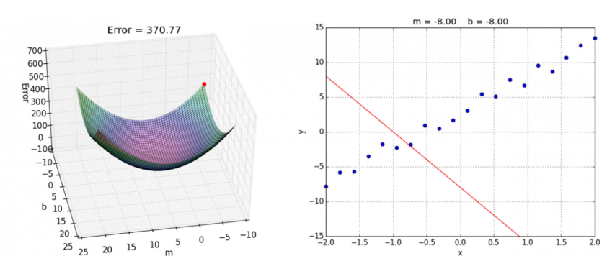

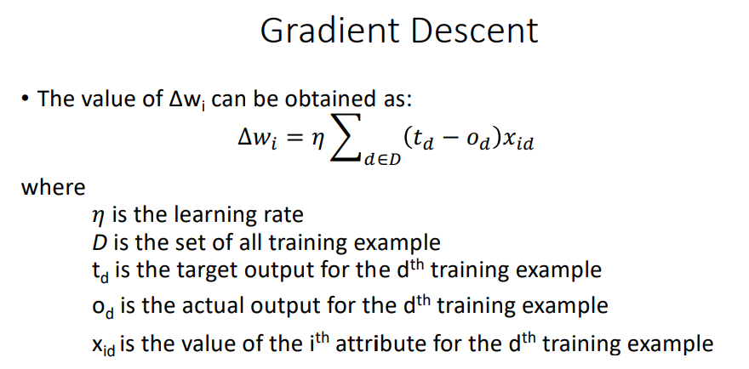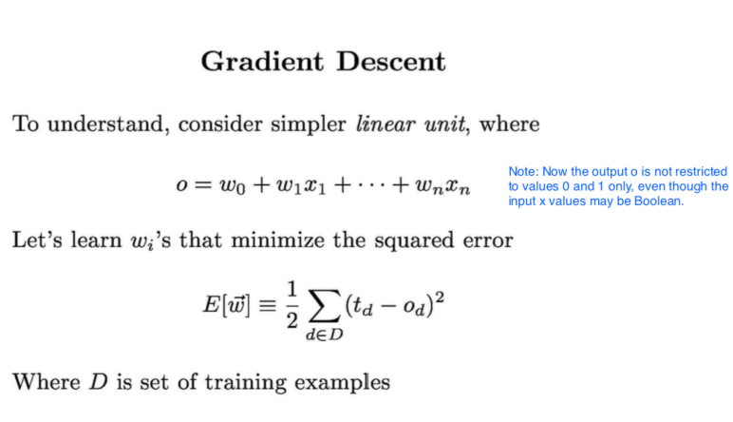

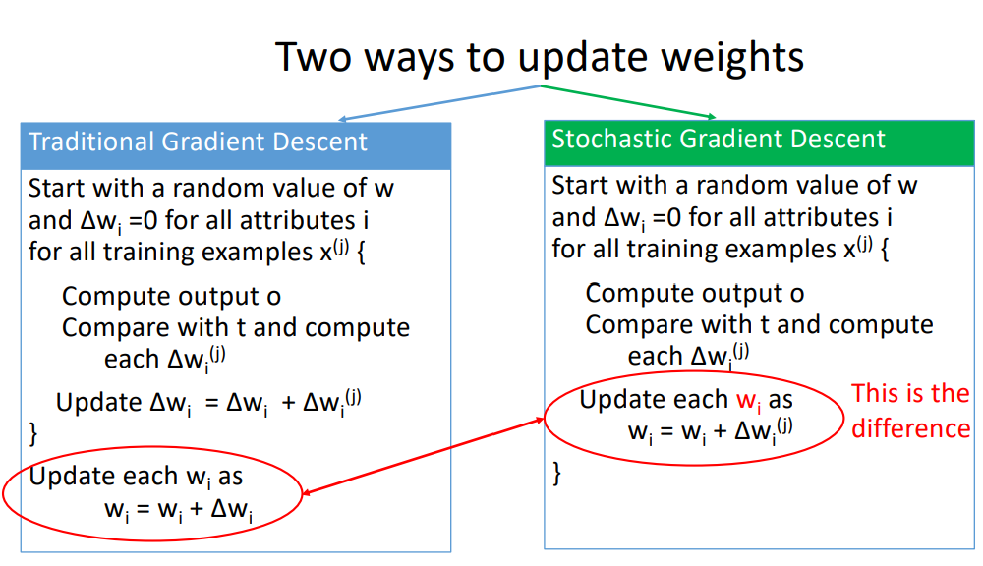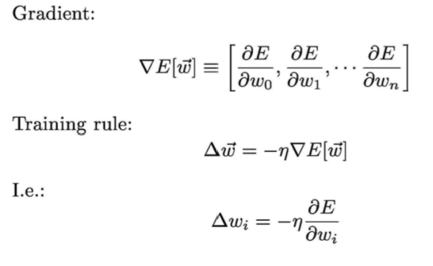

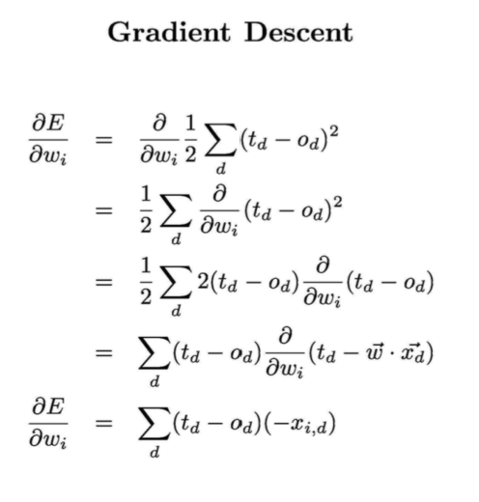

Difference

Traditional gradient descent can lead to:

1. Convergence to local minimum can be quite slow (many thousand of gradient descent steps)

2. If there are multiple local minima in the error surface, then there is no guarantee that the procedure will find global minimum.

Stochastic gradient descent can alleviate these problems. (Section 4.4.3.3 of Tom Mitchell)

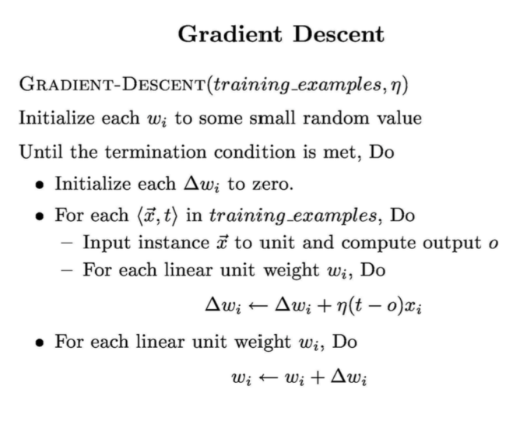

Thought Questions:

• Pros and Cons

- Only works with linearly separable data

- Is error driven

- Does it converge? If you input data that is not separable, what would happen?

- Efficient?

- Easy to visualize

- Can weight attributes

- Activation function concept is nice

What is next? • How do we extend it to non-linear datasets?

**Neural Net**

Extending Perceptron

• Perceptron only works with linearly separable data.

• How do we make it learn more complicated, non-linear datasets?

• Change the output function from step to a non-linear one.

• Strength in unity

• Combine multiple perceptron units

What is a NN?

• We saw earlier that a single perceptron can only separate linear data

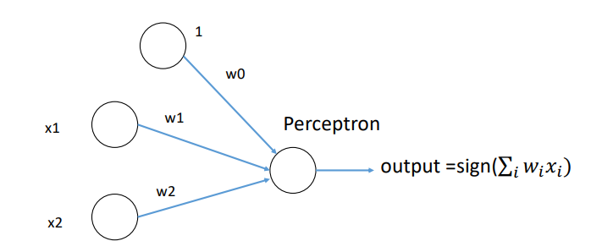

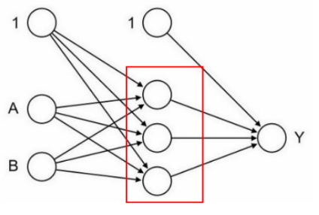What is a NN?

• What would happen if we create a network of perceptron.

• Initial input is fed to a set of nodes in the intermediate layer, known as hidden layer.

• Output from hidden layer can be sent to another hidden layer or output

Hidden Layers that perform transformation of input signals to outputs

Neural Network

• A set of perceptron joined together in multiple layers.

• The output can represent highly complex and nonlinear functions.

• By constructing this network, we use a combination of simple perceptron to build a powerful classifier.

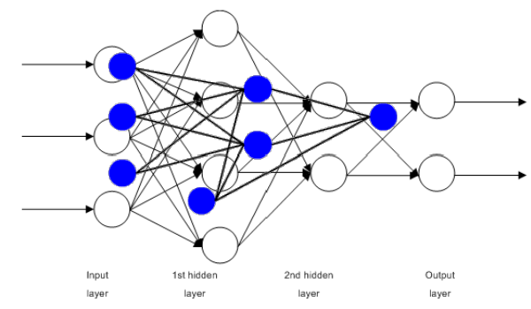

Properties of NN

• A large number of very simple neuron-like processing elements.

• A large number of weighted connections between the elements.

• Highly parallel, distributed control.

• An emphasis on learning internal representations automatically.

ANN as universal approximator

• We can approximate any Boolean function and almost all continuous functions with a multi-layer perceptron.

• Let's check the XOR function: Remember: x1 **XOR** x2 = (x1 **AND** NOT x2) **OR** (NOT x1 **AND** x2)

ANN as universal approximator

• Let's check the XOR function: Remember: x1 **XOR** x2 = (x1 **AND** NOT x2) **OR** (NOT x1 **AND** x2)

• In the diagram, step activation function is used everywhere.

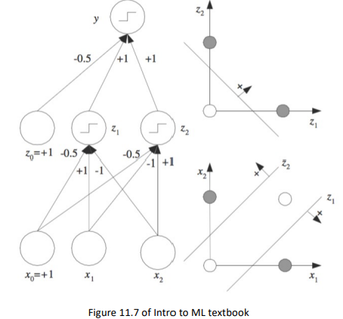

Applications of NN

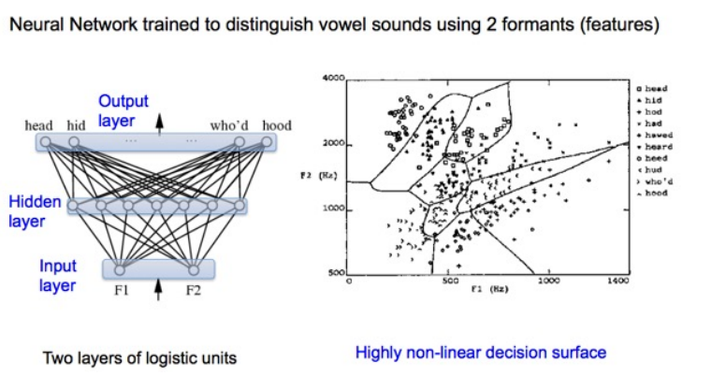

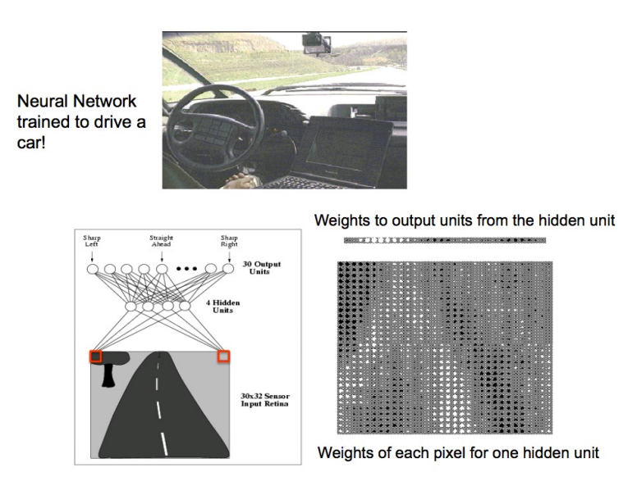

Training a NN • All this sounds great, but.. • How do I train this complex network? • Let's see.

Artificial Neural Network (ANN)

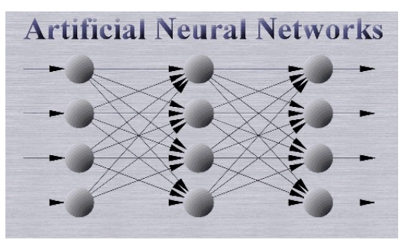• A group of perceptron joined together to achieve powerful results.

• Multi-layered processing.

• Each layer and unit has to be trained.

• Once trained, it can achieve great results.

Perceptron

• Let's revise to make sure we still remember the perceptron.

• It has only one decision unit.

Perceptron

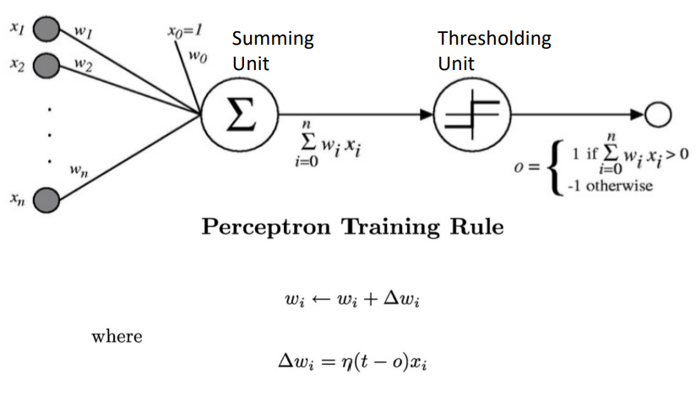

How to build a Neural Net

• Remember for a perceptron, there was a summing unit and a linear decision or activation unit. It's called threshold function

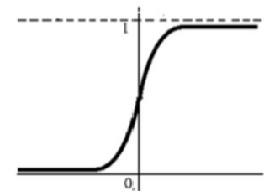• The linear unit works for linearly separable data, but to make it work with other data, we need a non-linear activation unit.

• Sigmoid activation function: 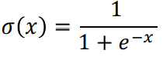

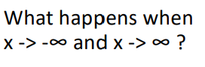

How to build a Neural Net

• Remember for a perceptron, there was a summing unit and a linear decision or activation unit.

• The linear unit works for linearly separable data, but to make it work with other data, we need a non-linear activation unit.

• In NN, we will create units that have a non-linear unit applied to the output of the summing unit.

Sigmoid activation function is applied to net Derivative of sigmoid unit

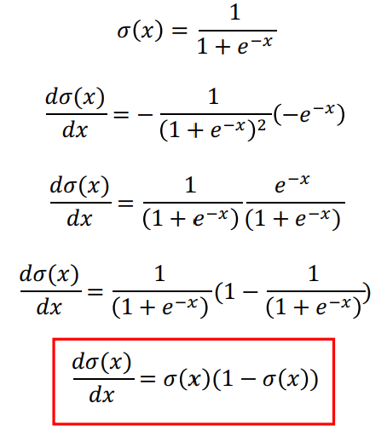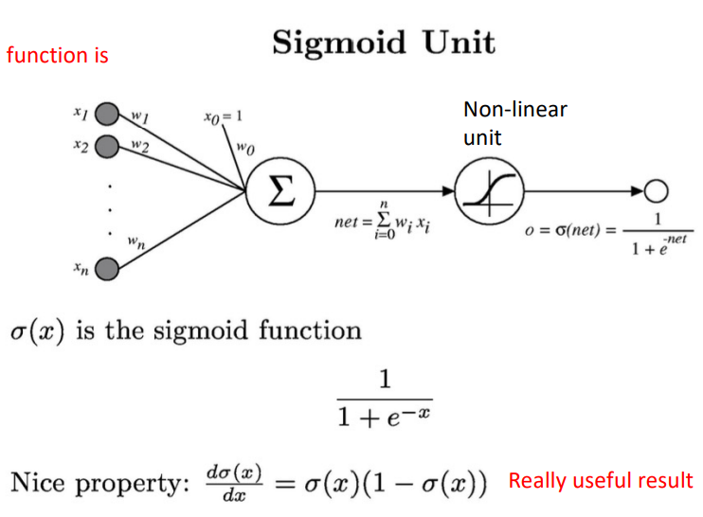

We can derive gradient descent rules to train

. One sigmoid unit

. Multiplayer networks of sigmoid units -> Backpropagation

Backpropagation Algorithm

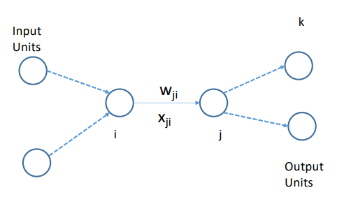• Consider the network shown on right and two intermediate nodes i and j

• Error for example d is:

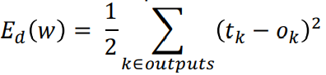

for all output units find squared error and sum

• Weight delta (from last class): How does wji affect E d ?

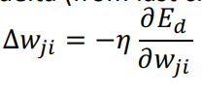

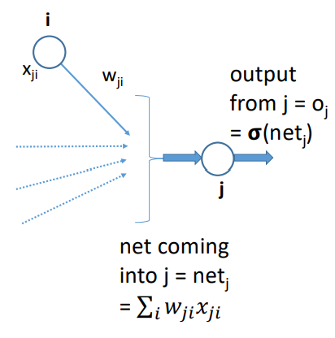Backpropagation Algorithm

• Let's try to compute 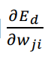

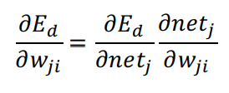

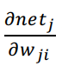is easy to compute: 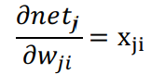

What about 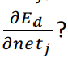

Backpropagation Algorithm

Two cases: - j is an output unit - j is a hidden unit

Value of 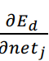 will be different for the two above cases.

Backpropagation Algorithm

Case I: j is an output unit

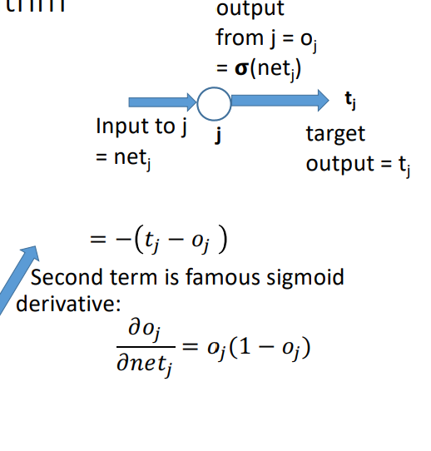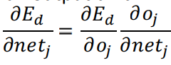

We know that error for data d is:

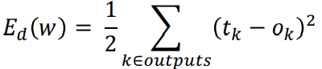

Differentiating wrt oj :

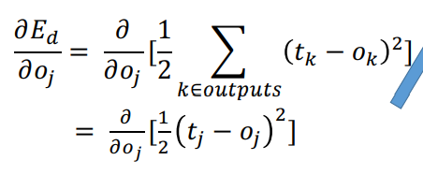

Backpropagation Algorithm

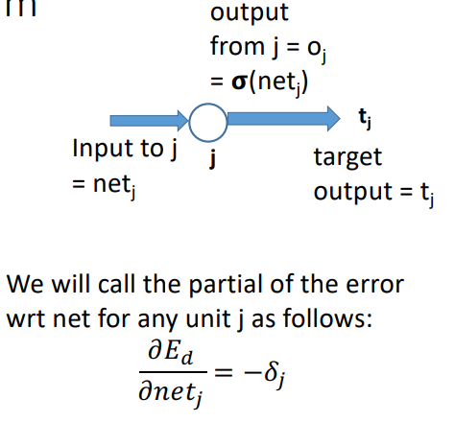Case I: j is an output unit: Putting it all together:

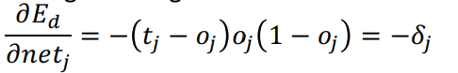

Let's plug this back in Δwji:

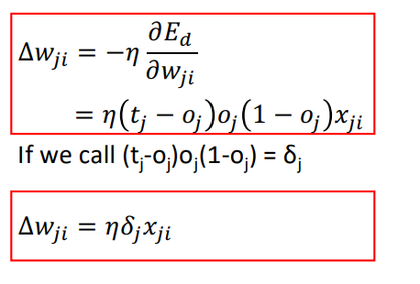

Backpropagation Algorithm

Case II: j is a hidden unit: Note that netj can influence the error only through downstream units:

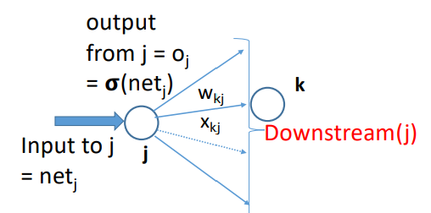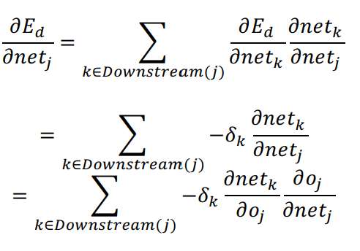

Backpropagation Algorithm

Case II: j is a hidden unit:

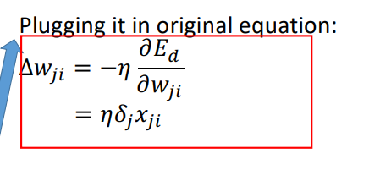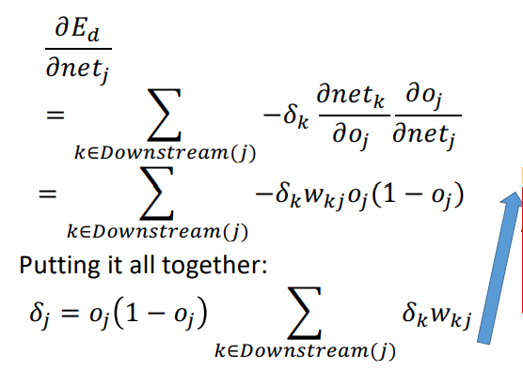

Backpropagation Summary

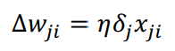

• Case I: j is output layer node:

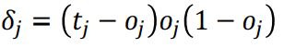

where xji is the weight of edge from i th node to j th node, where j is the output node.

• Case II: j is hidden layer node:

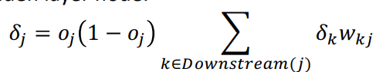

Unit j sends its output to Downstream(j) units. δk is the delta for the unit k which is part of Downstream(j).

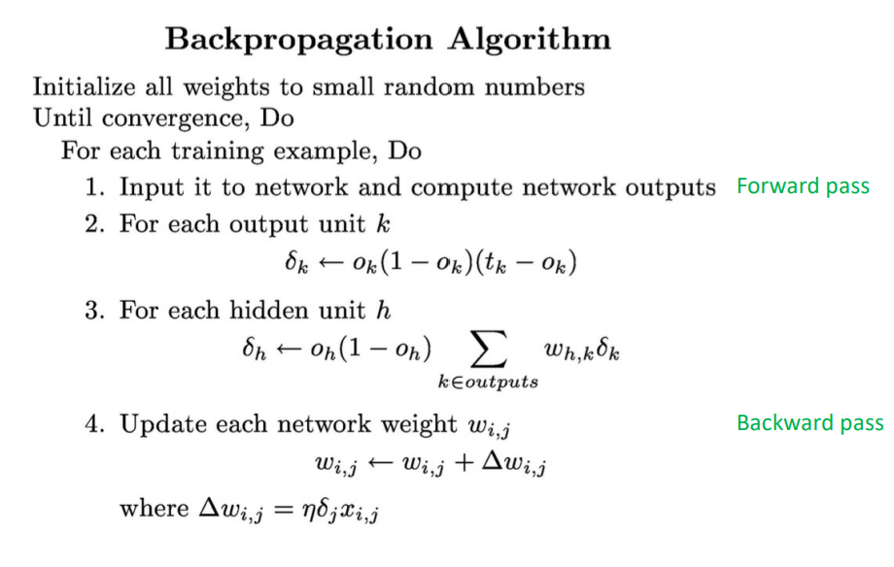

Example:

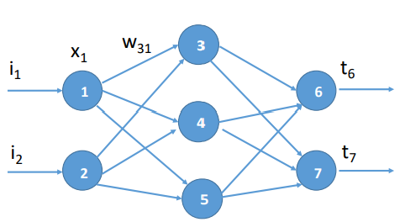

Assume random value for all weights on network:

Forward Pass: Compute all outputs of the nodes. Find δ for output nodes

Backward Pass: Use the value of forward deltas to compute backward deltas Update weights.

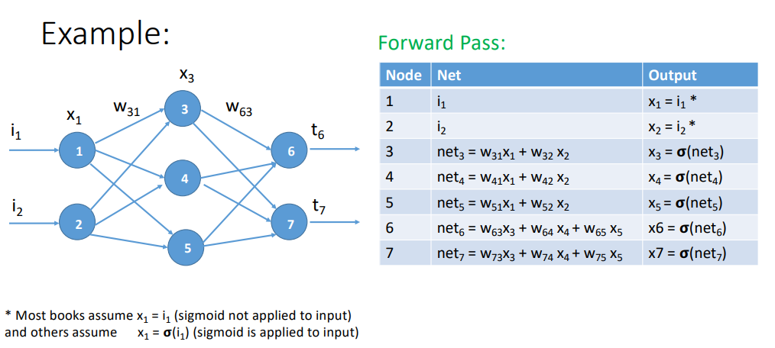

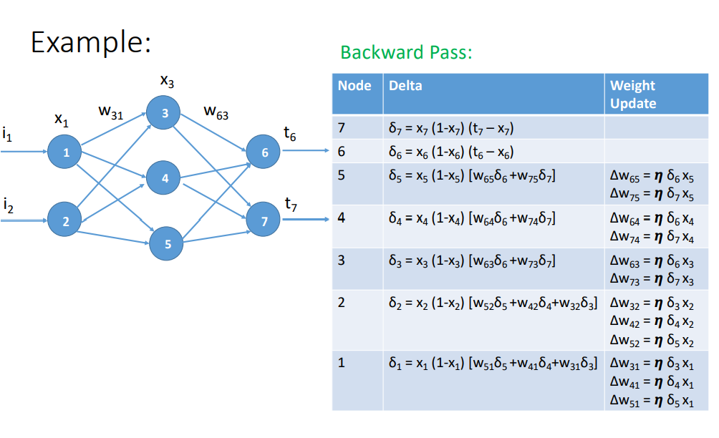

Worked Out Example

• The input to the ANN is (1, 0, 1) and target output is 1. i1 = 1, i2 = 0, i3 = 1, and t6 = 1

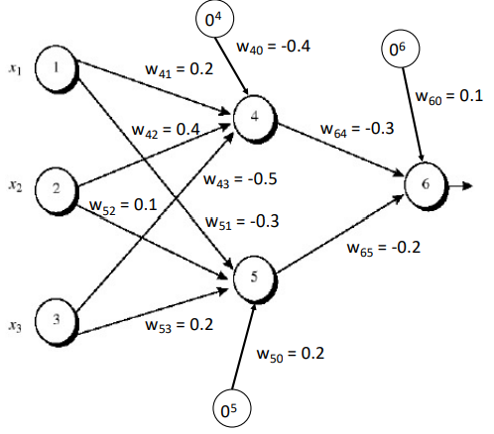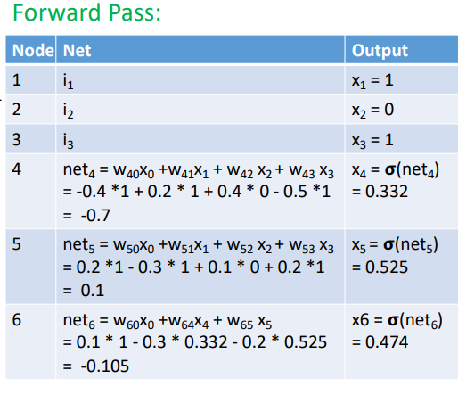• Run one forward and one backward pass on the ANN

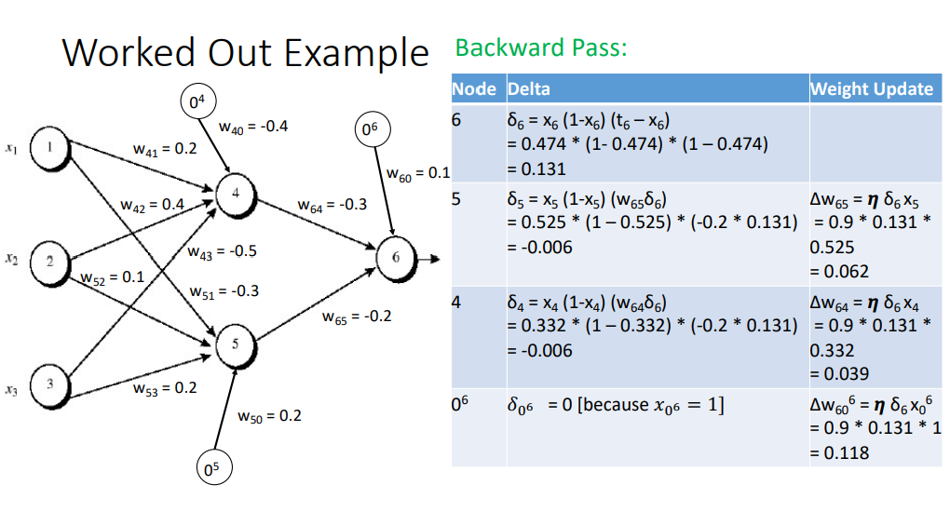

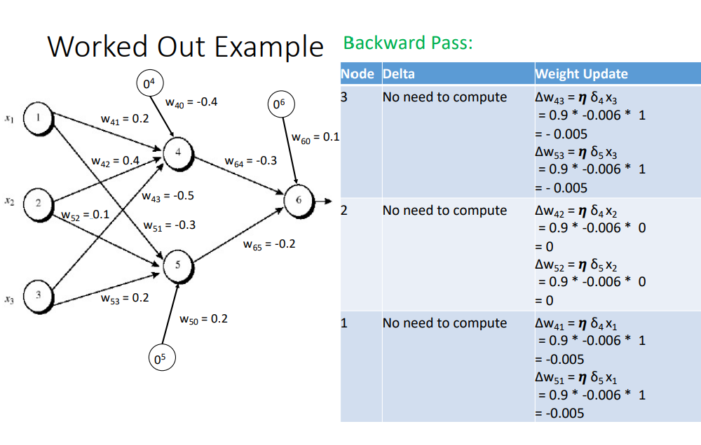

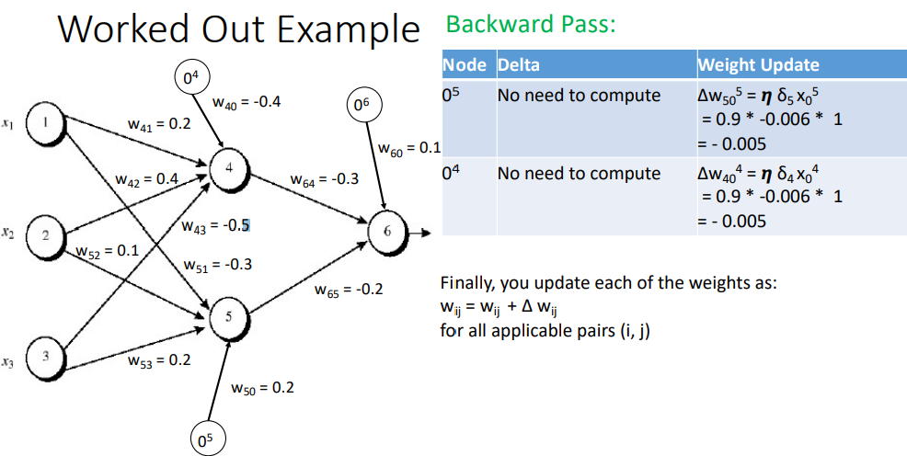

Finally, you update each of the weights as: wij = wij + Δ wij for all applicable pairs (i, j)

More on Backpropagation

• Gradient descent over entire network weight vector

• Easily generalized to arbitrary directed graphs

• Will find a local, not necessarily global error minimum

- In practice, often works well (can run multiple times)

• Often include weight momentum α

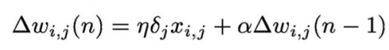 The update at step n depends on step n-1

• Minimizes error over training examples

- Will it generalize well to subsequent examples?

• Training can take thousands of iterations + slow!

• Using network after training is very fast

Expressiveness of Neural Nets

Boolean functions:

• Every Boolean function can be represented by network

with single hidden layer • But might require exponential (in number of inputs) hidden units

Continuous functions:

• Every bounded continuous function can be approximated with arbitrarily small error, by network with one hidden layer

• Any function can be approximated to arbitrary accuracy by a network with two hidden layers

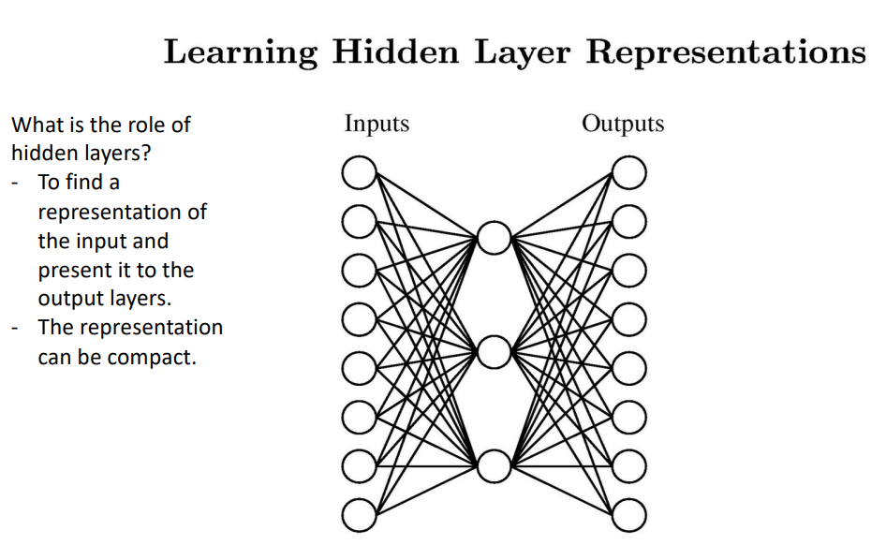

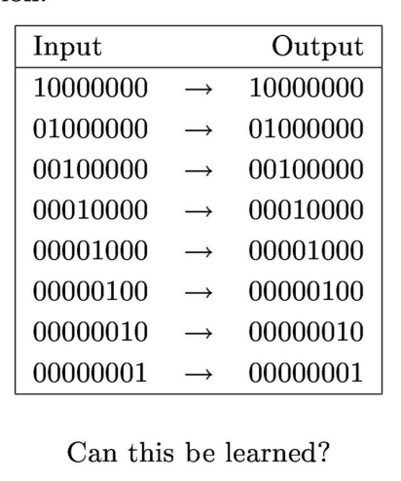What is the role of hidden layers? - To find a representation of the input and present it to the output layers. - The representation can be compact.

A target function

Can the NN learn this function?

- Well, it's just the identity function

- Yes, with one hidden layer.

- The hidden layer will try to find a compact representation of the input

- Let's run the backprop algorithm on it and see what weights we get.

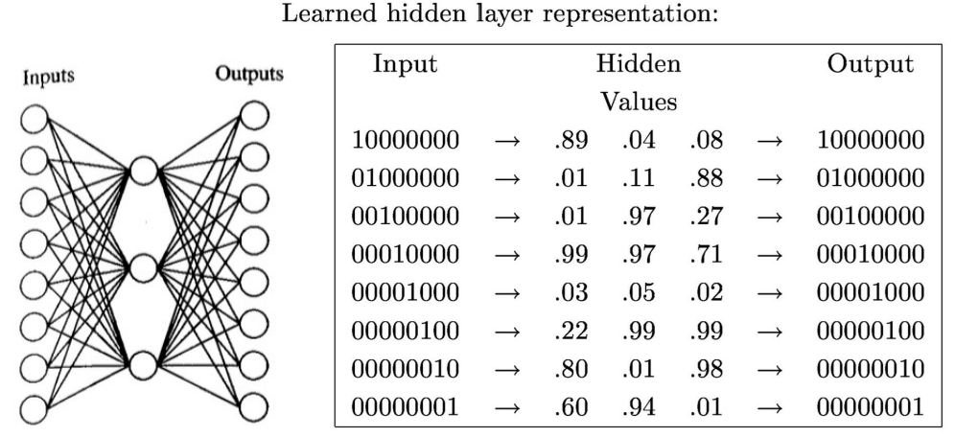

You can represent numbers 1 to 8 using 3 Boolean bits as (001) to (111)

Note: The weights do not necessarily correspond to human interpretation. The NN has its own encoding mechanism

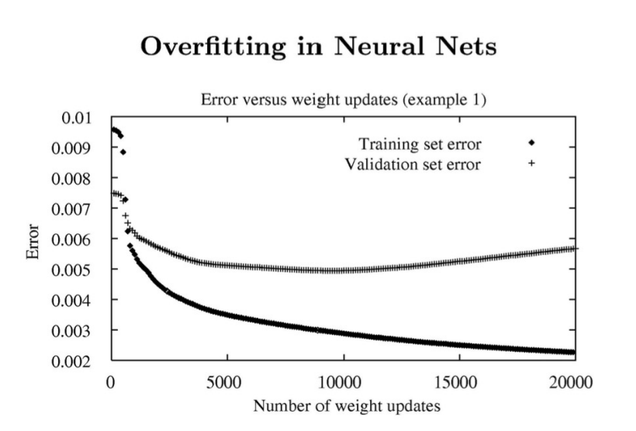

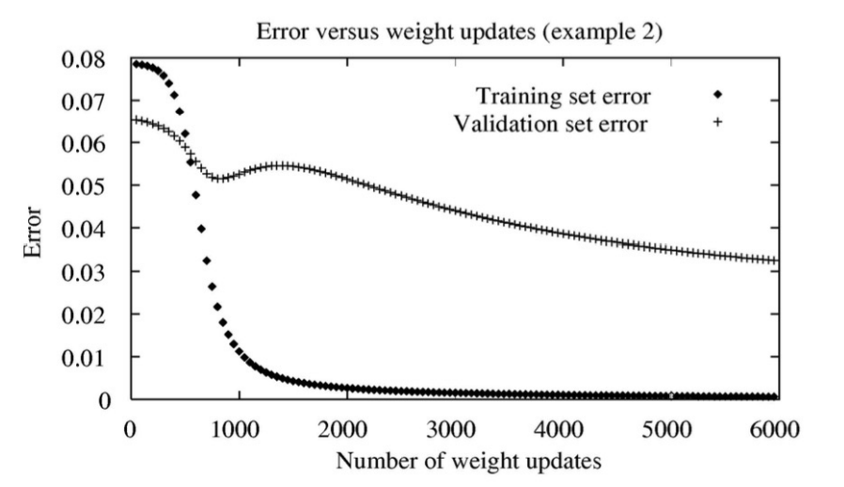

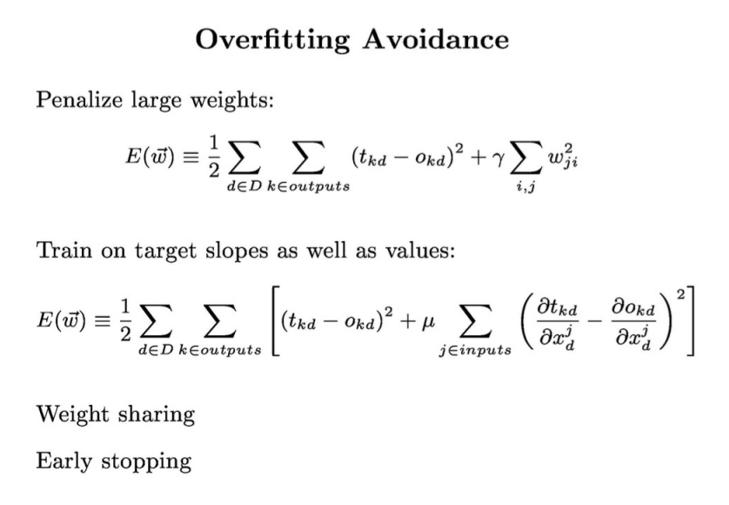

Regularization Coeff (factor)

**Probability Refresher**

Sample Space of an Experiment

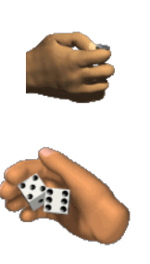• A random experiment is one whose outcome cannot be predicted with certainty.

e.g. Toss of a coin, roll of a dice, etc.

• **Sample space** (S) represents the set of all possible outcomes of the experiment.

e.g. Toss of a coin = {H, T}

Roll of a single dice = {1, 2, 3, 4, 5, 6}

Roll of two dice = { 11, 12, …, 16,

21, 22, ..., 26,

...,

61, 62,..., 66 }

Sample Space and Event

• An event (E) is a subset of S (sample space).

• Example:

- Tossing a coin: S = {H, T} E = {H} is an event.

- Tossing a coin twice: S = {HH, HT, TH, TT}

E = {HH, HT} is an event which describes the set which has the first outcome as heads

- Tossing a dice:

S = {1, 2, 3, 4, 5, 6}

E = {2, 4, 6} is an event which describes the set in which the number is even.

Random Variable

• Supposed to **each outcome** in the sample space, we associate a **value**.

e.g. for heads, +1 and for tails -1 for even rolls of dice +1 and for odd rolls of dice -1

• Such a variable is known as a random variable.

• Formal definition: A **random variable** is a function that assigns a real number to each outcome in the sample space of a random experiment.

• It is generally denoted by X. If X takes a value x, it is wriUen as: X = x

Random Variable

• If we restrict the random variable to the Boolean set, it may be defined as a function f:

f is a function defined over S as follows: f: S -> {0, 1}

f maps every value in S to either 0 (failure) or 1 (success)

Examples of Random Variables:

• Suppose each experiment is tossing of 4 coins. You do this experiment multiple times

Results:

{HHHT}

{HTHT}

…

If you count the number of heads in each experiment, it would be a random variable (X) X could have values from 0 to 4.

• Each element of the sample space would map to one value of X

Examples of Random Variables:

• Suppose each experiment is sampling 100 people from a population and measure their heights.

If you measure the average of the heights of the 100 samples, you would get a random variable (X). It would be a continuous variable.

Each element of the sample space would map to a value of X

Random Variable

• Each random event A has a probability P(A) associated with it.

• It defines the fraction of the sample space in which A is true.

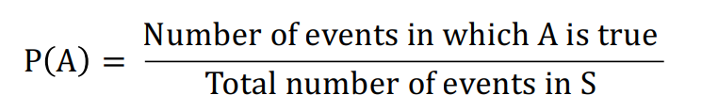

e.g. in case of toss of a dice, probability of even number:

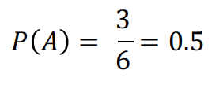

Useful Theorem

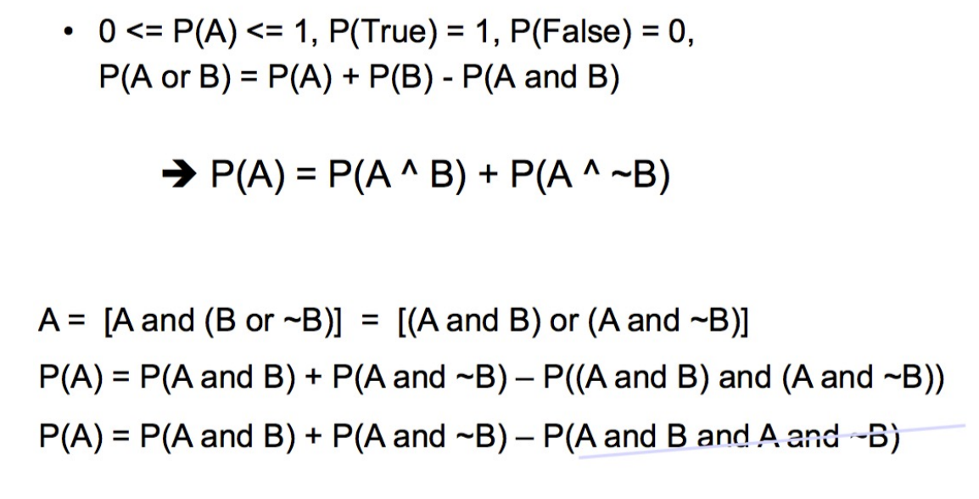

Definition of condition Probability

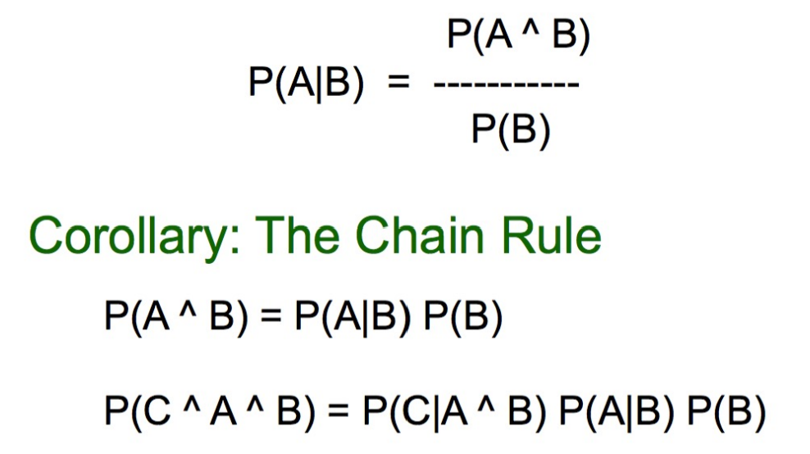

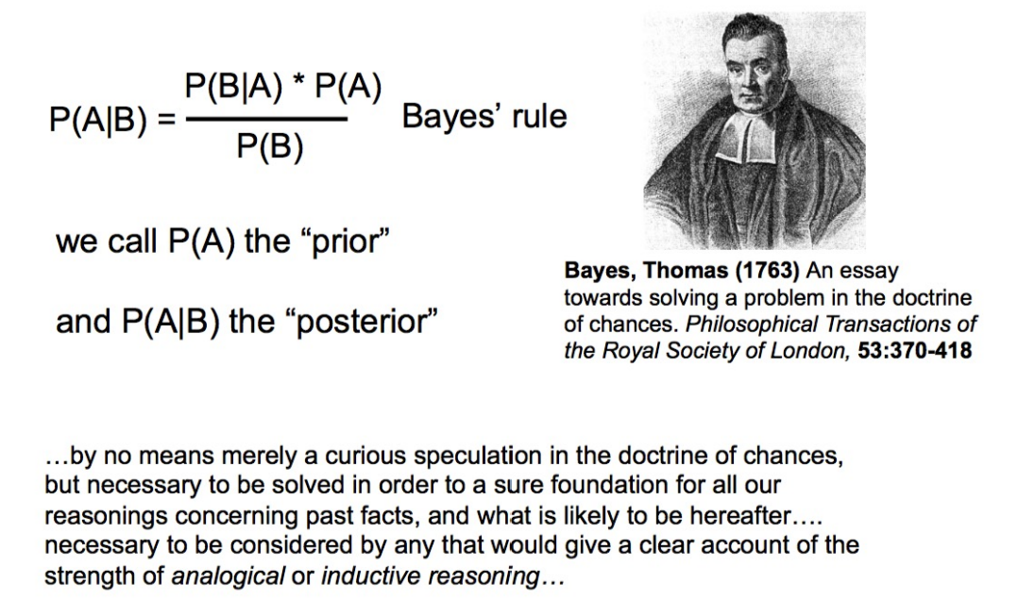

Applying Bayes Rule

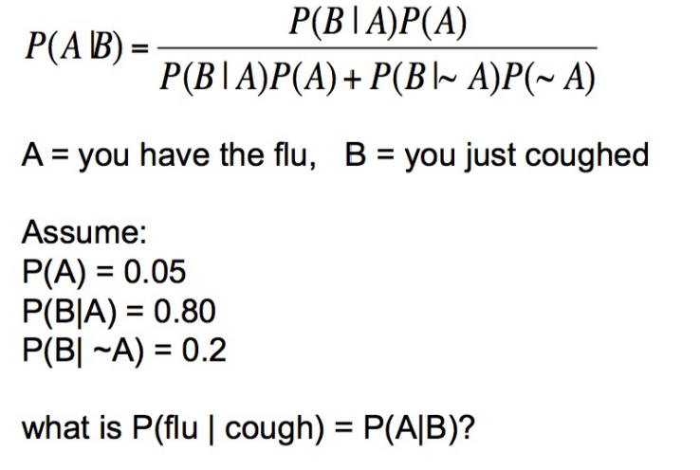

What does all this have to do with function approximation?

After all, that’ what we are looking for.

Function approximation by probability

• Our aim is to approximate the class separating function

F: X -> Y

X is the set of attributes and Y is the class.

• In case of probabilistic reasoning, we approximate it with the conditional probability

P(Y | X)

we find the probability of each class, given the data i.e. P(Y = 1| X) and P(Y = 0 | X).

• How do we find the probability of class given the data?

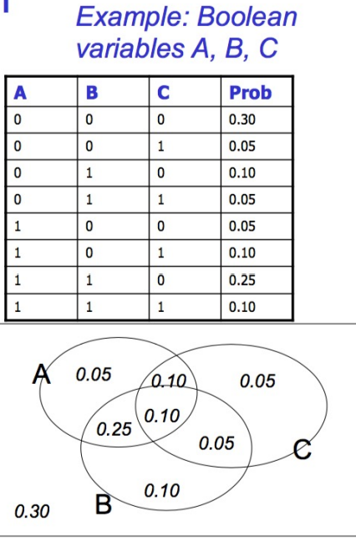• Need a joint distribution

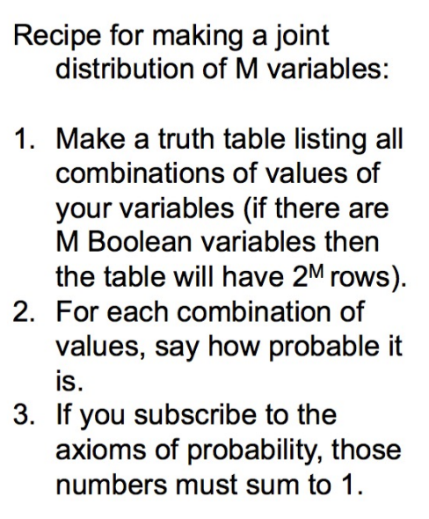The joint distribution

Using the joint

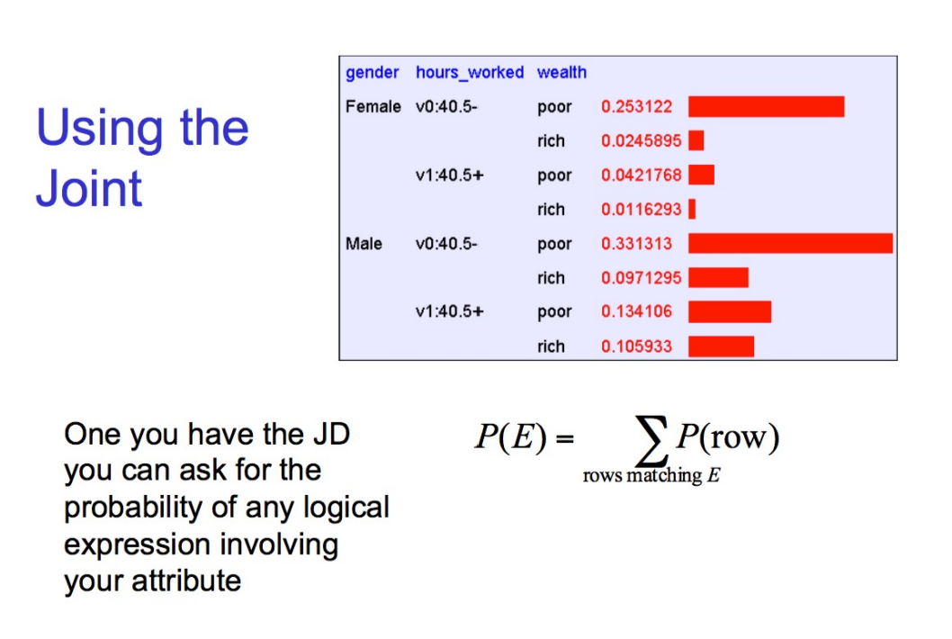

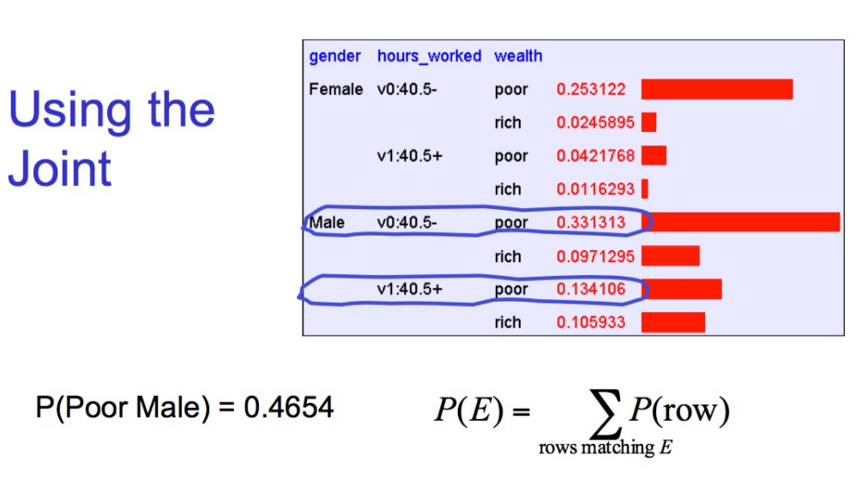

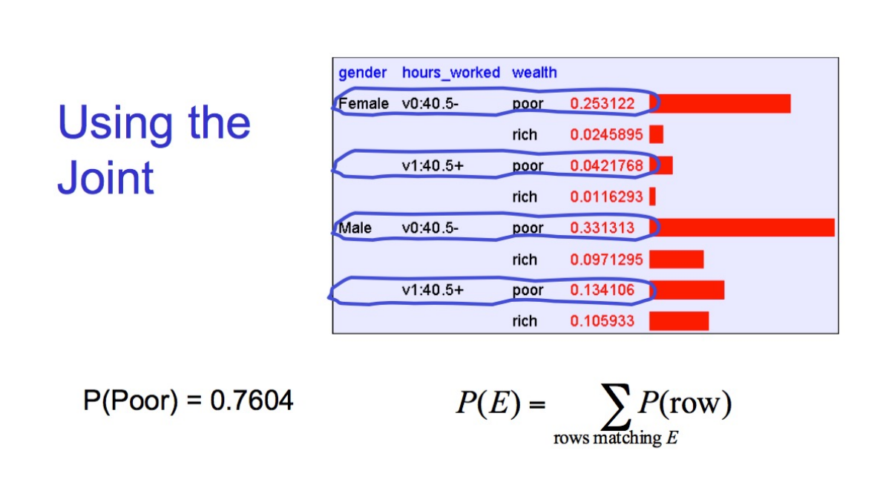

Inference with the Joint

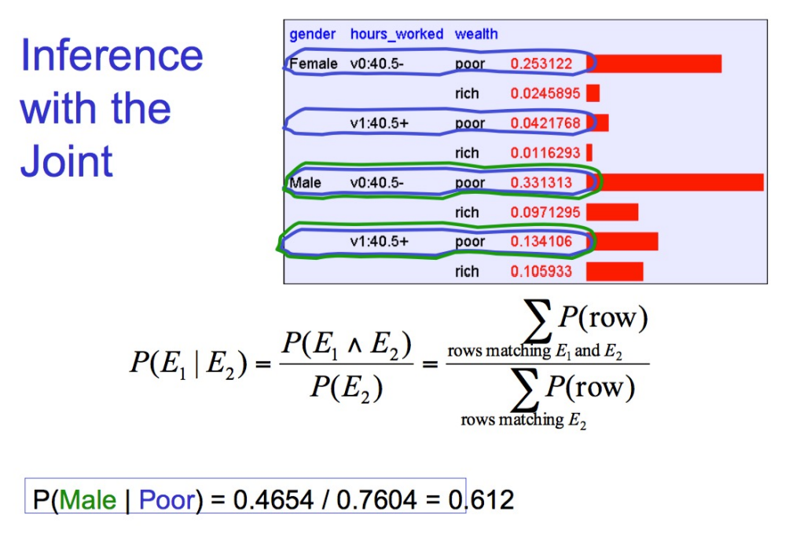

Learning and Joint Distribution

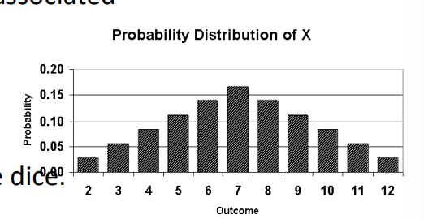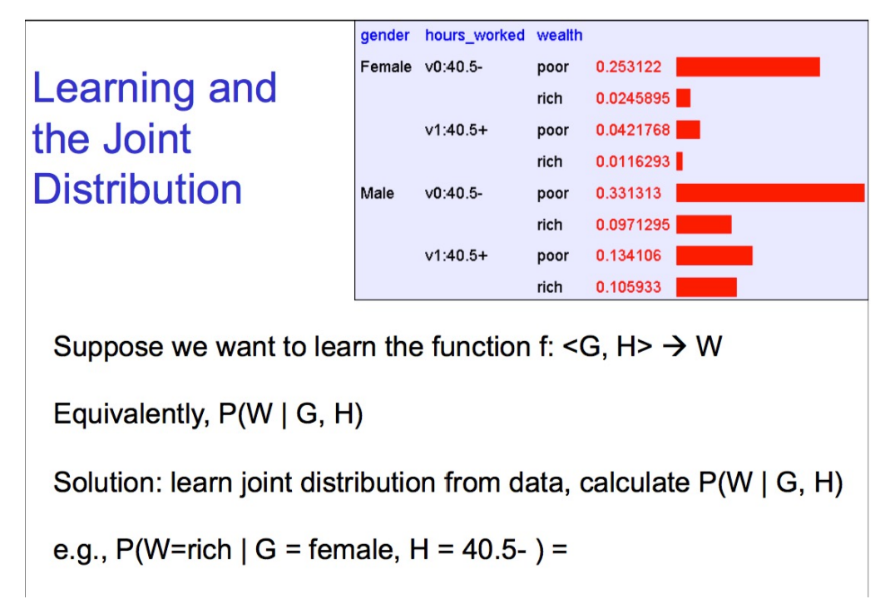

Let's get back to random variables

• Each random variable X has a domain **D(x)** associated with it. It is the set of outcome

values possible. e.g. for a dice D(x) = {1, 2, 3, 4, 5, 6} for a Boolean outcome D(x) = {0, 1}.

• For a pair of dice, D(x) = {11, …., 66}. Suppose X is the sum of the outcome of the dice. X can range from 2 to 12. Each value of X has a different probability.

• A plot of the random variable and probability values is called the **probability distribution** plot and the function is called **probability distribution function (pdf) or probability mass function (pmf).**

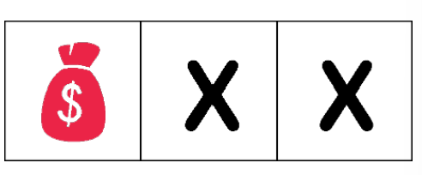Example:

• Imagine there are 3 doors – one of them has a treasure, the other 2 nothing.

• Each one is equally likely to be selected. Once you open a door, you don't open it again.

• Define random variable X as the number of doors needed to open before finding the treasure.

X can have values {1, 2}. Find the probability distribution of X.

P(X = 1) = 1/3

P(X = 2) = (2/3) * (1/2)

-- Assume a person is smart enough to figure it out after two attempts – J

Example 2

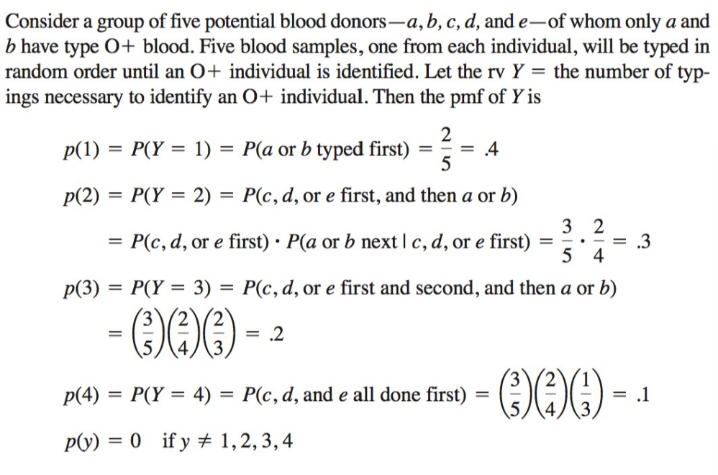

Binary Variables

• Let's focus on the case where the random variable X can only take two values {0, 1}. • X is said a Boolean random variable.

• For every outcome in the sample space, you associate 0 (failure) or 1 (success).

• Example: - Coin toss – Heads = 1, Tails = 0

- Lottery - Winning Number = 1, Rest of the numbers = 0

Expected Value and Variance

• Expected value of a **discrete** random variable under P:

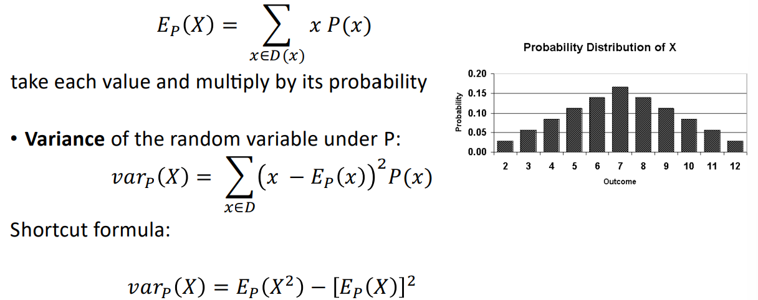

Expected Value and Variance

• Expected value of a **continuous** random variable under a **continuous** probability function f:

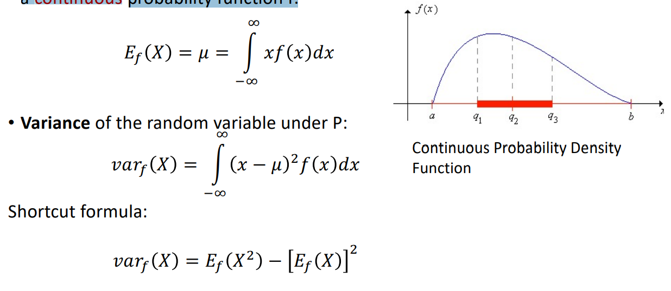

Example:

You draw one card from a standard deck of playing cards. If you pick a heart, you will win$10. If you pick a face card (K, Q, J), which is not a heart, you win $8. If you pick any other card, you lose $6. Do you want to play? Explain.

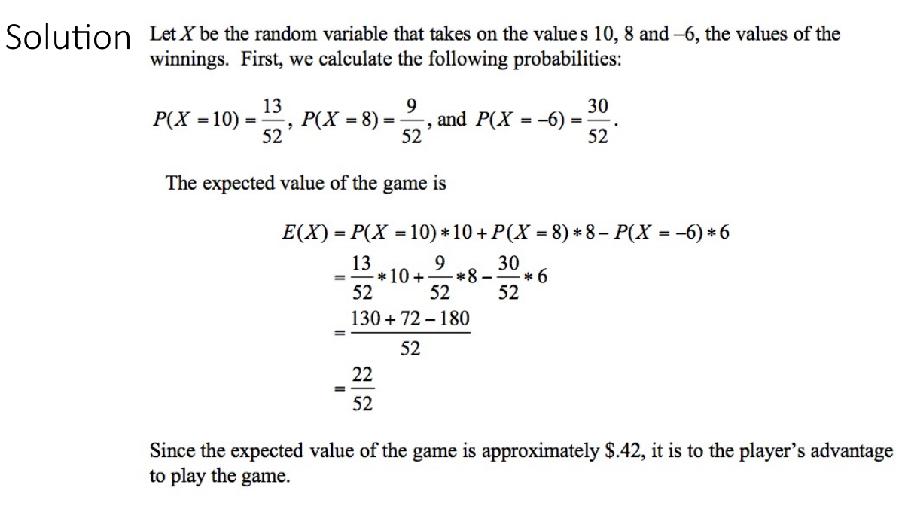

Binary Variables

• Consider coin flipping which has 2 outcomes (heads = 1 and tails = 0) If you know probability of heads, you know the distribution. Let's say

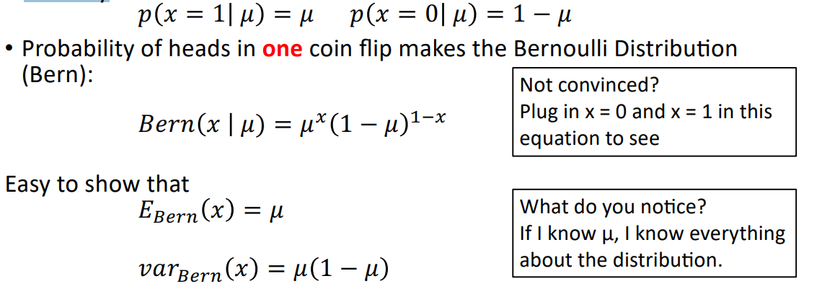

Binomial Distribution

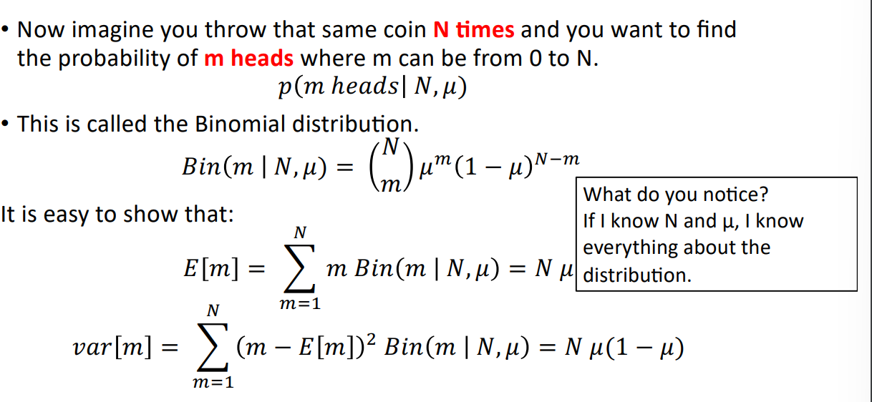

Uniform Probability Distribution

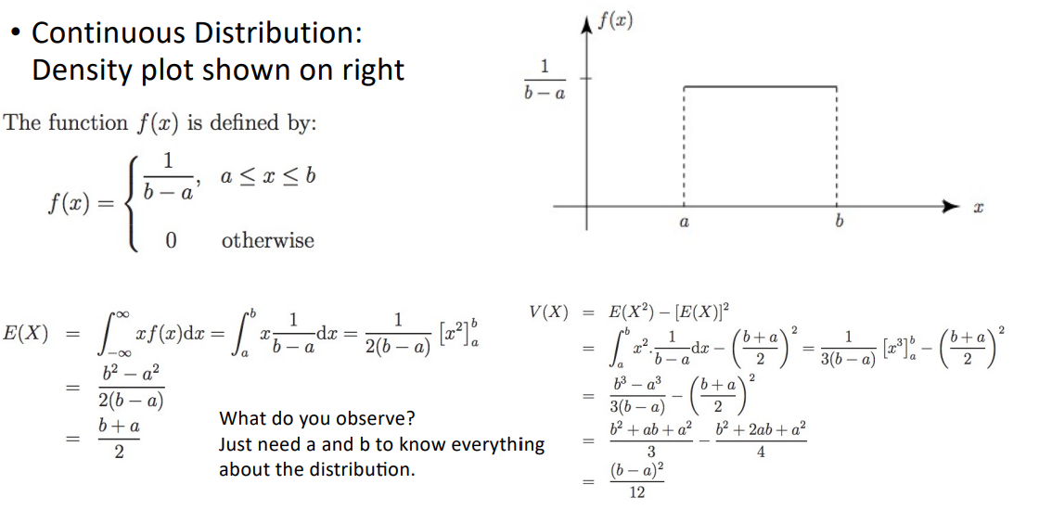

Naïve Bayes Classification

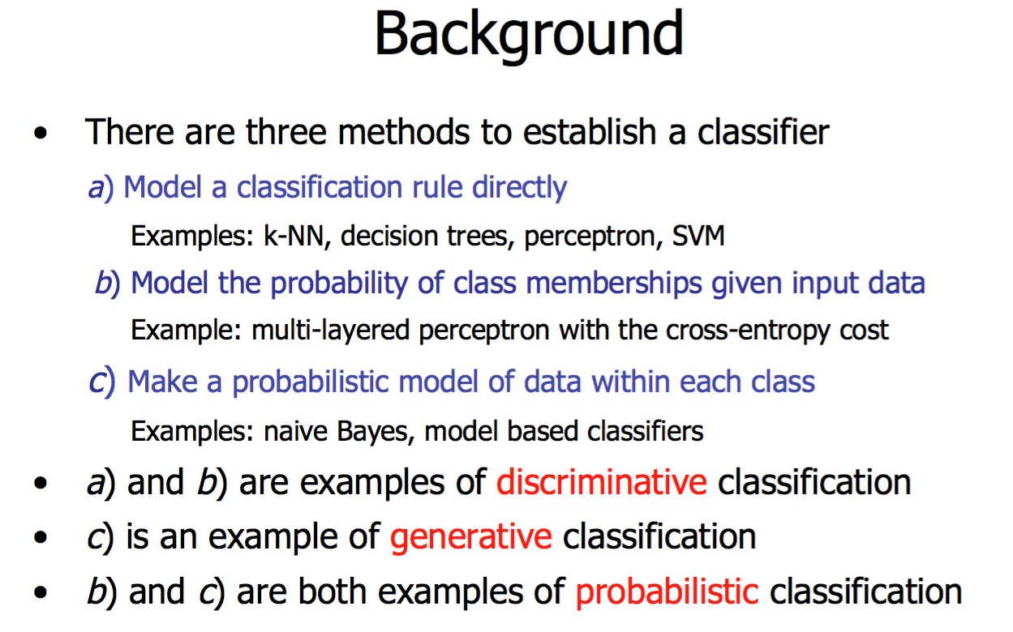

Probability Basics

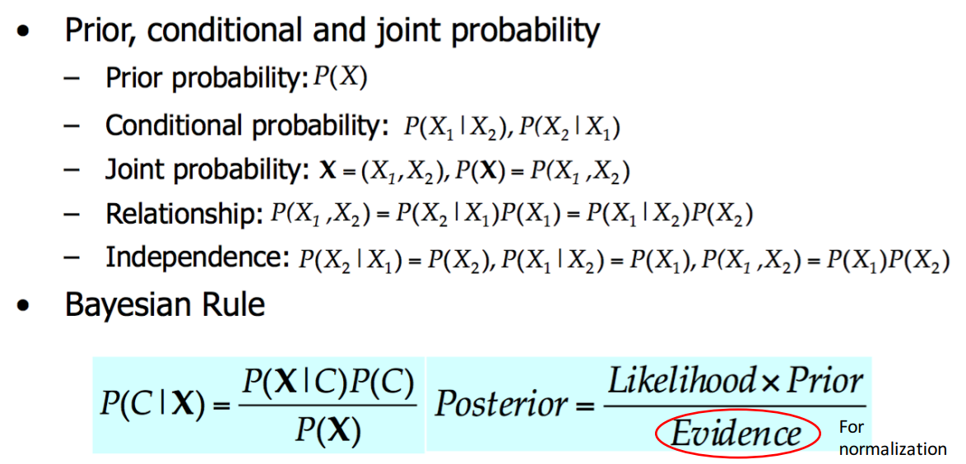

A side note:

probabilistic inference H = “Have a headache” F = “Coming down with Flu” P(H) = 1/10 P(F) = 1/40 P(H|F) = 1/2

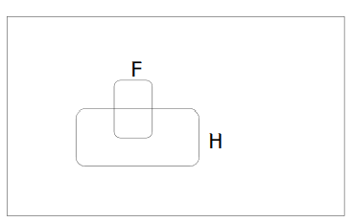

One day you wake up with a headache. You think: “Drat! 50% of flus are associated with headaches so I must have a 50-50 chance of coming down with flu” Is this reasoning good?

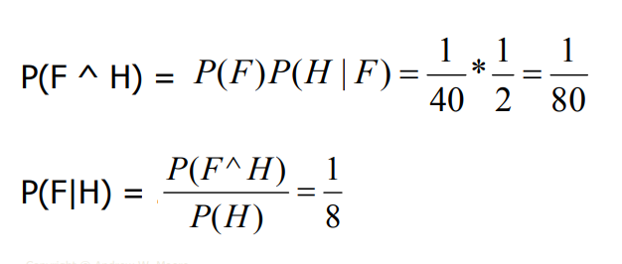

Bayes classifier

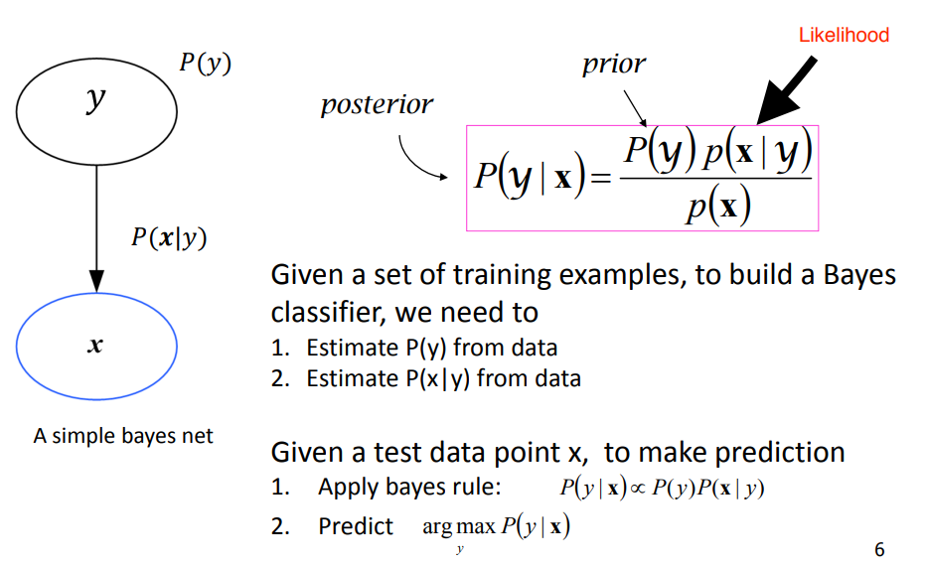

Maximum a Posteriori (MAP)

• Given data D and a set of classes C = {c1, c2, …, cn}, the most probable class is the one having the highest value of posterior probability:

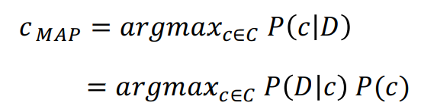For all the classes, find the value of / 0 ! /(!), the class with the highest value is the most likely class, given the data D.

Bayes Classifiers in a nutshell

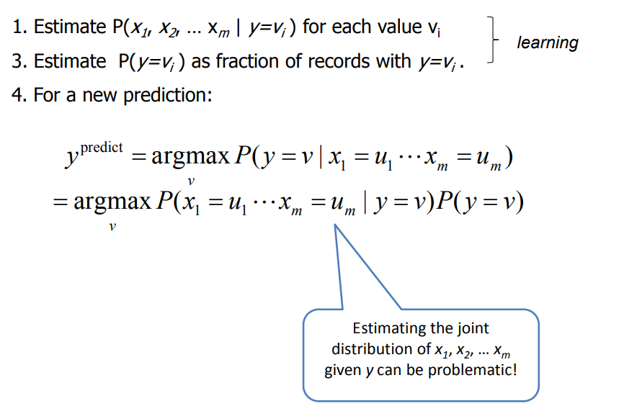

Example: Spam Filtering

• Assume that our vocabulary contains 10k commonly used words & tokens‐‐‐ we have 10,000 attributes • Let’s assume these attributes are binary

• How many parameters that we need to learn?

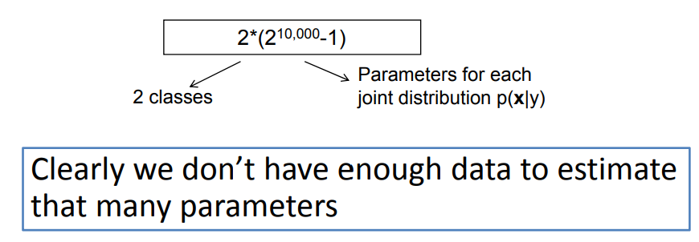

The Naïve Bayes Assumption

• Assume that each attribute is independent of any other attributes given the class label

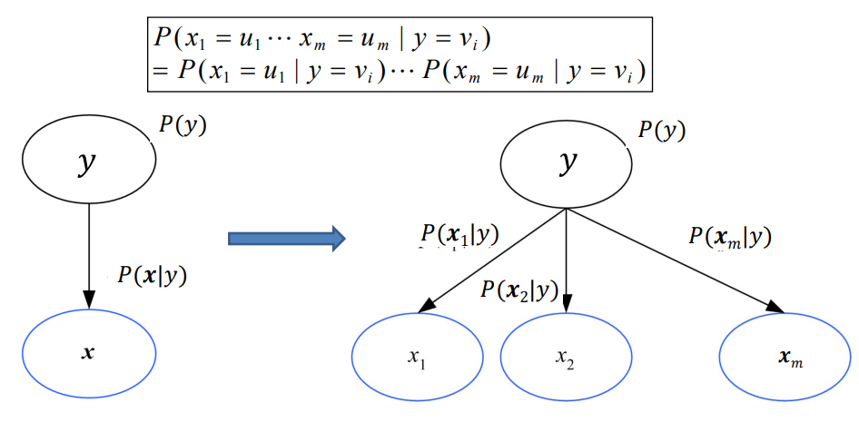

Naïve Bayes Classifier

• By assuming that each attribute is independent of any other attributes given the class label, we now have a Naïve Bayes Classifier

• Instead of learning a joint distribution of all features, we learn p(xi|y) separately for each feature xi

• Everything else remains the same

Naïve Bayes Classifier

• Assume you want to predict output y which has nY values v1, v2, … vny.

• Assume there are m input attributes called x=(x1, x2, … xm)

• Learn a conditional distribution of p(x|y) for each possible y value, y = v1, v2, … vny,, we do this by:

– Break training set into nY subsets called S1, S2, … Sny based on the y values, i.e., Si contains examples in which y=vi

– For each Si, learn p(y=vi)= |Si |/ |S|

– For each Si , learn the conditional distribution each input features, e.g.

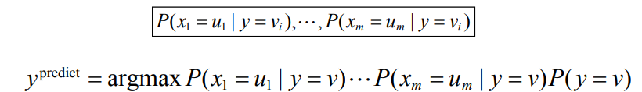

Naïve Bayes

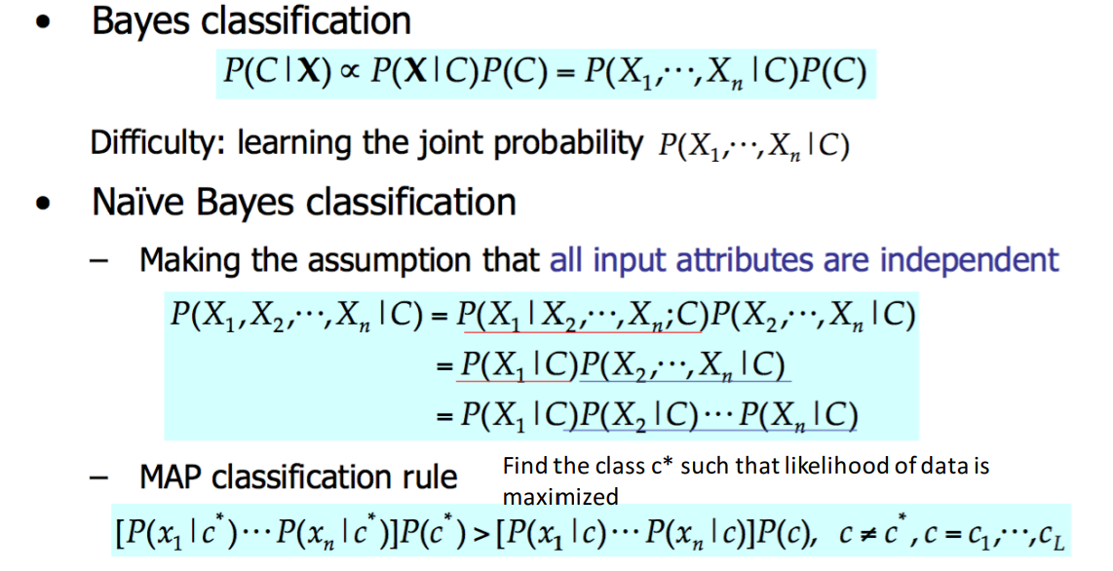

Naïve Bayes Classifier

• Based on MAP rule

• Extremely simple yet powerful

• Idea: Given a dataset, find which class is most likely i.e. which class has highest posterior.

• This means you have to find the posterior for every class and then find the one that gives the max value.

• Computationally simple.

Naïve Bayes

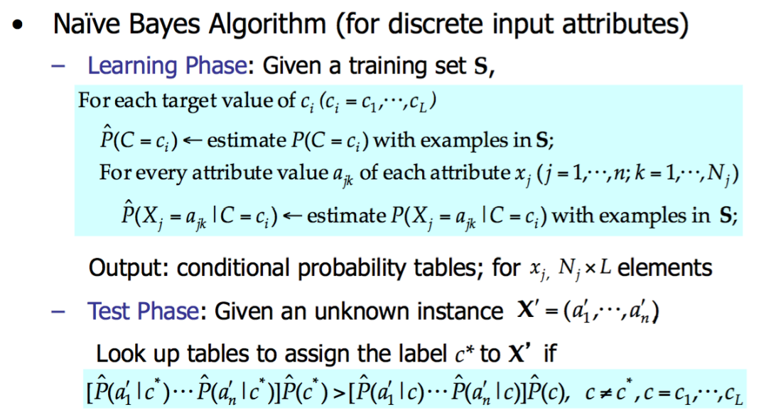

Example:

Play tennis

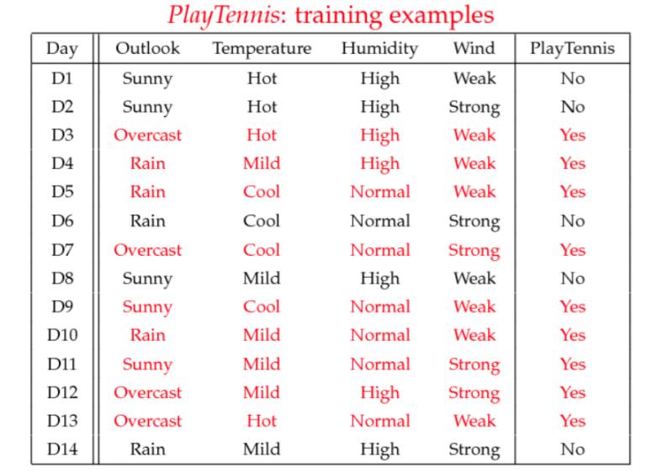

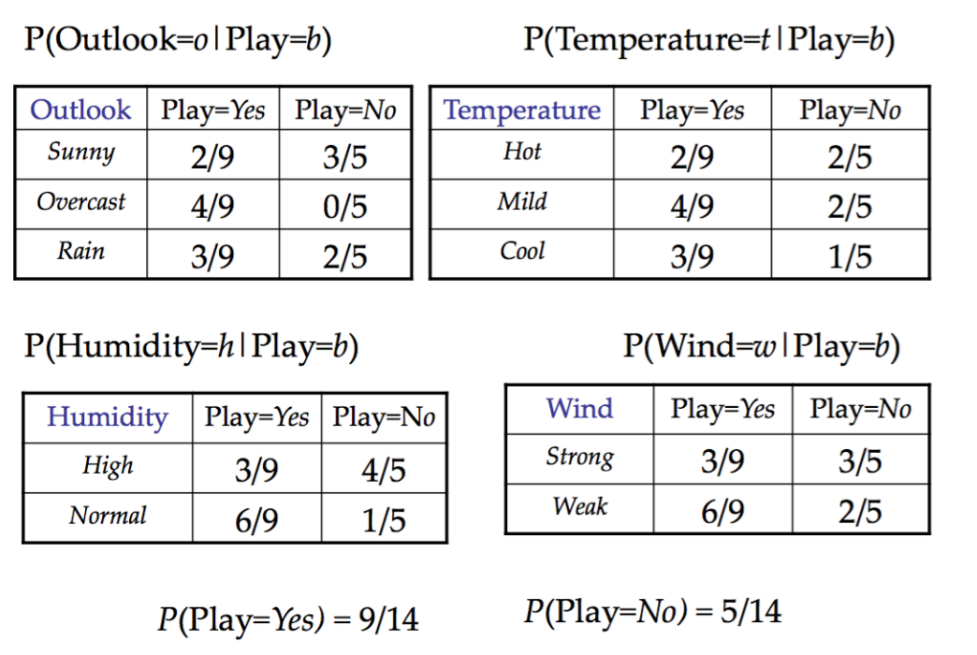

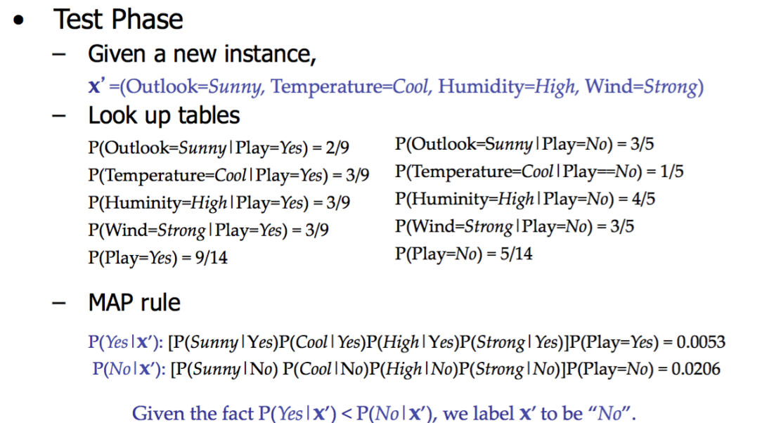

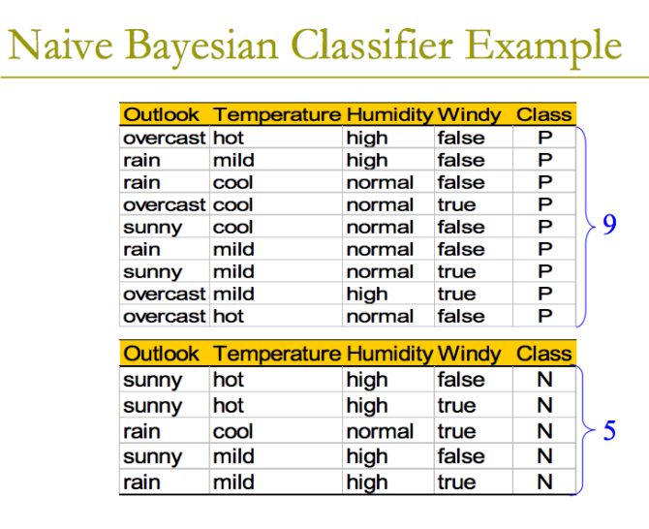

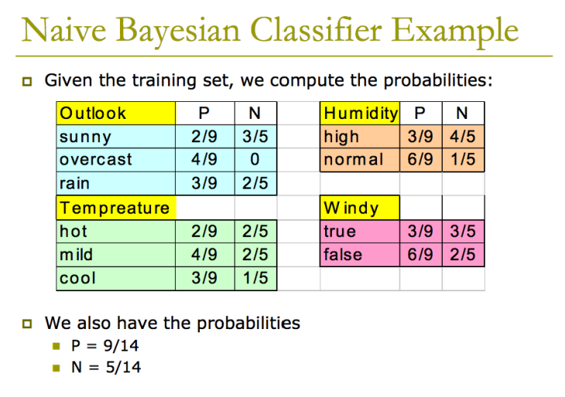

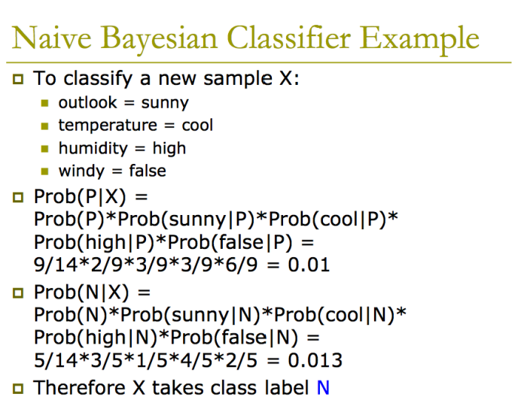

Laplace Smoothing

• With the Naïve Bayes Assumption, we can still end up with zero probabilities

• E.g., if we receive an email that contains a word that has never appeared in the training emails

– P(x|y) will be 0 for all y values

– We can only make prediction based on p(y)

• This is bad because we ignored all the other words in the email because of this single rare word

• Laplace smoothing can help

P(X1=1|y=0)

= (**1+** # of examples with y=0, X1=1 ) /(**k+** # of examples with y=0)

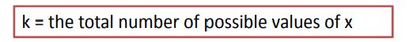

• For a binary feature like above, p(x|y) will not be 0

Relevant Issues

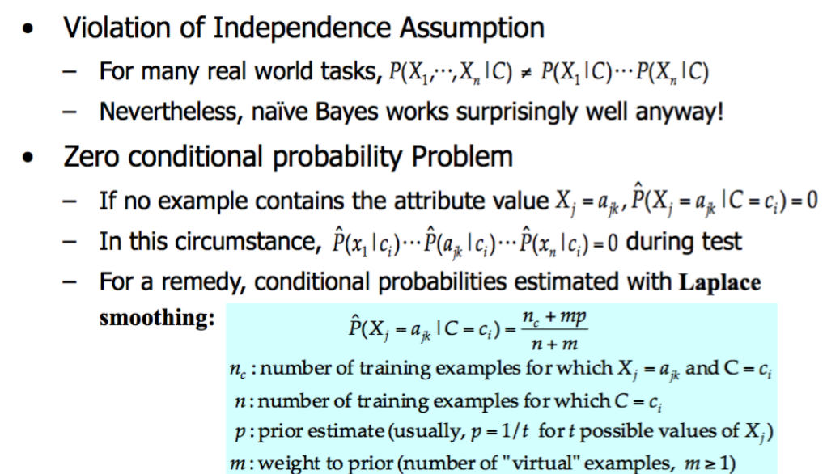

**Logistic Regression**

Generative vs Discriminative Classifiers

• Classification task is to find a function h: X -> Y from training sample.

• h is an approximation to the real classification function f

• **Generative Classifiers**: approximate the function by P(Y|X) based on: P(Y|X) ∝ P(X|Y) P(Y)

- X is a vector of features

- First term P(X|Y) is **likelihood** and Second term P(Y) **is prior**

- How do we get their values -> from training data.

- For likelihood term, we need **joint probability distribution**

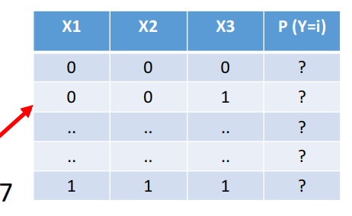Generative vs Discriminative Classifiers

• What is **joint probability distribution**? Suppose you have 3 Boolean attributes X = (X1, X2, X3) and two classes Y = 0 and Y = 1

• For each class, you need the complete table filled out. How many entries do you need? 23 – 1 = 7

• For two classes, total number of values (parameters) needed = 2 * (23 – 1)

• For n Boolean variables, parameters = 2 * (2n – 1)

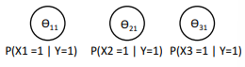• That's too many parameters to estimate. Can we do better?

• How does conditional independence help

P(**X** | Y ) = P(X1 | Y) * P(X2 | Y) * P(X3 | Y)

e.g. for class Y = 1, if I know P(X1 = 1), I know P(X1 = 0). So, one parameter for each attribute per class.

• In this case, we just need 3 parameters for each class. We needed 7 without conditional independence (CI) assumption.

• For n Boolean attributes and 2 classes, we need 2n parameters, if we make the conditional independence assumption. We needed 2 * (2n – 1) without conditional independence (CI) assumption.

Generative vs Discriminative Classifiers

• Well, what if we make a functional model for probability: P(Y=1 | X) = h(X)

• Sounds like a good idea!

• What should be the form of h? How do we learn it from data?

• This is the focus of **discriminative classifiers**.

• Logistic regression is an example of discriminative classifiers.

Review of Types of Classifiers

3 types of classifiers:

1. **Create a model for y (output)** as a function of attributes. e.g. **Perceptron**, ANN, SVM y = sign(wTx)

2. **Probabilistic (Generative) classifiers** P(Y | X) ∝P(X | Y) * P(Y) We estimate likelihood and prior from training data. Naïve Baye

3. **Discriminative classifiers** – Create a model for P(Y|X) – Logistic Regression

Discriminative Classifiers

• Discriminative classifiers assume a functional form for P(Y|X).

• It can be shown that for discrete-valued Y and discrete or continuous X, **Naïve Bayes equation** is equivalent to the following functional form for P(Y | X) :

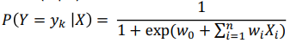

• Details of derivation are in the updated chapter of Tom Mitchell's book section 3.1.

Logistic Regression Learning Scenario for continuous attributes:

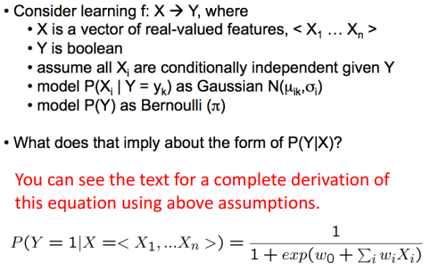

Logistic Regression

• Form of LR for Boolean Y:

Note: Sometimes we may swap the equations for P(Y=1|X) and P(Y=0|X).

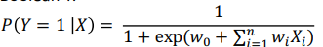

• This is similar to the logistic function if we let:  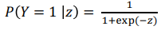

• Since P(Y=1 | X) + P(Y=0 |X) = 1 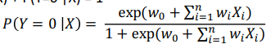

Logit Function

• If we let P(Y=1|X) =p, and take the ratio of P(Y=0|X) and P(Y=1|X),

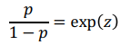

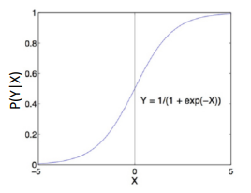• Take log of both sides:

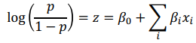

• The LHS of the function is also called the **logit** function

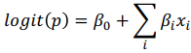

Logistic Regression

• We assume a functional form for learning P(Y|X)

- logistic or sigmoid function

• Plot shown on the right.

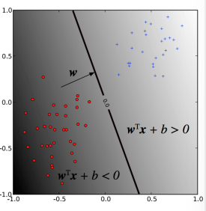• We have encountered this function before as an activation function for perceptron.

Logistic Regression

• We are creating a model for P(Y|X), but what does the decision boundary in the attribute (e.g. x1, x2) plane look like. **Remember for linear classification:**

• The separating hyperplane has the equation: wTx + b = 0

• The two classes are decided by whether wTx + b > 0 or < 0

• Can we get something similar in logistic regression?

Function Form: Two Classes

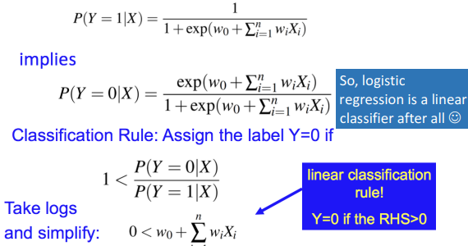So, logistic regression is a linear classifier after all

Another way to express it

Logistic Regression can also be expressed as:

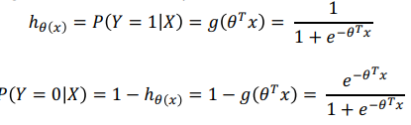

To predict class = 1, 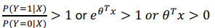

Logistic Regression

• The ratio of probability of success and failure is called **odds ratio** in statistics.

• In our case, it would be ratio of classes i.e. P(Y=1 |X) divided by P(Y=0 | X).

• Let's do some probability,

Statistical Insight – Odds Ratio

What is the odds (or odds ratio)? Suppose you have following data:



What is the probability of choosing a red ball P(F): 3/12

What is the probability of NOT choosing a red ball P(¬F): 9/12

We define **odds for (of) red as**: 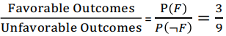

Statistical Insight – Odds Ratio

What are the odds of winning a game of roulette?

Choices are numbers: 1 – 36 + 0 + 00 = Total 38

Only 1 of them wins: Odds of winning: **1/37**

What if I play on 1st /2nd /3rd 12: Odds of winning: **12/26**

Odd / Even Numbers: Odds of winning: **18/20**

Statistical Insight – Expected Value

What is the probability of winning a game of roulette?

Choices are numbers: 1 – 35 + 0 + 00 = Total 38

Only 1 of them wins: Probability of winning: **1/38** Probability of losing: **37/38**

If I bet $1 and my number wins, I get $35, else I lose $1.

What's expected value of win/loss? **E (W) = 35 * 1/38- 1 * 37/38 = -0.0526 or 5.26%** House Edge

Back to Machine Learning

• Like in any other model, we need to find the parameters – **weights** in this case.

• How do we do that? What techniques do we know for parameter estimation?

- Gradient Descent of error - **Maximum Likelihood** - MAP (naïve Bayes)

Learning the weights

• How do we learn the weights?

• Maximum likelihood to the rescue.

• Remember, we want to maximize the parameters **given the training data**. Example: Suppose you observe following observations: { Y = 1|**X1**, Y = 0|**X2**, Y = 0|**X3**, Y = 1|**X4**}

We first evaluate how likely is this data in terms of parameters (ϴ)

Likelihood (L) = P(Y=1|**X1**, ϴ) * P(Y=0|**X2**, ϴ) * P(Y=0|**X3**, ϴ) * P(Y=1|**X4**, ϴ)

Log Likelihood (LL) = log[P(Y=1|**X1**, ϴ)] + log[P(Y=0|**X2**, ϴ)] + log[P(Y=0|**X3**, ϴ)] + P[(Y=1|**X4**, ϴ)]

We know how to get this value in Logistic Regression.

=> Differentiate LL w.r.t. ϴ, set to 0 and solve for ϴ

Learning the weights

• The value P(Yl |Xl , W) is known as conditional likelihood for a **training example l.**

• The optimization problem can be expressed as:

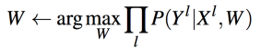

W = vector <w1,w2,…,wn>of parameters to be estimated

Yl = observed value of Y in the lth example

Xl = observed value of X in the lth example

**Learning the weights**

**~~• Remember the old trick~~**~~: take the log of the likelihood function~~

~~• Want to maximize: 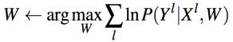~~

~~• This is called the conditional data log likelihood, called l(W)~~

~~• Remember Y~~~~l~~ ~~can take only 2 values -> 0 and 1~~

~~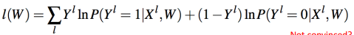~~

~~Not convinced? Set Y~~~~l~~ ~~= 0 and check and then Set Y~~~~l~~ ~~= 1 and check.~~

• To proceed, we use the following functional forms:

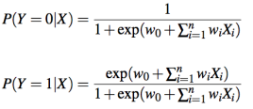

Using in equation for l(W): 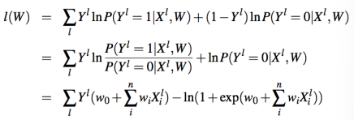

Learning the weights

• There is no closed form solution for above equation.

• So how do we proceed? **Gradient Ascent**

• Why **ascent**? Because we want **maximum value**.

• When we wanted to **minimize** a function e.g. error, we used **gradient descent**

Convex and Concave functions

• For **error,** we want a **convex** function.

• For **maxima evaluation**, **concave** function.

• What type of function is the Entropy function E = ∑- p * log2(p) [assume range of p to be between 0 and 1]?

Hint: Use R code: curve(-x*log2(x)-(1-x)*log2(1-x) ,0, 1)

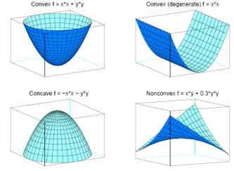

Learning the weights

• We need the slope of the curve: 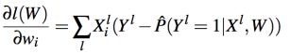

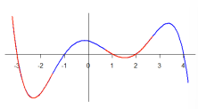where 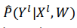 is the LR prediction using current set of weights W What's the update rule for gradient ascent?

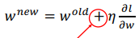

Note the + sign. We are climbing up the hill.

Learning the weights

• This leads to the gradient ascent weight update rule:

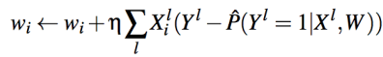

• This is what most software packages use as a starting point for Logistic Regression.

Large weights are a sign of overfitting. Let's penalize them:

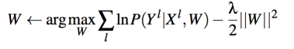

This is called **regularization**.

• If we repeat the steps using this new objective function, we get the following update rule:



where η a small constant that determines step size

Summary

• Logistic Regression directly learns the parameters of the model for P(Y|X).

• Naïve Bayes learns the parameters for P(X|Y) and P(Y) and then uses the naïve Bayes equation.

• If we assume that for each value yk of Y, the distribution of each continuous Xi is Gaussian, then this is called Gaussian Naïve Bayes (GNB).

• The two approaches have been shown as converging towards each other in the textbook and the famous paper

Model Evaluation

• Metrics for Performance Evaluation – How to evaluate the performance of a model?

• Methods for Performance Evaluation – How to obtain reliable estimates?

• Methods for Model Comparison – How to compare the relative performance of different models?

Metrics for Performance Evaluation

• Focus on the predictive capability of a model

– Rather than how fast it takes to classify or build models, scalability, etc.

• Confusion Matrix:

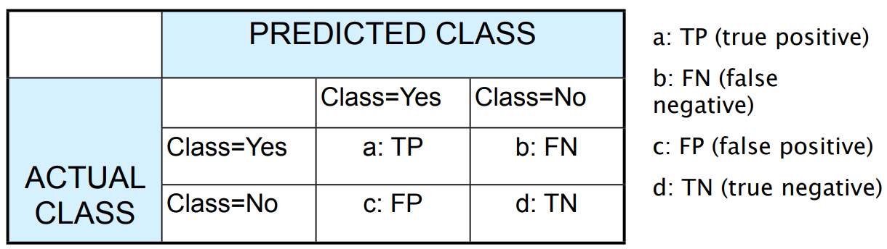

Metrics for Performance Evaluation…

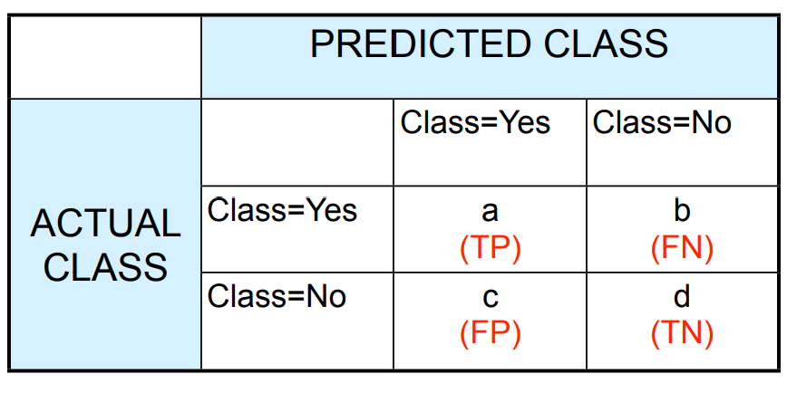• Most widely-used metric:

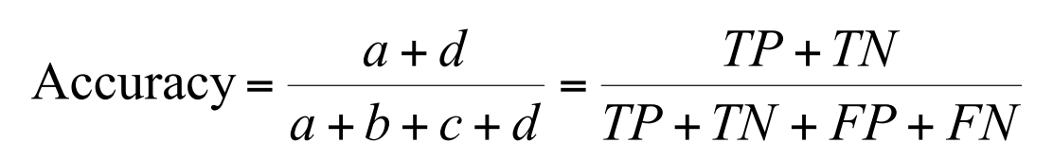

Limitation of Accuracy

• Consider a 2-class problem

– Number of Class 0 examples = 9990

– Number of Class 1 examples = 10

• If model predicts everything to be class 0, accuracy is 9990/10000 = 99.9 %

– Accuracy is misleading because model does not detect any class 1 example

Cost Matrix

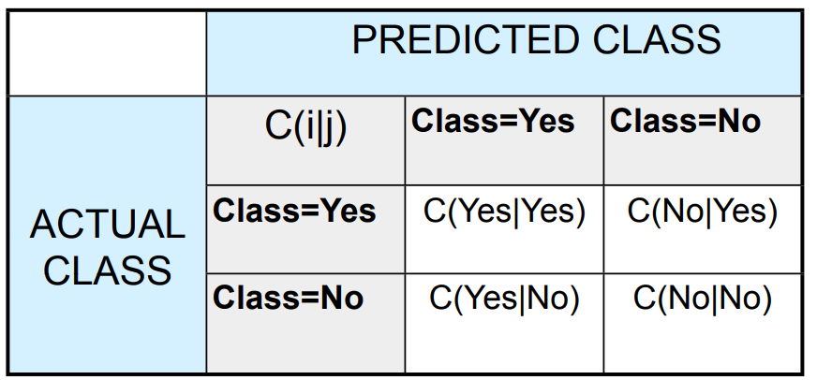

**C(i|j):** Cost of misclassifying class j example as class i. (100(-1)+20(100)+40(1)+200(0)=1940)

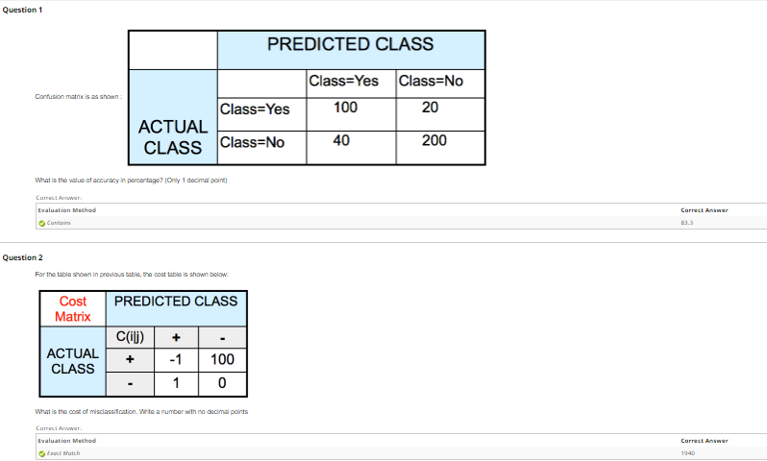

Computing Cost of Classification

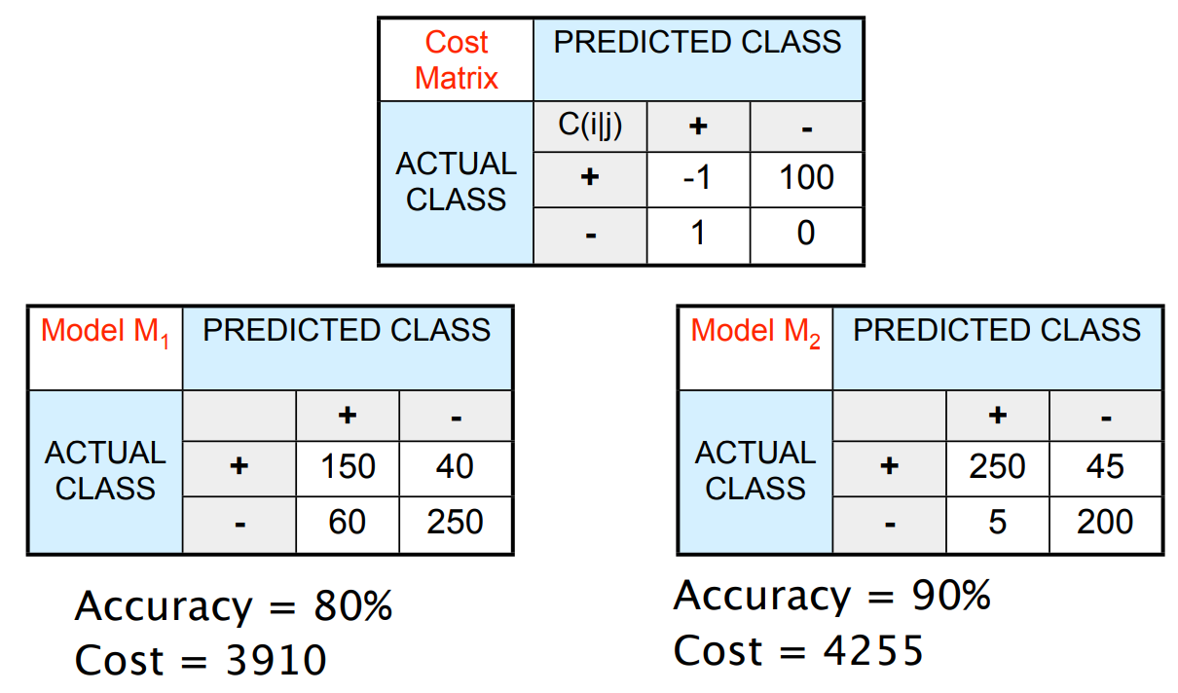

Cost vs Accuracy

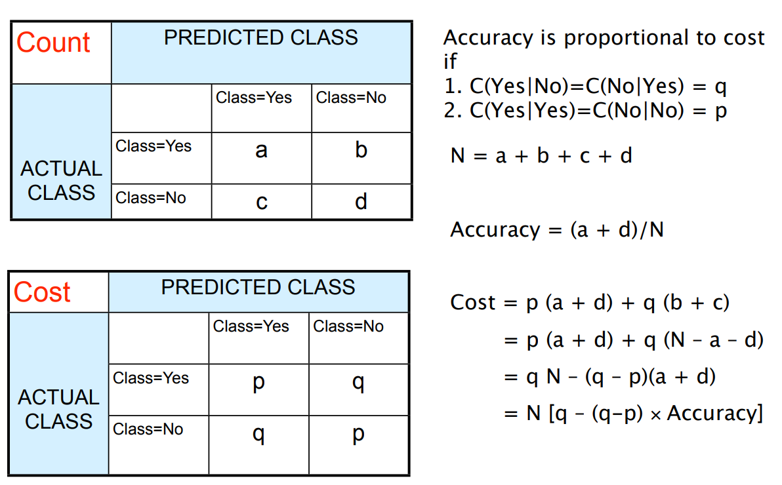

Cost-Sensitive Measures

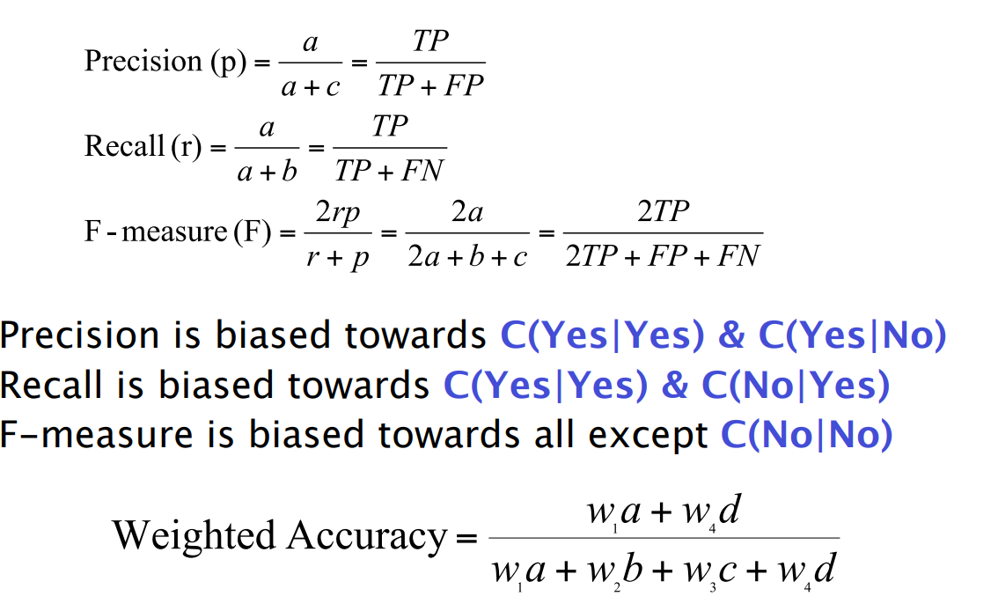

Model Evaluation

• Metrics for Performance Evaluation – How to evaluate the performance of a model?

• Methods for Performance Evaluation – How to obtain reliable estimates?

• Methods for Model Comparison – How to compare the relative performance of different models?

Methods for Performance Evaluation

• How to obtain a reliable estimate of performance?

• Performance of a model may depend on other factors besides the learning algorithm:

– Class distribution – Cost of misclassification – Size of training and test sets

Learning Curve

. Learning curve shows how accuracy changes with varying sample size

. Requires a sampling schedule for creating learning curve

. Effect of small sample size: - Bias in the estimate - Variance of estimate

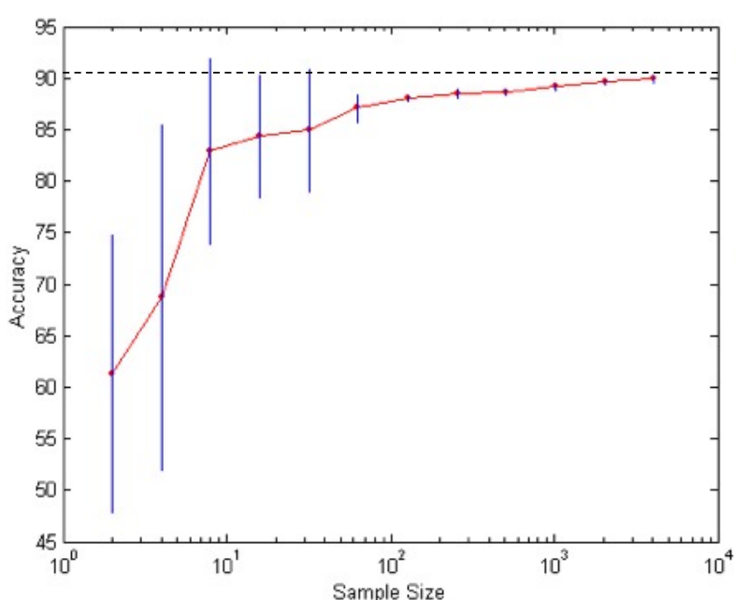

Methods of Estimation

• **Holdout** – Reserve 2/3 for training and 1/3 for testing

• **Random subsampling** – Repeated holdout

• **Cross validation**

– Partition data into k disjoint subsets

– k-fold: train on k-1 partitions, test on the remaining one

– Leave-one-out: k=n

• **Bootstrap** – Sampling with replacement

Model Evaluation

• Metrics for Performance Evaluation – How to evaluate the performance of a model?

• Methods for Performance Evaluation – How to obtain reliable estimates?

• Methods for Model Comparison – How to compare the relative performance of different models?

ROC (Receiver Operating Characteristic)

• Developed in 1950s for signal detection theory to analyze noisy signals – Characterize the trade-of between positive hits and false alarms

• **ROC** curve plots TPR (on the y-axis) against FPR (on the x-axis)

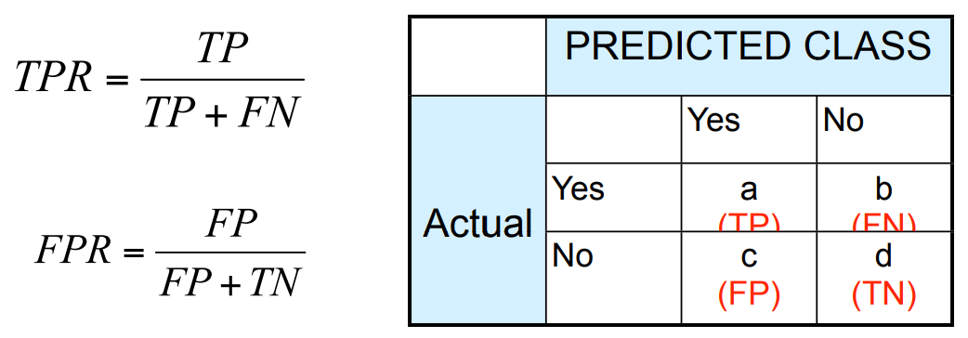

ROC (Receiver Operating Characteristic)

• Performance of each classifier represented as a point on the ROC curve

– changing the threshold of algorithm, sample distribution or cost matrix changes the location of the point

ROC Curve

- 1-dimensional data set containing 2 classes (**positive** and **negative**)

- any points located at x > t is classified as **positive**.

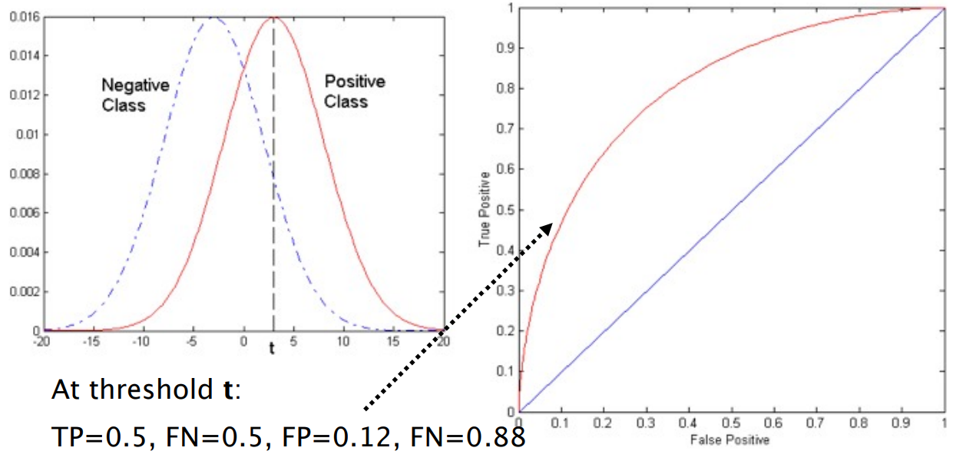

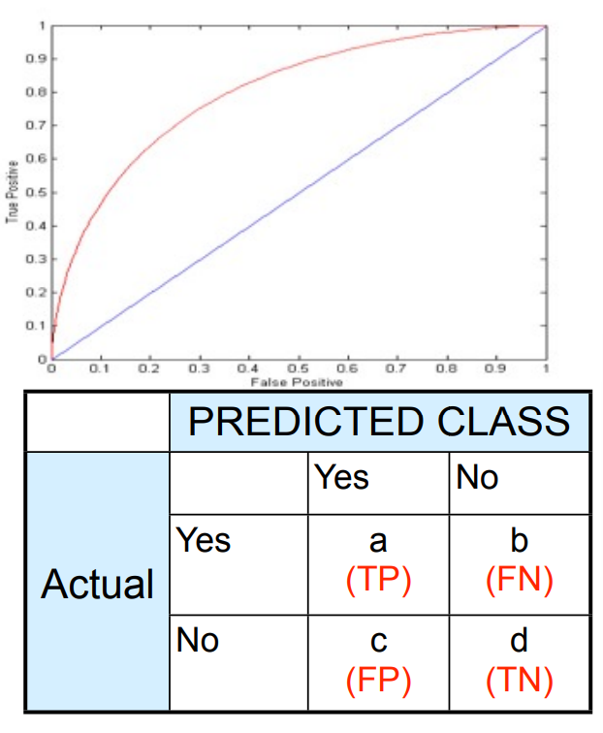ROC Curve (TP,FP):

• (0,0): declare everything to be negative class

• (1,1): declare everything to be positive class

• (0,1): ideal

• Diagonal line: – Random guessing – Below diagonal line: • prediction is opposite of the true class

Using ROC for Model Comparison

l No model consistently outperform the other

l **M1** is better for small FPR

l **M2** is better for large FPR

l Area Under the ROC curve

l Ideal: Area = 1

l Random guess: Area = 0.5

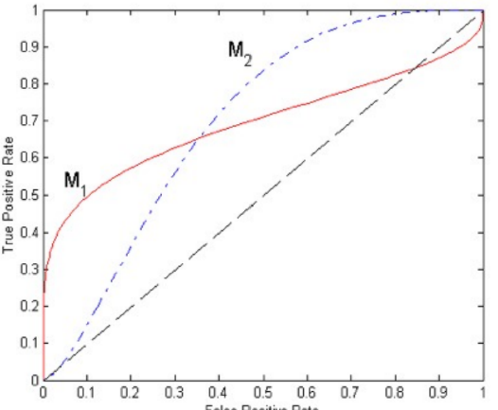

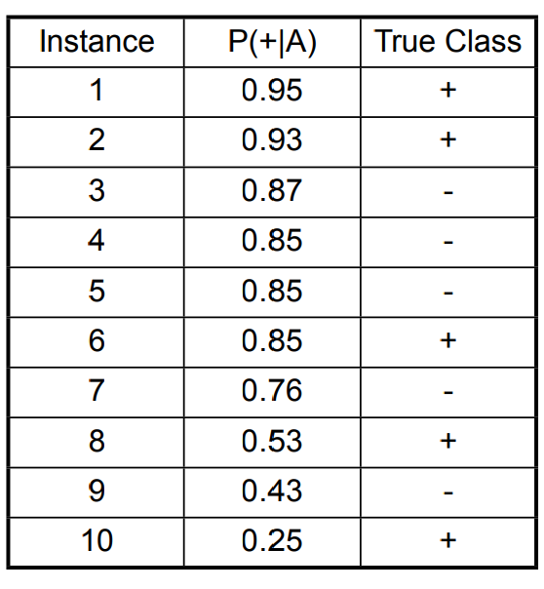How to Construct an ROC curve

• Use classifier that produces posterior probability for each test instance P(+|A)

• Sort the instances according to P(+|A) in decreasing order

• Apply threshold at each unique value of P(+|A)

• Count the number of TP, FP, TN, FN at each threshold

• TP rate, TPR = TP/(TP+FN)

• FP rate, FPR = FP/(FP + TN)

How to construct an ROC

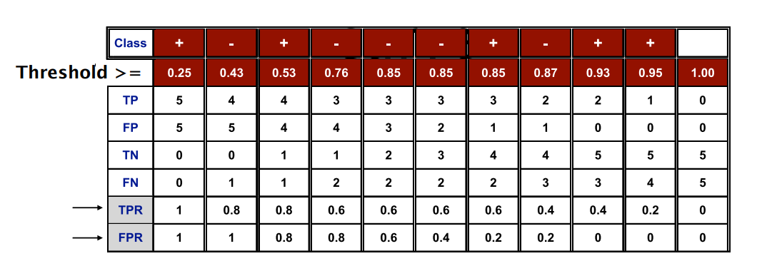

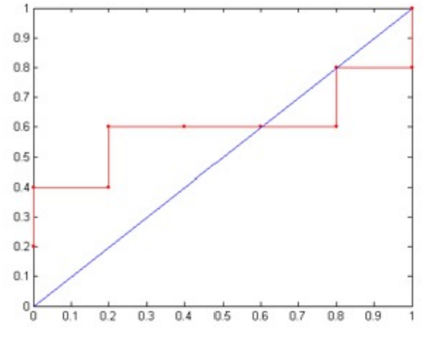

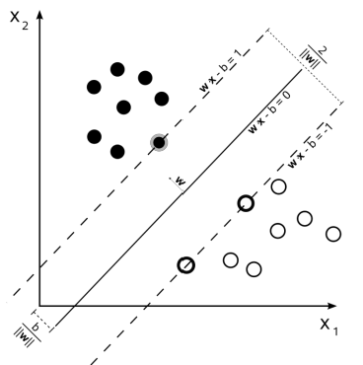**Instance Based Learning**

Review of Types of Classifiers

We have studied 3 types of classifiers:

1. Create a model for y (output) as a function of attributes. e.g. Perceptron, ANN, SVM y = sign(wTx)

2. Probabilistic (Generative) classifiers P(Y | X) ∝P(X | Y) * P(Y) Probability of class membership estimated from likelihood and prior in the training data.

3. Discriminative classifiers – Create a model for P(Y|X) – Logistic Regression

Today's topics

• Instance Based Learning - k-Nearest Neighbors - Locally Weighted Regression (LWR)

• Practice Questions

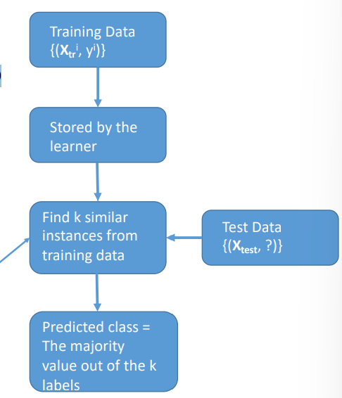• Reading: Chapter 8 of Tom Mitchell

Instance Based Learning - Classification

• Learning phase consists of simply storing all the training examples [referred to as **instances**]

• In fact there is no model creation, just storing the data.

• When a query (test) data is presented, a set of similar instances is retrieved from memory and used to classify the data.

• k-Nearest Neighbors (kNN) is **the most** popular IBL algorithm.

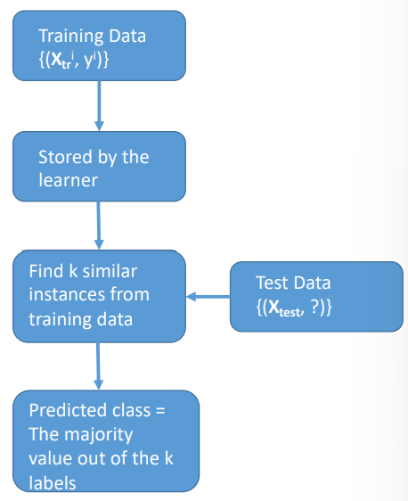k- Nearest Neighbors (kNN)

• What happens during testing phase?

– k similar items are scanned

- their class labels are identified

- majority of the class labels gives the predicted class label.

• What are the hyper-parameters?

- Similarity metric

- Value of k

k-NN Algorithm

**Training data:** Labeled instances {Xi, yi }

**Training Phase**: Just store the examples

**Test Phase**: Given a test instance Xq, take a vote among its k-nearest neighbors for the class value:

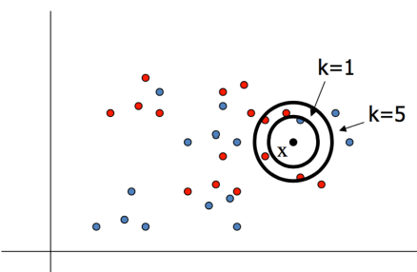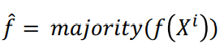

where 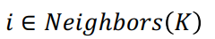

Example

• Image on the right shows a k-NN example with k = 1 and k = 5.

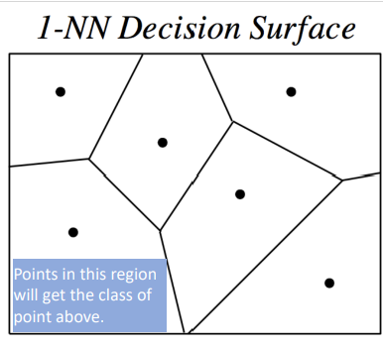Decision Boundary

• The decision boundary for a 1-NN case can be shown as:

• This forms a Voronoi diagram,

**Defn**: partitioning of a plane into parts based on distance to specific points.

Example

• Image on the right shows a k-NN example with k = 15.

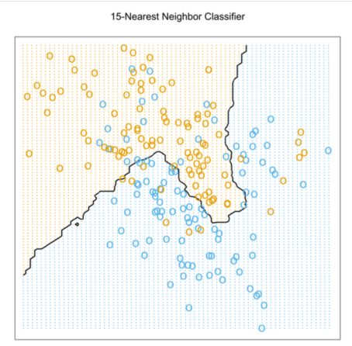Example

• Image on the right shows a k-NN example with k = 1.

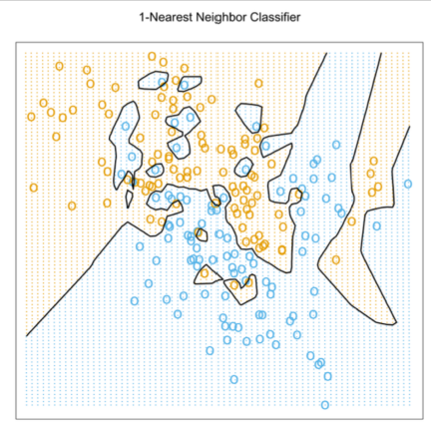• Point to note: You can get really complex decision boundaries by this very simple model.

• It pays to be lazy sometimes.

Distance Metric

• k-NN is critically dependent on the distance metric.

• For a function D to be used as a distance metric, it should satisfy certain properties:

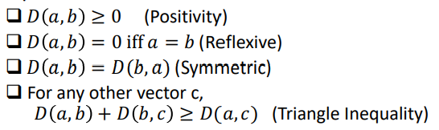

• What are some of the commonly used distance metrics?

Similarity Metrics

Some commonly used similarity metrics for vectors Xi and Xj having d dimensions each:

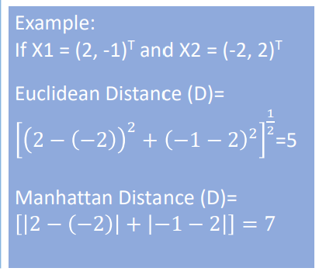• Euclidean distance:

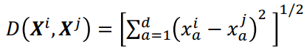

• Manhattan distance:

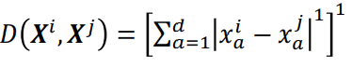

Similarity Metrics

Both of these are generalization of the Minkowski distance (or norm)

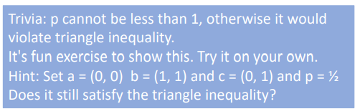• Minkowski distance of order p:

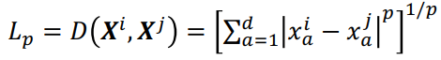

• p can range from 1 to ∞.

A word of caution

• For these distance metrics to work nicely, the attributes must be scaled before using them.

• We have done this earlier in neural net training.

• In many cases, you might want to weight each attribute differently. This is called weighted distance.

• Example of weighted Euclidean distance:

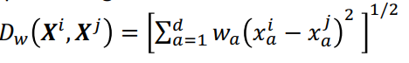

where wa is weight for the ath attribute

Example:

Data for UTD students' GPA (attribute) and getting internship (class) is presented below:



Using Manhattan distance, what will be the prediction of k-NN for a student with GPA of 3.5 in the following cases:

1. k = 1: Nearest neighbor: {(3.55, 1)} => Majority class = 1

2. k = 3: Nearest neighbors: {(3.55, 1), (3.4, 0), (3.6, 0) } => Majority class = 0

3. k = 5: Nearest neighbors: {(3.55, 1), (3.4, 0), (3.6, 0), (3.3, 1), (3.6, 1) } => Majority class = 1

Handout

• Let's practice some questions from the handout.

• Realization:

- The calculations become more and more tedious as k increases and more so when dimensions increase.

- More work is done during the testing phase than during the training phase.

Advantages and Disadvantages of k-NN

**Advantages:**

• Training is very fast

• Can learn complex target functions easily

• Easy to program

**Disadvantages:**

• Slow at query time

• Lots of storage and processing in memory

• Doesn't scale well in higher dimensions

• Easily tricked by noisy data items and irrelevant attributes (Curse of Dimensionality)

• Value of k can vary results significantly

k-NN for Continuous Output

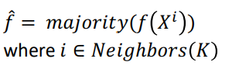• We presented k-NN for classification, but it can easily be used to approximate functions where the output is continuous.

• How? Simply replace the majority function by the average function: Instead of:

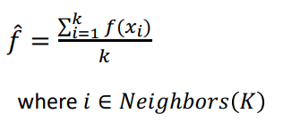Use this:

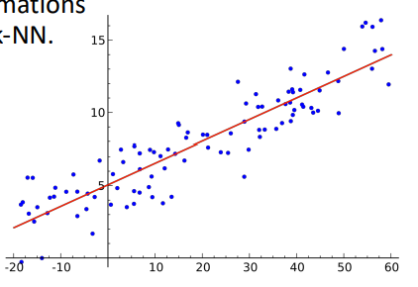Locally Weighted Local Regression

• In typical regression, we create a global model for the data.

• A better option? Creating local approximations using the idea of "neighborhood" and k-NN.

• The local functions produce piecewise approximation to the global function.

LWR Example:

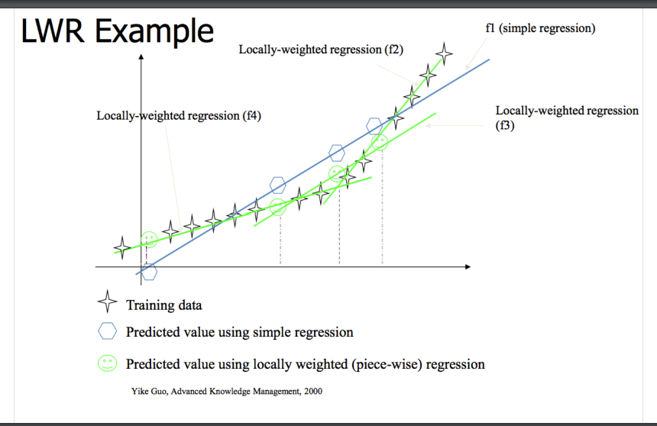

Lazy vs Eager Learners

• **Lazy:** Wait for query before generalizing i.e. going beyond training data.

-> Model doesn't propose a function until a query point arrives.

-> When a query point arrives, a local search for the best function is done and it is outputted as the generalization for the test query.

-> Model is adaptable.

• **Eager:** After all training data is received, a generalization function is outputted.

-> ID3 algorithm creates a decision tree (generalization model) after incorporating all training data.

-> A generalized linear regression outputs an approximation function after seeing all the training data.

-> One model for all the query instances.

Parametric vs Non-Parametric Methods

• **Parametric:** A particular **functional form** is assumed, e.g., linear, Gaussian distribution, naïve Bayes

-> may have **high bias** because the real data may not obey the assumed functional form.

-> Parameter estimation is required.

-> Advantage of simplicity – easy to estimate and interpret

• **Non-Parametric**: Distribution or density estimate is **data-driven** and relatively **few assumptions are made a priori about the functional form**.

-> Parameter estimation is not as involved.

Thought Questions

• Can you think of a lazy algorithm for decision tree construction?

• Will it help if we are able to pre-process and remove irrelevant or redundant attributes?

• What is the time complexity of k-NN?

Thought Questions

• Can you think of a lazy algorithm for decision tree construction?

– Delay generalization as much as possible should be the principle. **1st approach**: At the root level, find the best splitting attribute, let's say it's xk. Check the query for this attribute, suppose it's 1, then you will grow only the right subtree. Idea is to grow the subtree only when test data requires it.

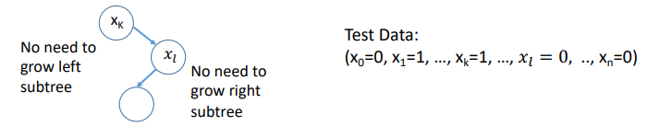

• Can you think of a lazy algorithm for decision tree construction?

- Delay generalization as much as possible should be the principle**. 2nd approach**: For the query point, find k closest examples and build tree only using those examples.

**Ensemble Methods**

Bias and Variance

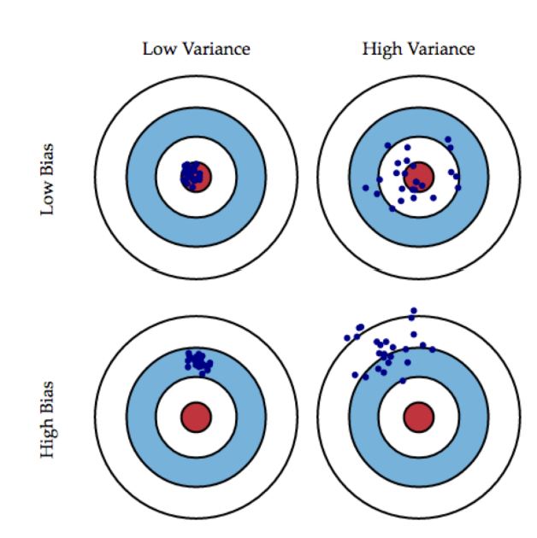• **Bias** measures the difference between expected value of an estimator (E[Y]) and the "true" value (p). Bias = E[Y] – p (A lower bias is preferred)

• **Variance** measures how much the estimate varies between samples. A low variance is generally preferred.

Intuition

**• Bias**: - measures accuracy of quality of an algorithm. - high bias means a poor match.

• **Variance**: - measures the precision or specificity of a match - Did the algorithm just get lucky on a few samples? Or is it really a good classifier?

- a high variance means a weak match.

**• Ideally, we would like to minimize both of them. Is that possible**?

Mathematical Derivation

• Let's consider the case of regression

• **True** function is: 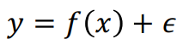

Where (We are assuming that there is some noise in the data.)

y is the output,

f(x) is the "best" possible function

Ε is a term that accounts for the noise in data

• Our hypothesis is h(x) = wTx + b

• We seek to minimize squared error: 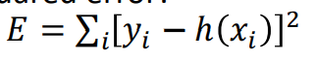

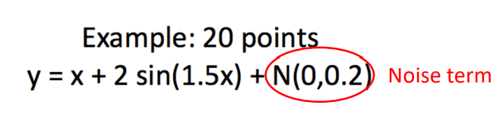Actual data y = Best f(x)

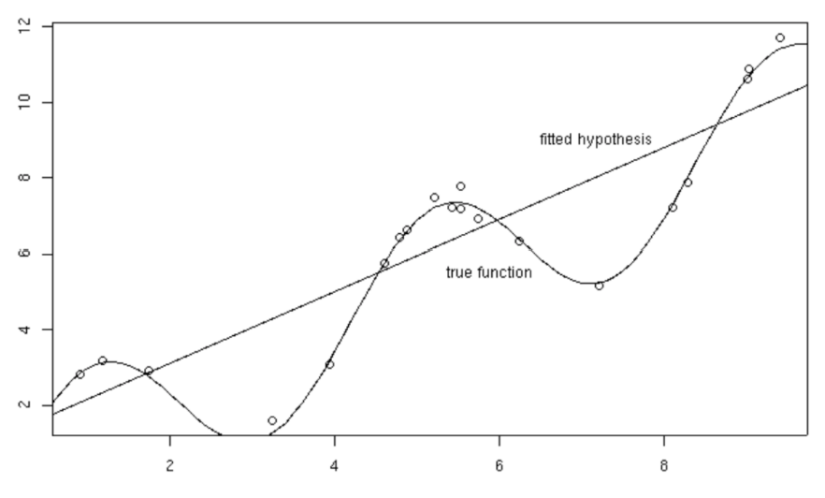

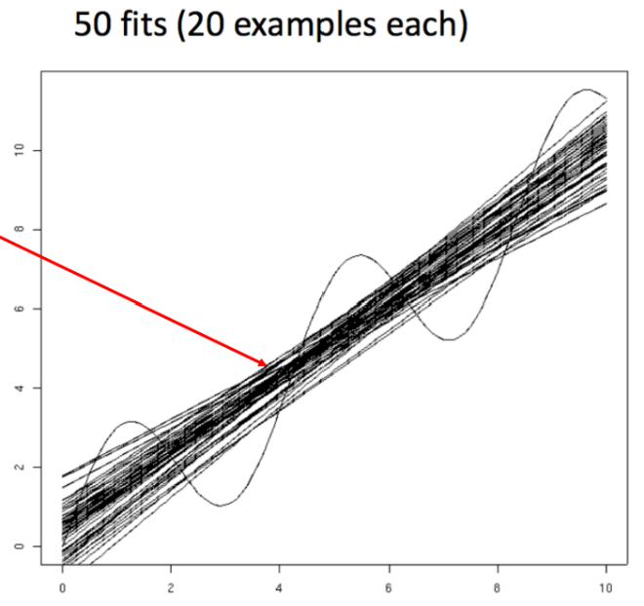

50 samples of 20 instances each are sampled and hypothesis is tested on them

Bias – Variance Analysis

• Now, given a new data point x*, with observed value 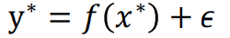

• Prediction of our hypothesis = h(x*)

• Let's examine expected value of squared error: 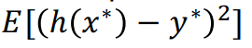

• Before going there, let's look at a lemma that will help us.

Bias – Variance Analysis

• Let Z be a random variable with distribution P(Z) and average value defined as:

Using linearity property of E and the fact that E[Z] = ; also the fact that E[C] = C where C is a constant.

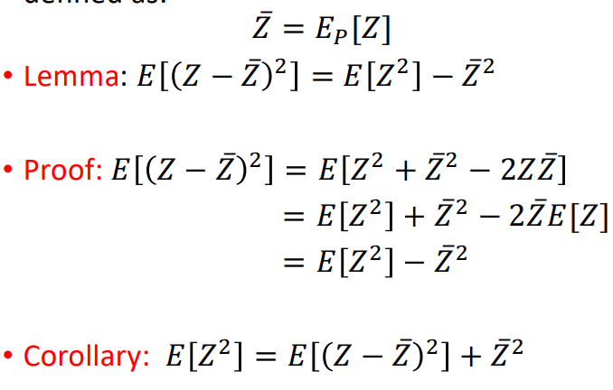

Bias Variance Analysis

• Let's go back to what we were trying to solve:

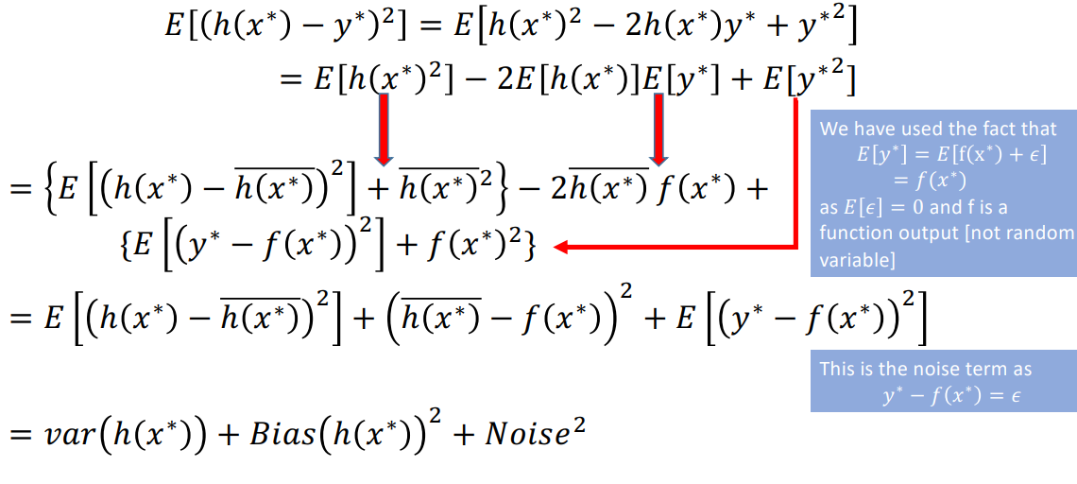

Bias Variance Tradeoff

• Summarizing,



• **Variance** = How much h(x*) varies from its average value over multiple samples.

• **Bias** = Describes average error of h i.e. how far is average error from actual expected value

• **Noise** = Describes how much the best function differs from actual value.

Bias

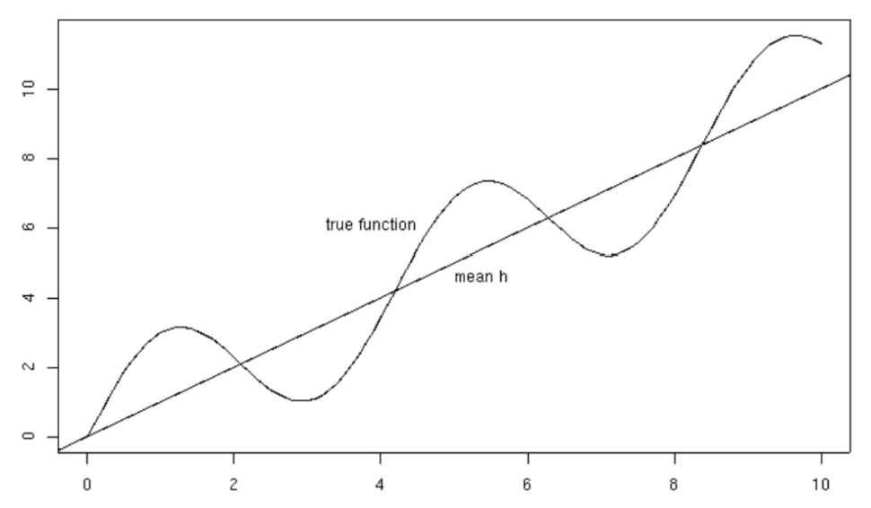

Variance

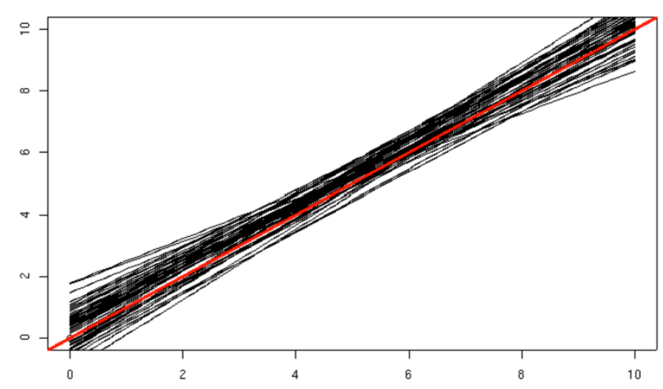

Noise

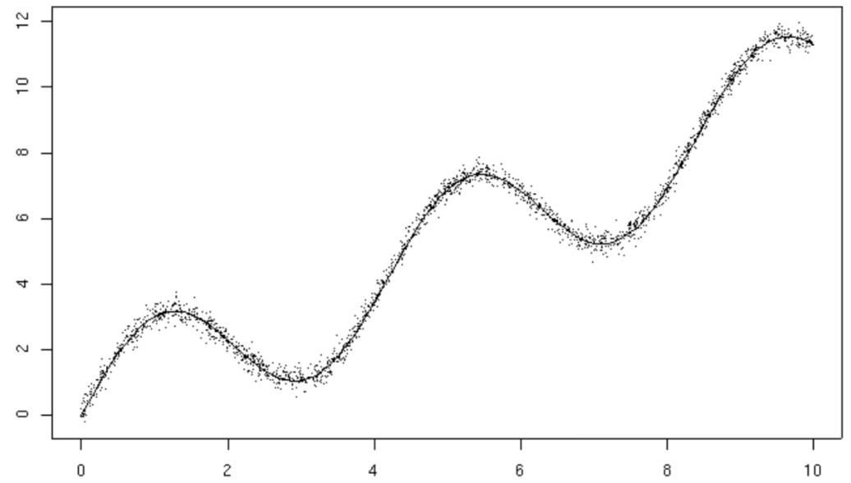

Bias-Variance

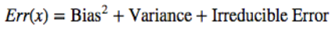 Var >> then bias <<. ortherwise

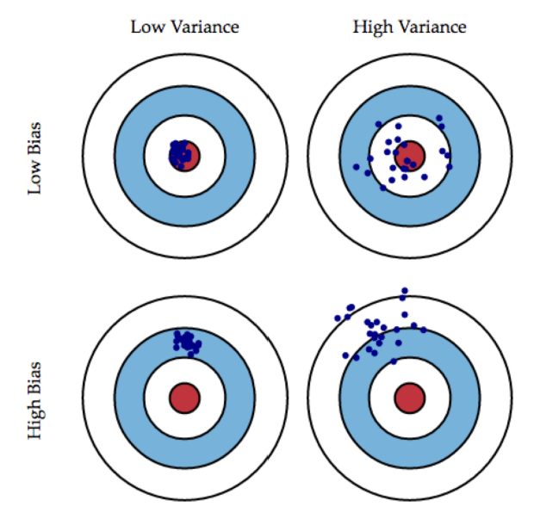

Bias Variance Tradeoff

• For machine learning models, there is always a tradeoff between bias and variance.

• Generally, we can't have low bias and low variance for real world data.

• The next slides explain this concept.

Bias – Variance Tradeoff

• **Low Bias** – model gets close to actual value - linear regression applied to linear data - 2nd degree polynomial applied to quadratic data

• **High Bias** – model is a poor approximator - constant function applied to highly non-linear data - linear regression applied to non-linear data

**• Low Variance** – for different samples, output of model doesn't change much - constant function always - simple model independent of data

• **High Variance** – for different samples, output of the model changes a lot - complex model e.g. neural net - high degree polynomial function

Bias Variance Tradeoff

• Can I get both low bias and low variance?

• To get low bias -> you need to get very close to the real function. -> need a complex model that has a number of parameters. -> parameters depend on data -> **so for** **each sample, you get a different output from model**.

• If you get different output from the model for different samples, you have **a high variance**.

**• So, I get a low bias but ended up with high variance**.

Bias Variance Tradeoff

• Can I get both low bias and low variance?

• To get low variance

-> you need a model whose output doesn't change across multiple samples

-> Suppose you choose a constant function. It doesn't change its output for different data samples.

• But, the output will be very different from the real function that you are trying to approximate => **High Bias**

• **So, I get a low variance but ended up with high bias**.

Why can't we reduce both error and variance

• If we make the mode more complex, bias goes down but variance goes up.

• If we create a very simple model, variance is low but bias goes up.

Bias / Variance

• Suppose, we are trying to learn the sine function:

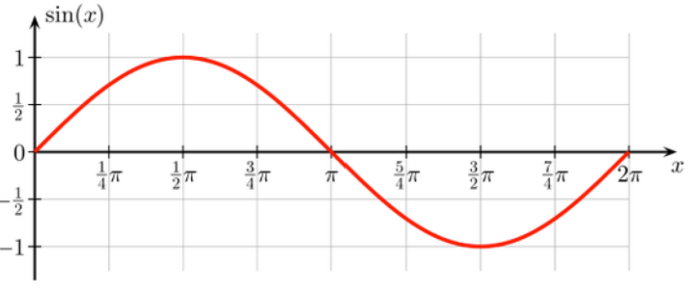

Bias/Variance

• We have a small sample dataset e.g. only 2 training points.

• Case I: Model: h0 = b where b is a parameter that we optimize

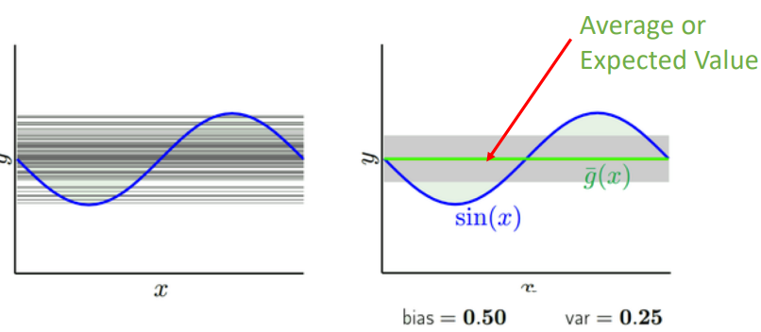

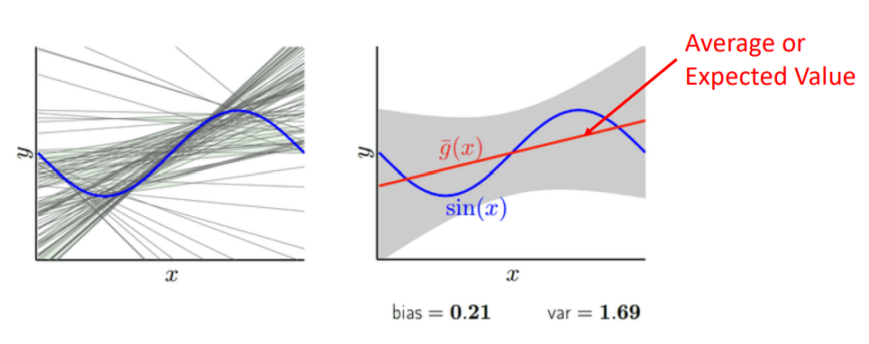Bias/Variance

• Case II : Model: h1(x) = a x + b where b is a parameter that we optimize

Comparison Observations:

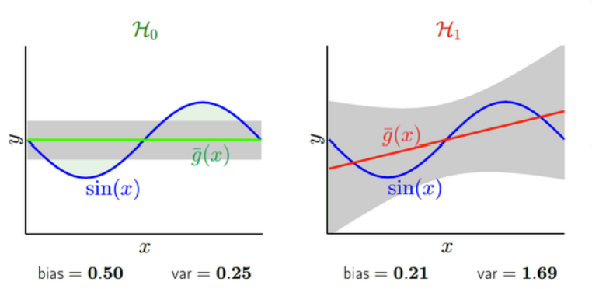• By making the model more complex, we have reduced bias but increase variance.

• A simple model has low variance, but high bias.

• Bias Variance Tradeoff

Bias-Variance Example 2

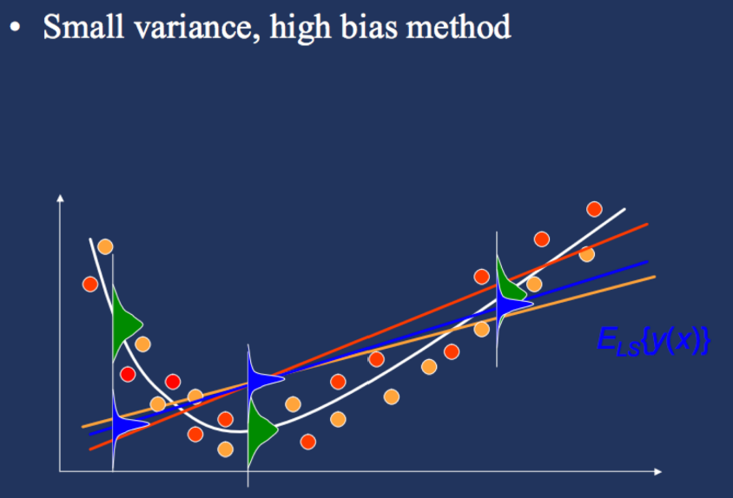

Model Complexity

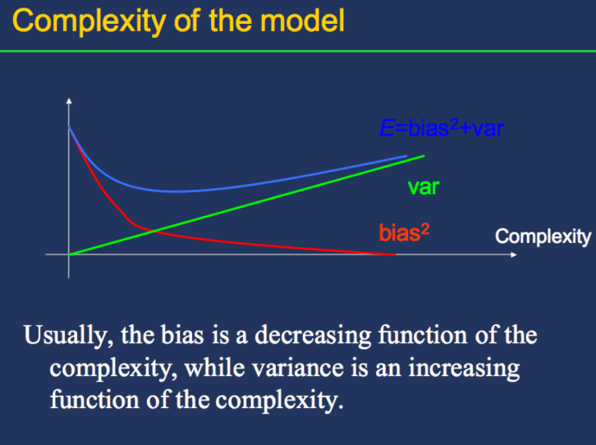Complex model: low bias; high var;

Simple model: high bias, lor var

Singular

How does all of this help me in ML?

• You begin to ask – do I really need to understand all of this?

• Keep in mind that my wish list is: - low bias - low variance - reasonable model complexity - avoid overfitting

• Can I get all of the above?

**Classifiers based on idea of bias and variance**

Background - Variance

• Property of Variance: 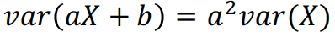

• Let's compute variance of the mean of a random variable:

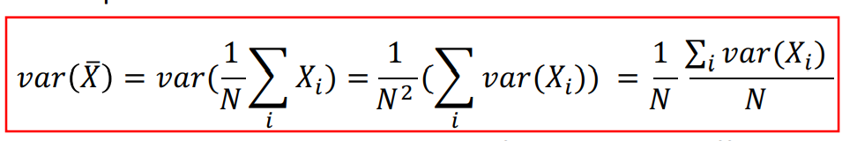

Suppose each Xi represents the output of a model on a different dataset. If we take the variance of the average of these outputs, it will be lower than the average of the variances by a factor of 1/N.

Background - Variance

• How do we get different datasets?

• In reality, you have only 1 dataset available and don't have the power to sample over and over from a population.

• How do we **simulate** random sampling using only the data available? -> **Bootstrap**

• Bootstrap – create new samples of the same size from original **dataset by sampling with replacement**.

Bootstrap - Example

• I have one data sample.

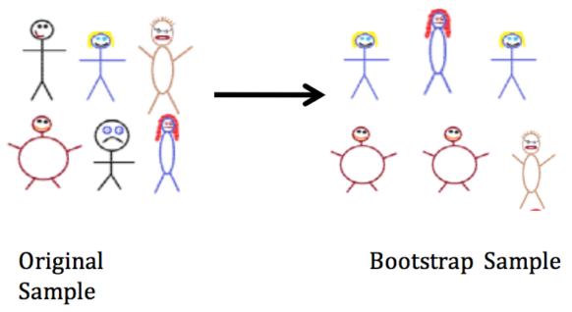• I **can't** sample again from the population.

• Can I simulate new samples from this sample?

• Sample with replacement from the dataset available.

Bootstrap - Example

• Suppose I have a sample of 6 people.

• That's all the data that you have to work with.

• I'd like another sample of same size.

• Idea of sampling with replacement: For each slot, I have all n choices.

Bootstrap Distribution

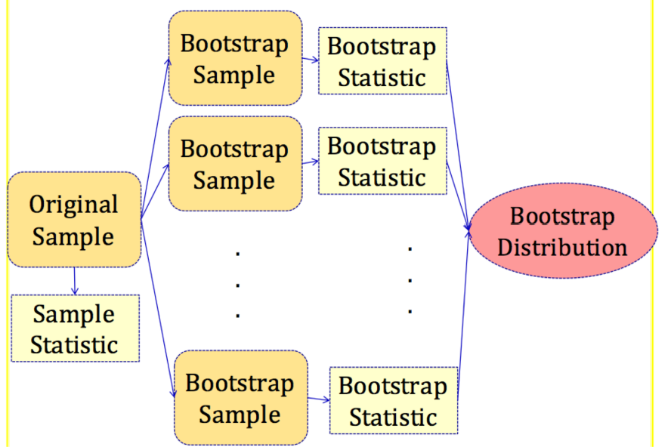

Bootstrap

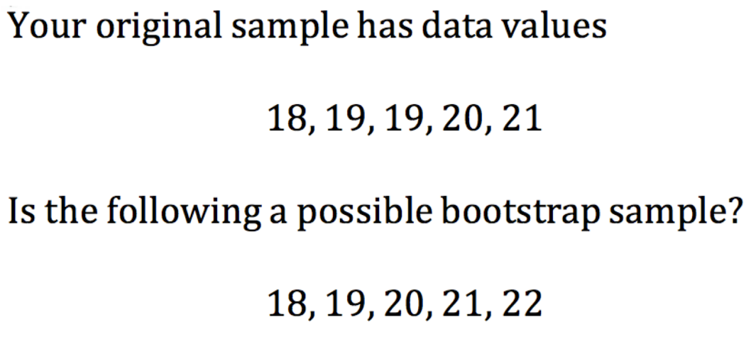

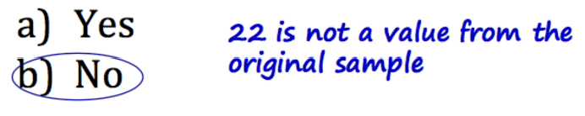

Bagging – **B**ootstrap **Agg**regation

• A set of classifiers based on the idea of bootstrap + aggregating the output of individual classifiers.

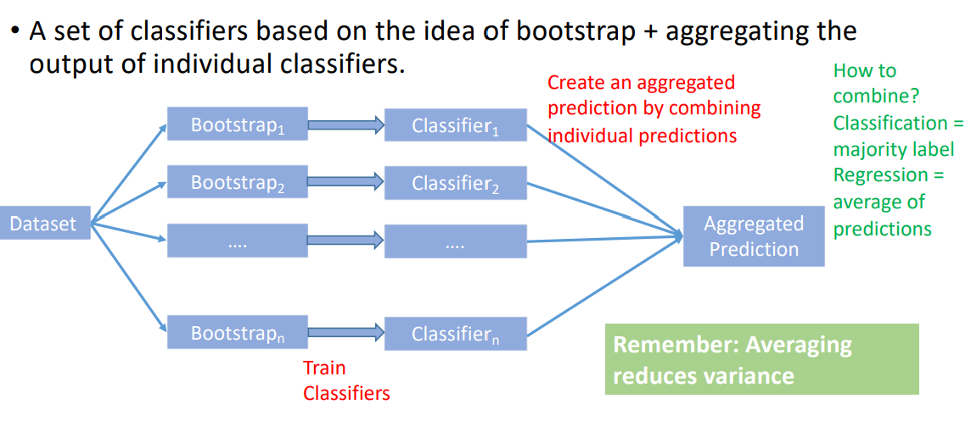

How to combine? Classification = majority label Regression = average of predictions

Remember: Averaging reduces variance

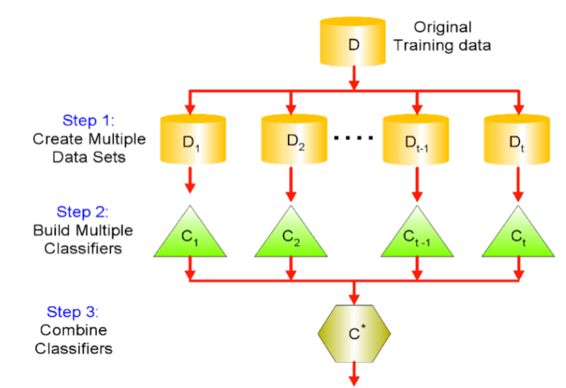Bagging Algorithm

• **Input:** Dataset D containing N training examples.

• **Steps:**

1. Create k bootstrap samples D1, D2, …, Dk

2. Train distinct classifiers C1, C2, …, Ck on each of these datasets

3. Create an aggregate prediction by taking the majority / average of these individual classifiers.

Analysis

• In a any bootstrap sample of size N, a given data point has probability of not being selected as: 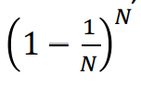

• So, probability of being selected as (p): 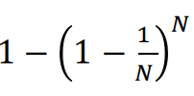

• Think of it like a binomial distribution with p as being probability of heads.

• Expected number of points that are selected in any given bootstrap sample 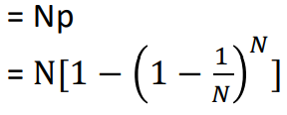

Analysis

• Remember, that ex can be written as: 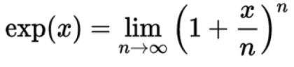

• So, for large enough values of N, the expected number of points in a bootstrap sample becomes:

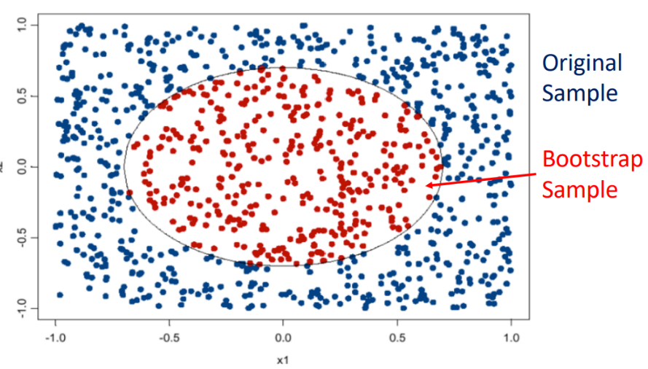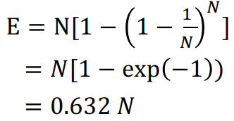

Analysis

• **So, what does Bagging model do for me?** Creates an aggregated model with less variance.

• **What is the reduction?** 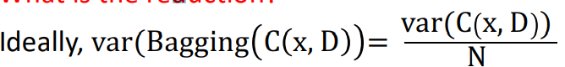

• But, in reality the models are not independent (since their datasets are correlated), so reduction is less than (1/N) times.

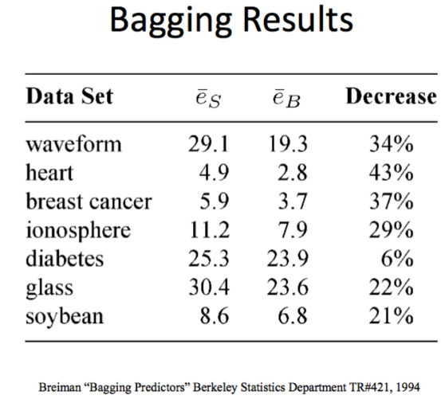• **Does Bagging also lead to an increase in accuracy?** Yes, it has been empirically shown to

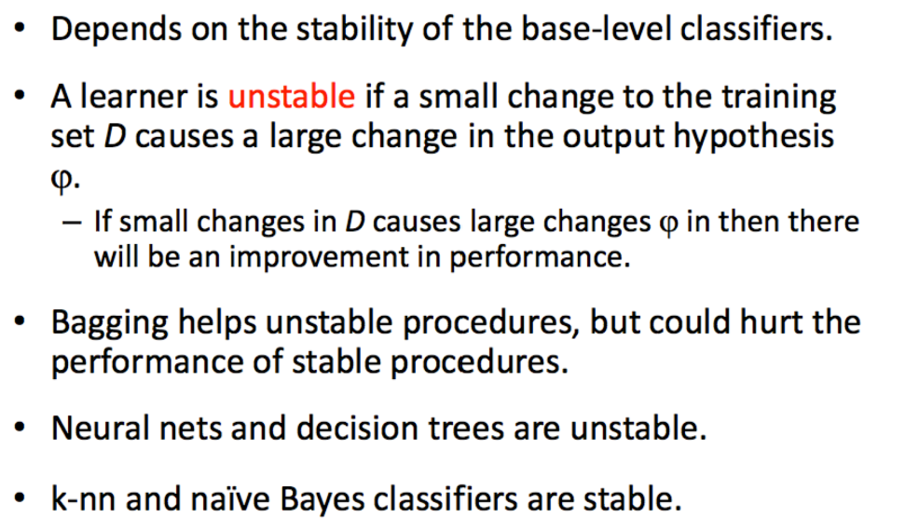When will Bagging improve Accuracy?

Random Forests

• In Bagging classifiers, we created new datasets by varying the **instances** from the original dataset.

• What if we vary **the attributes** also?

• This is the idea behind Random Forests (RF). The base classifiers are Decision Trees.

• **Idea:** Create Decision Tree (DT) models from the bootstrap samples, but in each DT limit the splitting criteria to a random subsample of the attributes.

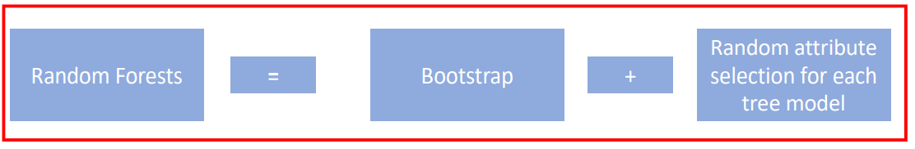

Random Forest Algorithm

**Input:**

Dataset D containing N instances and M attributes

**Training Phase:**

For b = 1 to B. Create a bootstrap sample of size N from original sample Grow tree Tb using the bootstrap sample as follows: Create a random sample of m attributes (m < M) Use these attributes to construct a decision tree as usual

Test Phase:

For a new data point X, take the aggregated prediction of models

For classification: aggregate = majority

For regression: aggregate = average

Best of both worlds

• Can we get lower variance and lower bias at the same time?

• We studied the bias-variance tradeoff. • But, is there a way around it?

• Can we average models and reduce bias? • Boosting

Boosting

• Boosting – combining a set of "weak" classifiers to produce a strong classifier.

• What is a "weak classifier"?

• In machine learning terminology, even a random predictor can predict with 50% error.

• If there exists a classifier that generates **slightly better** results than a random predictor, it's known as a weak classifier.

• Error of a weak classifier = (50 - y) %, where y is a small positive number.

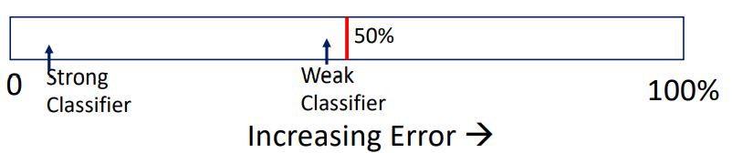

Boosting - Idea

• Start with equal weights given to all training instances.

• Run 1st rule of thumb (hypothesis G1) => Keep track of the instances where G1 makes an error. **Increase the weight of those instances**.

• Repeat this process for 2nd, 3rd , …, kth hypothesis.

• Create a final hypothesis by taking a weighted average of these k hypotheses. 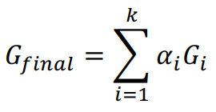

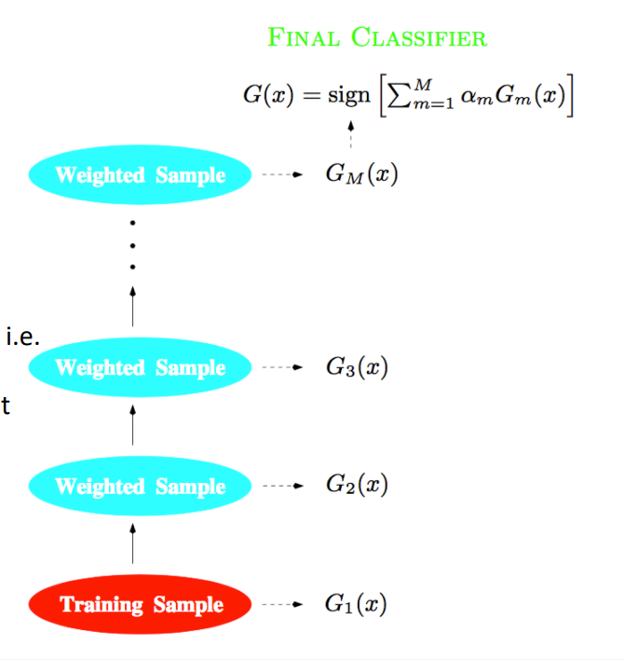Boosting

Key points to note:

- Each classifier gets a differently weighted sample.

- The classifiers work in a serial way i.e. one after the other.

- The classifiers are not independent as the output of one is input for the other

Boosting

• You want to build a spam filter based on N training examples (Xi,yi ) where yi is {Non-Spam (0), Spam(1)}, and i = 1 to N.

• Approach: Start with equal weight for each example: 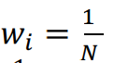

The initial weight distribution 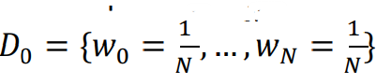

for i = 1 to T:

- Apply a rule of thumb (hypothesis Gi ) to the data with weight distribution Di

- Keep track of examples where the hypothesis makes an error and increase their weights to create a new distribution +#0)

end for

Ada boost

• One of the most popular implementations of Boosting was proposed by Freund & Schapire in 1996.

• Simple to implement and combines many weak classifier to produce a single strong hypothesis with excellent results.

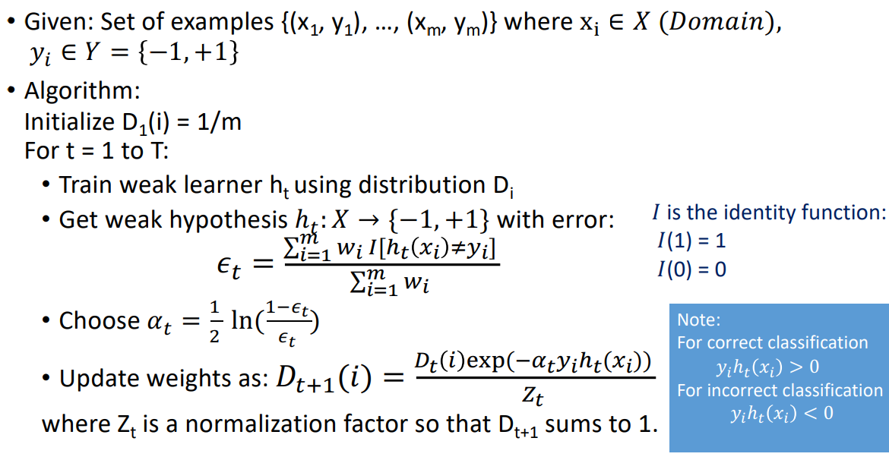

Adaboost

• The final hypothesis is obtained as: 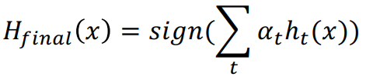

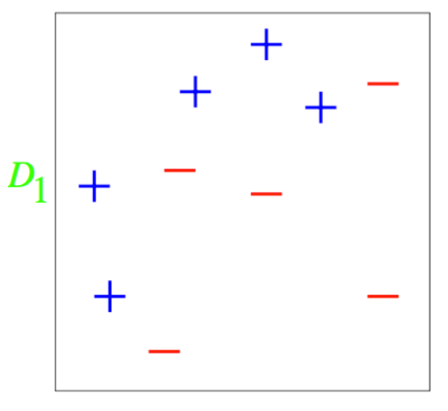Toy Example:

• Let's say we have the training data as shown on the right.

• There are 10 data points – 5 of each class.

• Initial weight distribution:

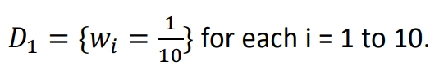

Toy Example – Round 1

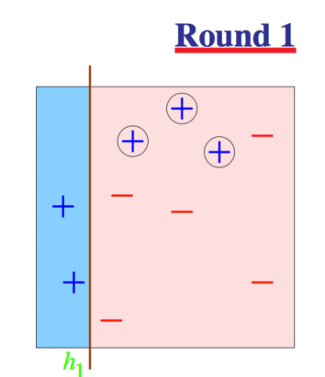• Our first weak hypothesis is shown on right.

• 3 points are misclassified.

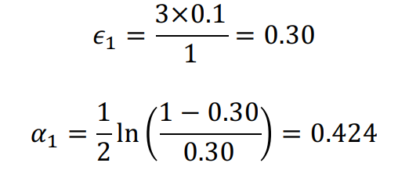

The weight of misclassified points: D2 = 0.1 × exp 0.424 = 0.153

The weight of correctly classified points: D+2 = 0.1 × exp −0.424 = 0.065

These are not normalized. After normalizing – dividing each value by total of weight of 0.914 –

Weight of misclassified: 0.167 each

Weight of correctly classified: 0.071 each

Toy Example:

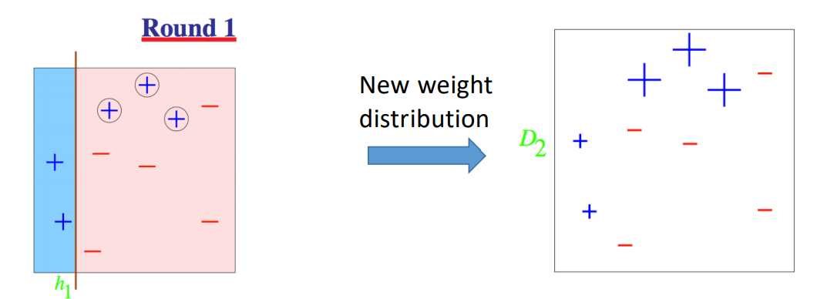

• After round 1, we get a new distribution D2. Note that the 3 misclassified points get a higher weight

Toy Example – Round 2

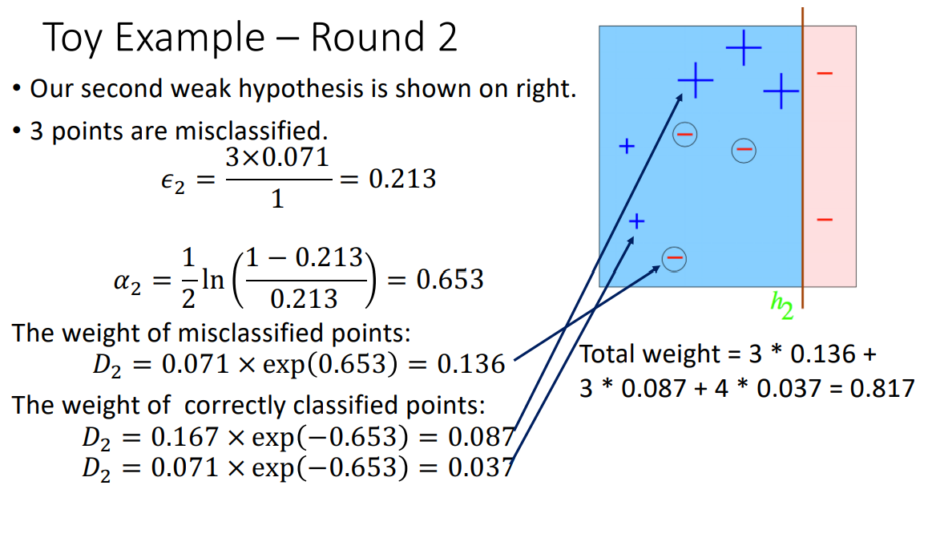

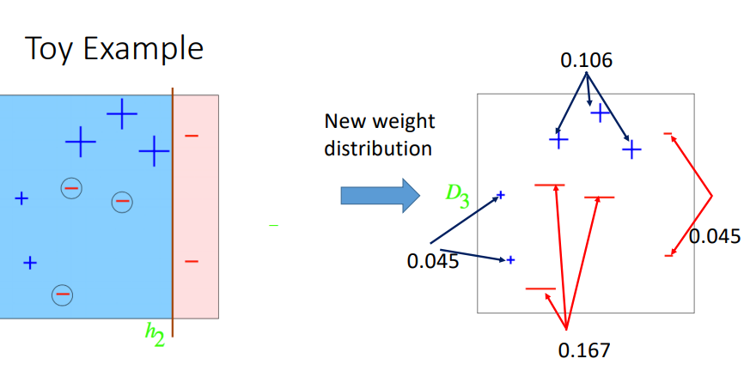

Toy Example – Round 3

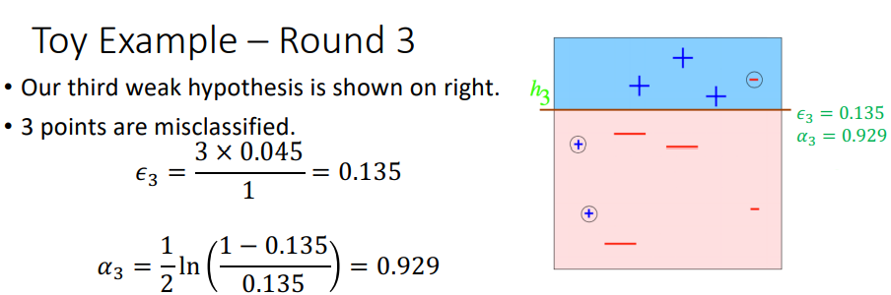

Final Hypothesis

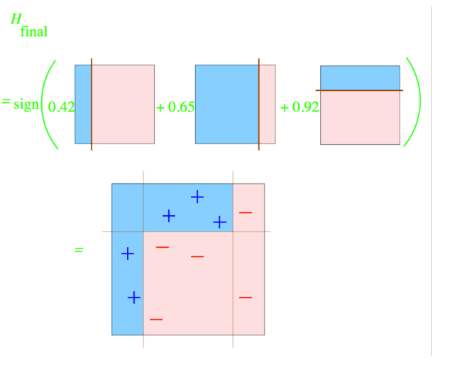

How to use this hypothesis

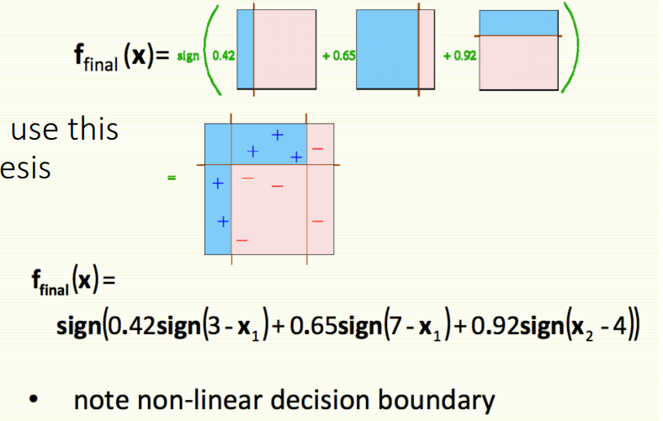

AdaBoost Analysis

• It is shown in the paper that the training error drops exponentially fast. 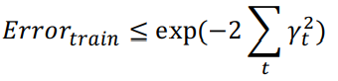

• Remember the definition of 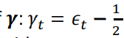, where Et is the error at round t of the Boosting algorithm.

• Example: : Let errors for the first four rounds be, 0.3, 0.14, 0.06, 0.03, 0.01 respectively. Then

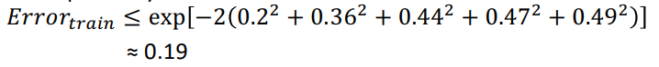

Another Toy Example

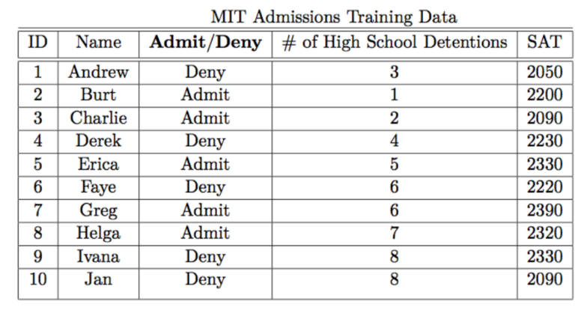

• Propose two simple hypothesis:

h1: If # of High School Detentions < 3, then ADMIT

h2: If SAT > 2200, then ADMIT

• Can you combine these two weak hypothesis to produce a strong hypothesis?

Summary

• Ensemble methods combine individual classifiers to achieve better results.

• Bagging doesn’t work so well with stable models. Boosting might still help.

• Boosting might hurt performance on noisy datasets. Bagging doesn’t have this problem.

• On average, boosting helps more than bagging, but it is also more common for boosting to hurt performance.

• Bagging is easier to parallelize.

Ensemble Methods: group of lighter classifires

Work in parallel: Bagging, RF -> de-coupling, lighter

Data science project

1. Data parsing/ loading/cleaning
2. Attribute scaling/ normalization
3. Feature selection/ engineering (= useful/ related/ strong/ attribute)
4. Model creation with hyper-parameter tuning
5. Result visualization and analysis.

Dog and cat image identification

1. Long tall vs short tail
2. Ears
3. Eyes

Image captioning

Scene recognition

**Unsupervised Learning**

Types of Learning

• Supervised Learning:

**Training data** is in the form: { X(i) , Y(i) } where X(i) is the attributes vector and Y(i) is the class label.

**Aim:** Learn the class separating function f: X -> Y, by proposing suitable hypothesis h(X)

• **Unsupervised Learning**

**Training data** is in the form: { X(i) } i.e. class labels are not provided.

**Aim:**

- Find **natural grouping** or clusters of data

- Find natural patterns in data

- Find out if there are any outliers or some data with unusual patterns.

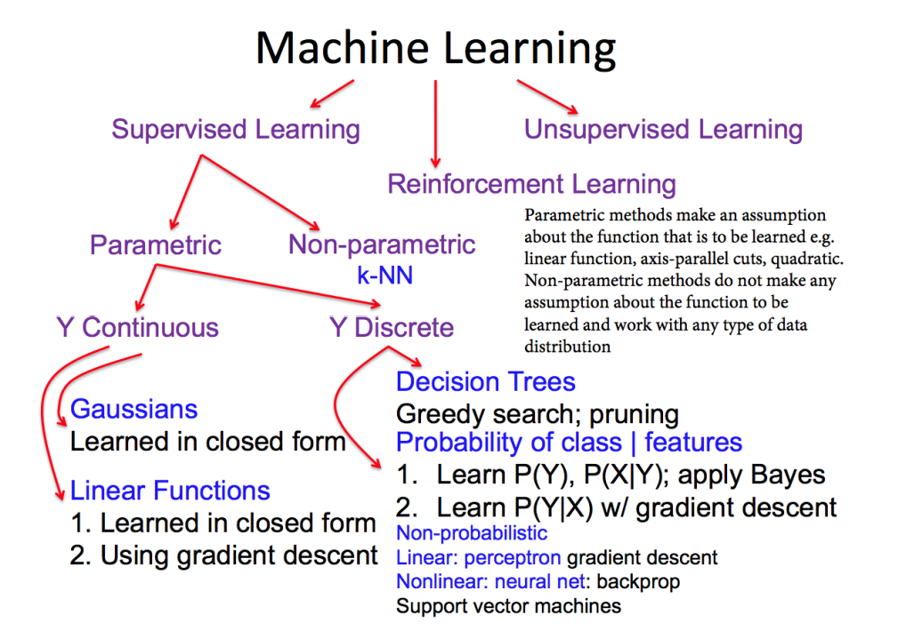

Clustering

• Clustering is a technique for finding **similarity groups** in data, **called clusters**.

• Clustering groups data instances that are similar to (near) each other in one cluster and data instances that are very different (far away) from each other into different clusters.

Data within each cluster are similar to each other and different from instances in other clusters.

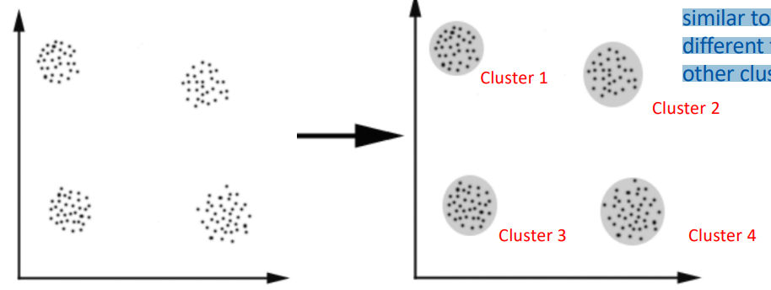

Cluster Analysis

• Finding groups of objects such that the objects in a group will be similar (or related) to one another and different from (or unrelated to) the objects in other groups

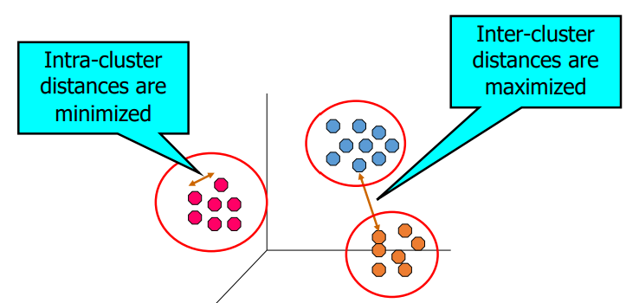

Notion of a Cluster can be Ambiguous

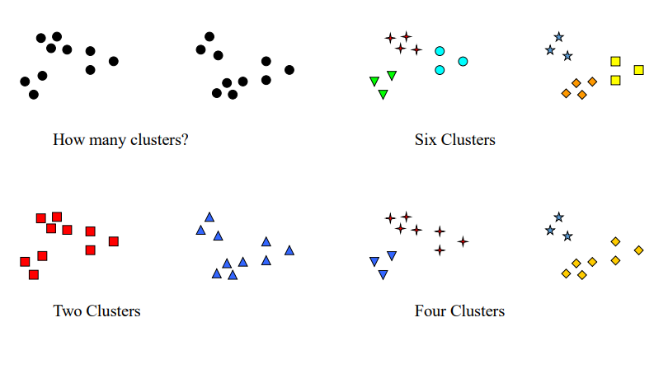

Clustering

• Clustering statement:

Given a dataset D={X1, X2, , Xn} of instances and an integer value representing the number of clusters k, the clustering problem refers to define a mapping f: D -> k, where each Xi is assigned to one cluster ki such that 1<=j<=k

• How is each cluster represented? By its mean or central value.

• How do you compare two instances? By a similarity (distance) metric that you define. E.g.

- To compare instances in 2-D, you can use Euclidean distance

- To compare people on a social network, you can propose a similarity metric.

What is clustering for?

• Let us see some real-life examples

• **Example 1**: In marketing, segment customers according to their similarities to do targeted marketing.

• **Example 2**: Given a collection of text documents, we want to organize them according to their content similarities.

e.g. Google News – similar news items are clustered together.



What is clustering for?

• Let us see some real-life examples

• **Example 3**: Find groups of related emails. This is different from spam/non-spam which is classification.

• **Example 4**: Finding clusters ("segments") in an image.

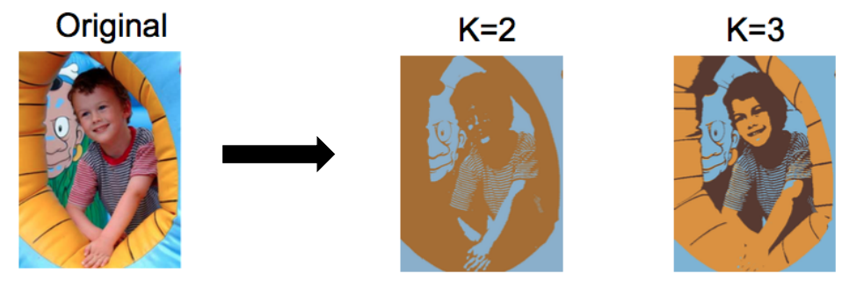

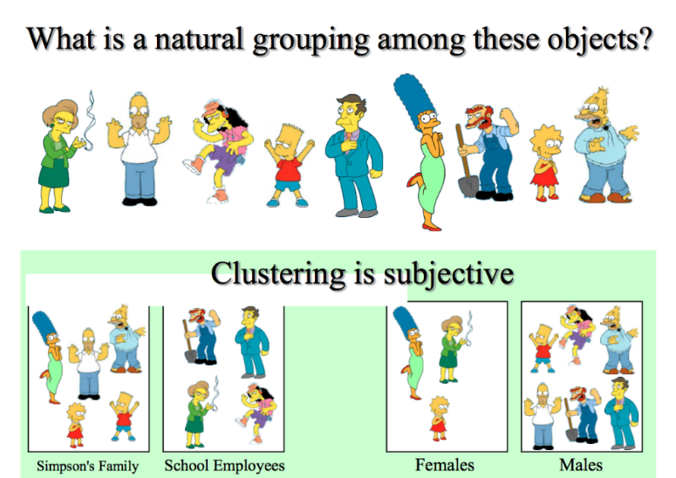Clustering

• Clustering finds **natural groupings** of similar objects.

• To implement clustering, we need **a distance** measure between objects.

e.g. Euclidean measure for 2-D

Number of common friends in a social network

RGB values of 2 pixels …

• Clustering is subjective i.e. it depends on **your** defined distance metric.

Types of Clustering

• A **clustering** is a set of clusters

• Important distinction between **hierarchical and partitional** sets of clusters

• Partitional Clustering

• A division data objects into **non-overlapping** subsets (clusters) such that **each data object is in exactly one subset**

• Hierarchical clustering

• A set of **nested clusters** organized as a hierarchical tree

Partitional Clustering

Note that each data point belongs to only one cluster.

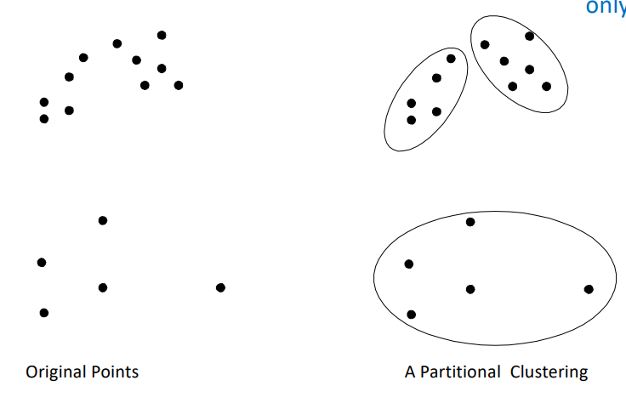

Hierarchical Clustering

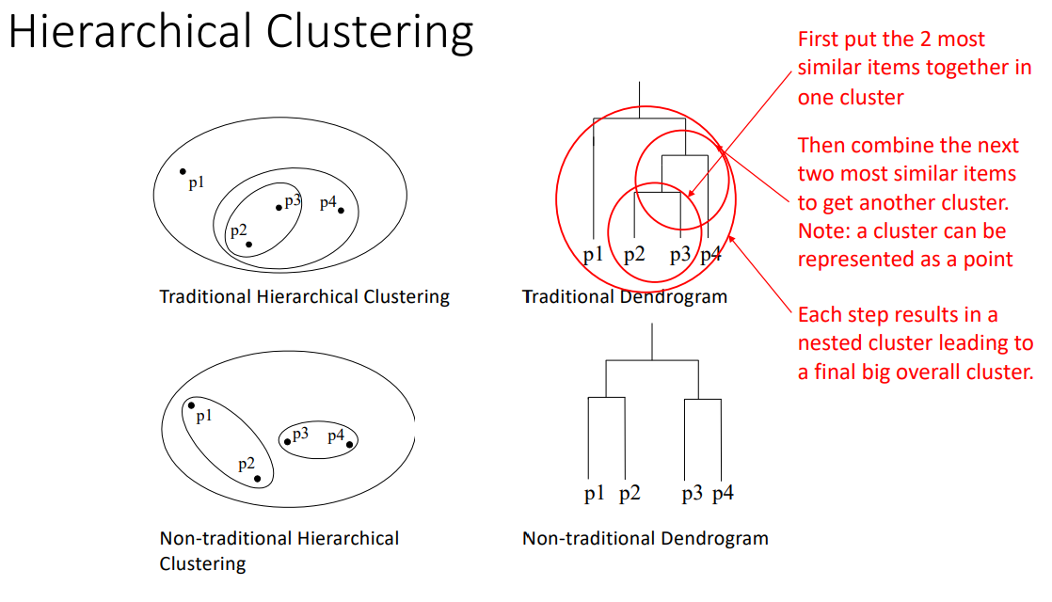

Partitional Clustering

• Let's start with partitional clustering.

• The most famous example of partitional clustering is the k-means algorithm.

• k-means seeks to partition the data into k clusters.

• Each cluster is identified by its **mean (centroid).**

K-means Clustering

• Each cluster is associated with a **centroid** (center point)

• Each data item is assigned to the cluster with the **closest centroid**

• Number of clusters, K, must be specified

• The basic algorithm is very simple

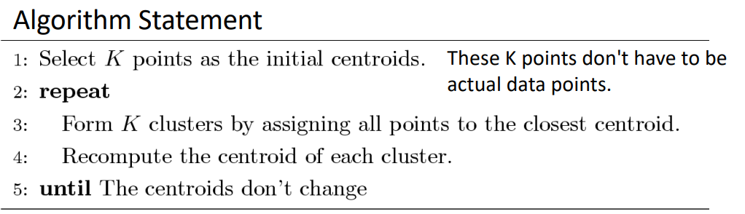

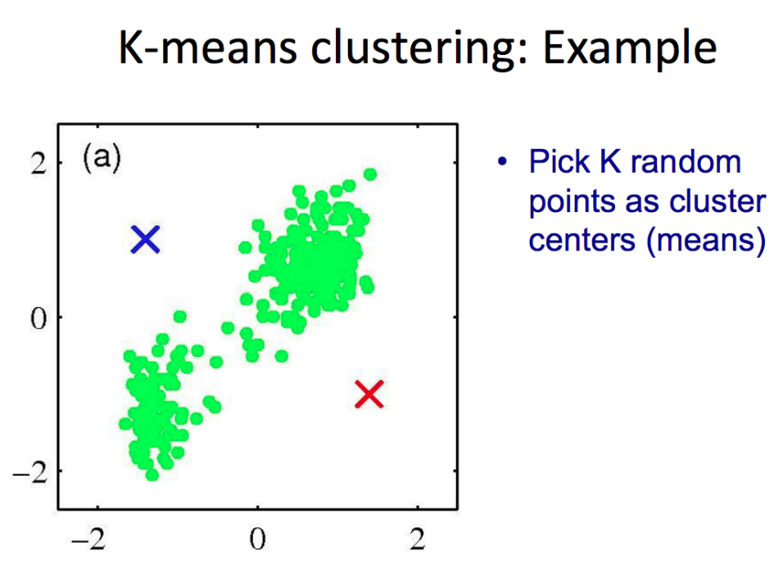

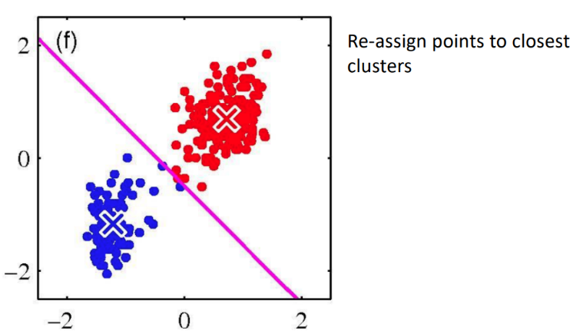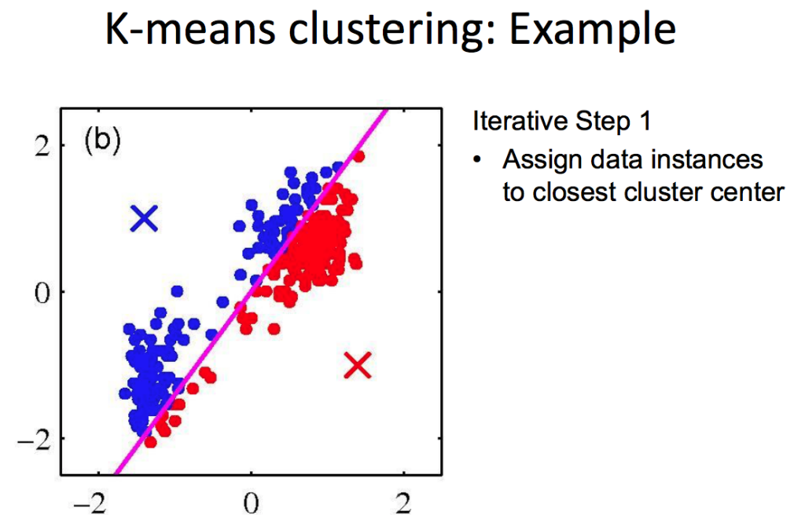

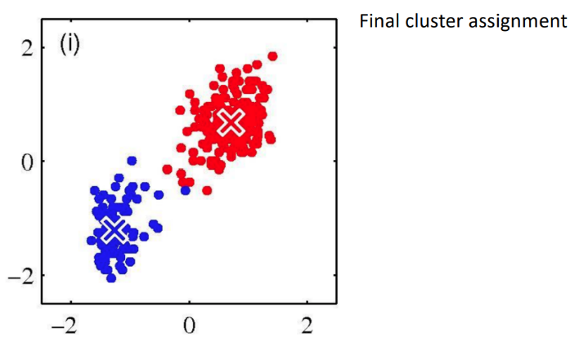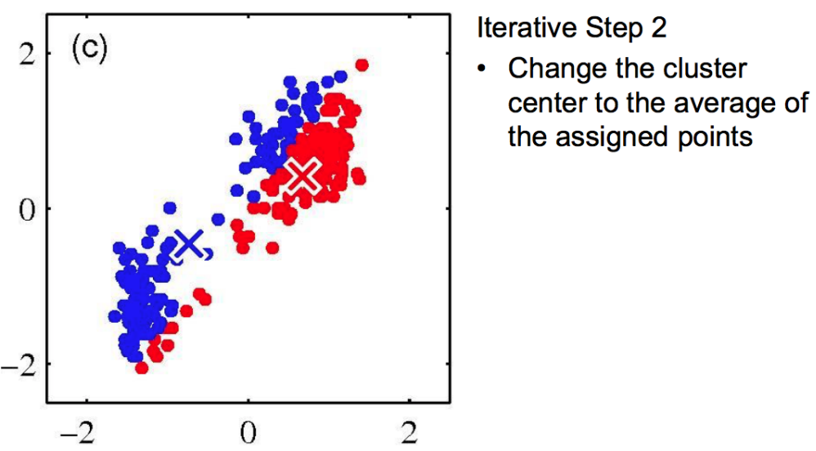

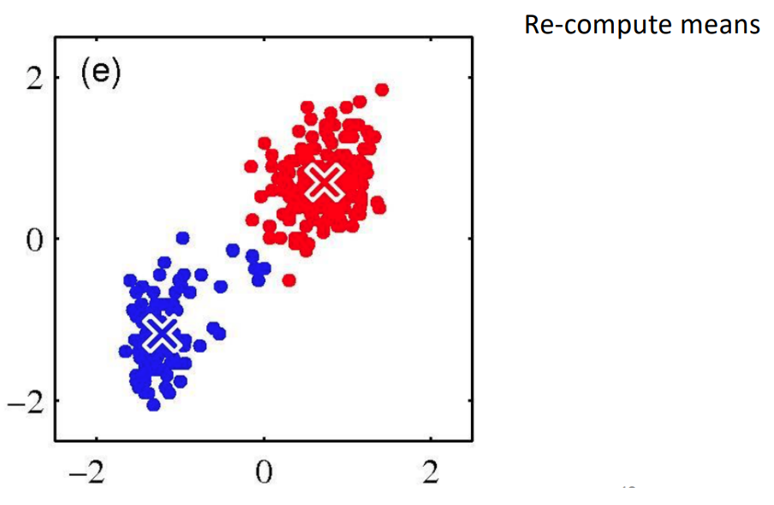

1 Converge? 2. Initialization

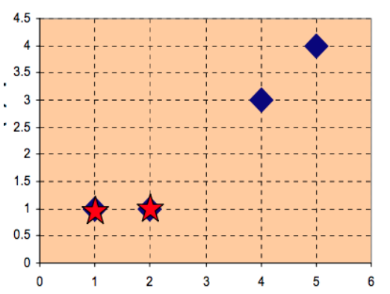K-means Example

Consider the following data points: X1 = (1,1), X2 = (2,1), X3 = (4,3), X4 = (5,4)



Starting with the centers u1 (0) = (1, 1) and u2 (0) = (2, 1), run iterations of k-means on these data points till convergence. Use **Manhattan distance.**



1st iteration:

Assignment Step:

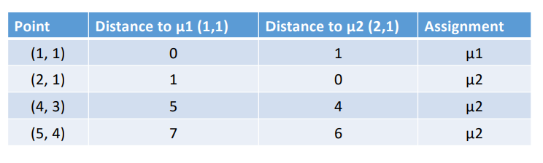

Update Step:

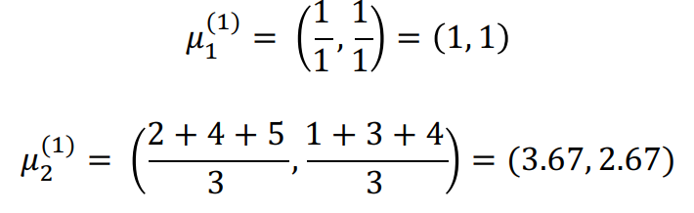

2nd iteration:

Assignment Step:

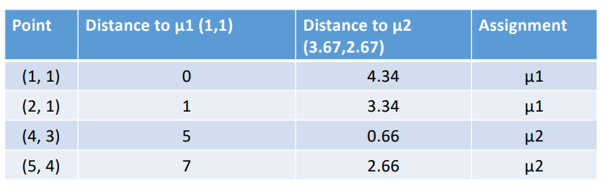

Update Step:

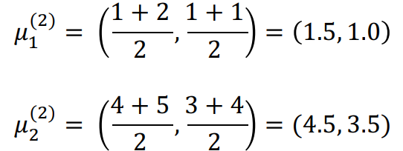

3rd iteration:

Assignment Step:

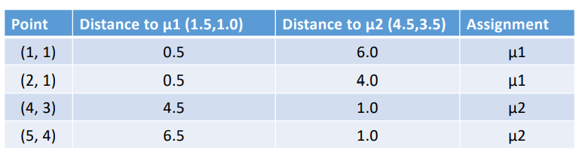

Update Step:

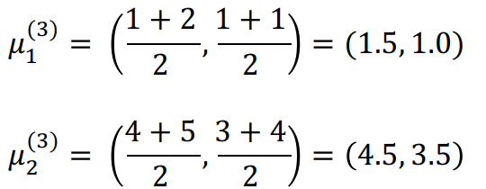

**No change in means, so the algorithm terminates**

K-means Algorithm

• The objective criterion that the algorithm seeks to optimize is: Given n data points, find the assignment of each point xi to one of K clusters, such that the objective function below is minimized.

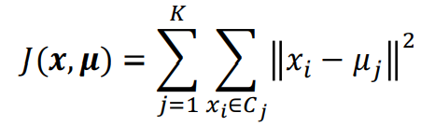

where uj represents the centroid of cluster Cj

• So, there are 2 things that you need to optimize – assignment of data to clusters and centroid of clusters.

K-means Algorithm

• In iterative step 1, we keep the **means fixed** and **re-compute** **assignment**.

• In iterative step 2, we **keep assignment fixed** and **re-compute means**

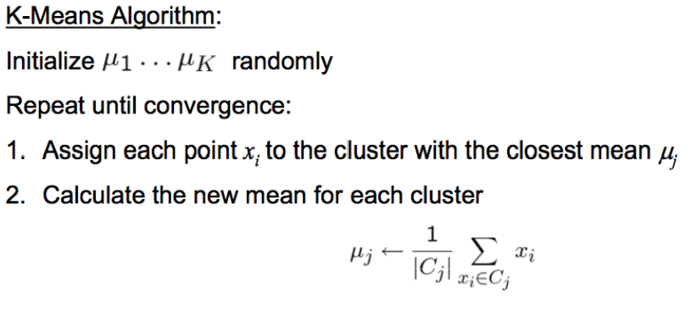

K-means Algorithm

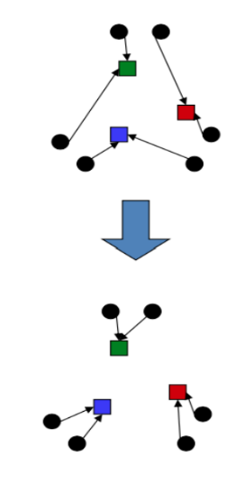• The optimization is a function of 3 parameters – points, assignments, and means. Optimization function 

{xi } is the set of points {aik} is the point-cluster assignment

{ck} is the means of the clusters

• We want to find the 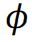 that minimizes the total distance J.

Why k-means works

• **Step 1:** Re-assignment Step Each point gets re-assigned to closest center.

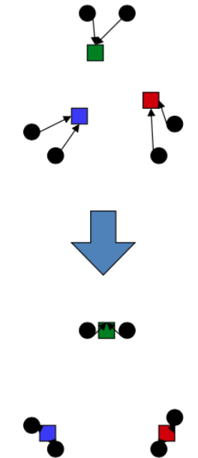• What happens to the total distance?

• It has to go down **as points** move closer to center.

• So, we have reduced J in this step.

• **Step 2**: Re-compute means step Means of each cluster gets re-computed.

• What happens to the total distance?

• It has to go down as **center** moves closer to assigned points

• So, we have reduced J in this step.

K-means

• **Is the algorithm deterministic i.e. do different runs take same number of iterations and exactly the same clustering?** • No, it depends on initialization.

• **How do you find best value of k?**

• It's a parameter. Like other ML algorithms, you need to experiment to find best value.

Strengths of k-means

• Strengths:

• Simple: easy to understand and to implement

• Efficient: Time complexity: O(tkn), where

n is the number of data points,

k is the number of clusters, and

t is the number of iterations.

• Since both k and t are small. k-means is considered a linear algorithm in terms of n .

• K-means is the most popular clustering algorithm.

• Note that: it terminates at a **local optimum** if SSE is used. The **global** **optimum** is hard to find due to complexity.

Weaknesses of k-means

• The algorithm is only applicable if the **mean** is defined.

• For categorical data, k-mode - the centroid is represented by most frequent values.

• The user needs to specify **k**.

• The algorithm is sensitive to **outliers**

• Outliers are data points that are very far away from other data points.

• Outliers could be errors in the data recording or some special data points with very different values.

Weaknesses of k-means: Problems with outliers

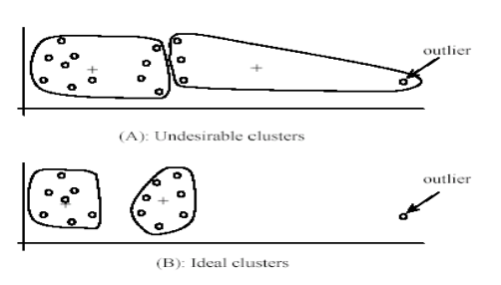

Weaknesses of k-means (cont …)

• The algorithm is sensitive **to initial seeds**.

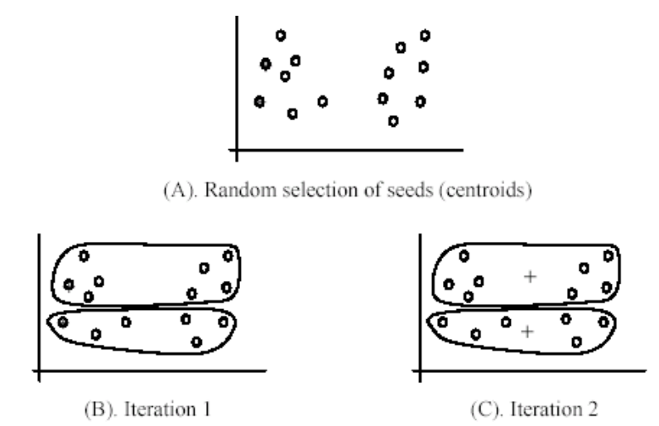

Weaknesses of k-means (cont …)

• If we use **different seeds**: good results

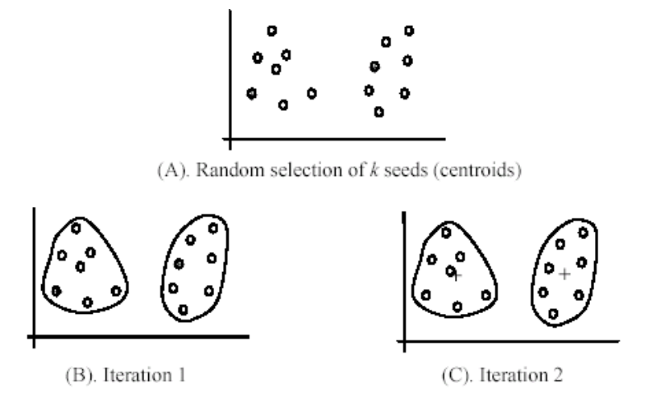

Weaknesses of k-means (cont …)

• The k-means algorithm is not suitable for discovering clusters that are not spherical shapes.

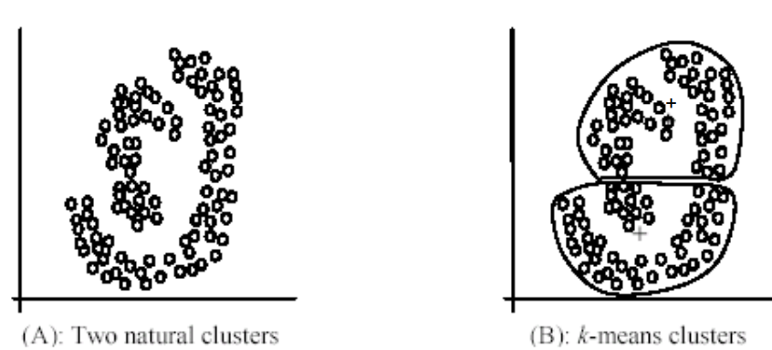

K-means summary

• Despite weaknesses, k-means is still the most popular algorithm due to its simplicity, efficiency and

• other clustering algorithms have their own lists of weaknesses.

• No clear evidence that any other clustering algorithm performs better in general

• although they may be more suitable for some specific types of data or applications.

• Comparing different clustering algorithms is a difficult task. No one knows the correct clusters.

Hierarchical Clustering

• Produces a set of nested clusters organized as a hierarchical tree

• Can be visualized as a dendrogram

• A tree like diagram that records the sequences of merges or splits

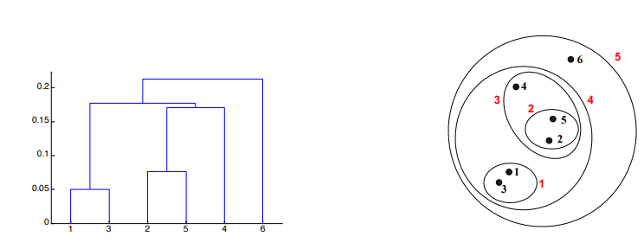

Strengths of Hierarchical Clustering

• Do not have to assume any particular number of clusters

• Any desired number of clusters can be obtained by ʻcuttingʼ the dendogram at the proper level

• They may correspond to meaningful taxonomies

• Example in biological sciences (e.g., animal kingdom, phylogeny reconstruction, …)

Hierarchical Clustering

• Two main types of hierarchical clustering

• Agglomerative:

• Start with the points as individual clusters

• At each step, merge the closest pair of clusters until only one cluster (or k clusters) left

• Divisive:

• Start with one, all-inclusive cluster

• At each step, split a cluster until each cluster contains a point (or there are k clusters)

• Traditional hierarchical algorithms use a similarity or distance matrix

• Merge or split one cluster at a time

Agglomerative Clustering Algorithm

• More popular hierarchical clustering technique

• Basic algorithm is straightforward

1. Compute the proximity matrix

2. Let each data point be a cluster

3. **Repeat**

4. Merge the two closest clusters

5. Update the proximity matrix

6. **Until** only a single cluster remains

• Key operation is the computation of the proximity of two clusters

• Different approaches to defining the distance between clusters distinguish the different algorithms

Starting Situation

• Start with clusters of individual points and a proximity matrix

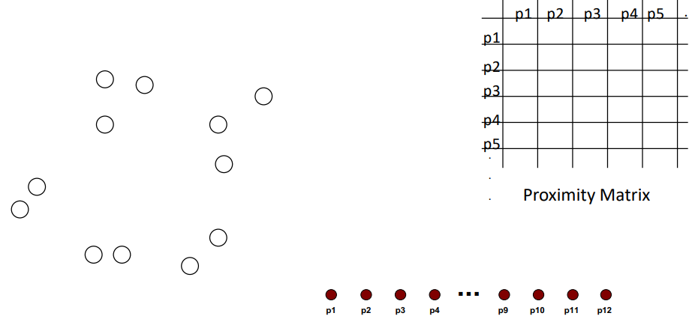

Intermediate Situation

• After some merging steps, we have some clusters

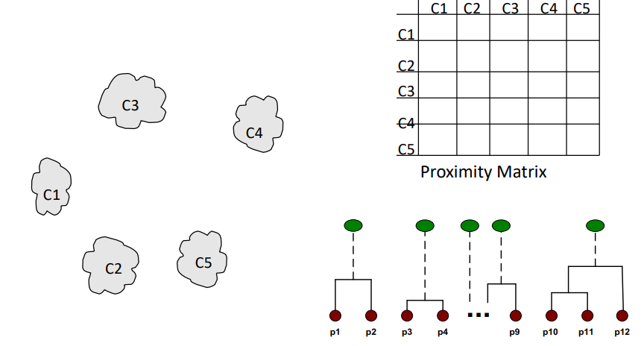

• We want to merge the two closest clusters (C2 and C5) and update the proximity matrix.

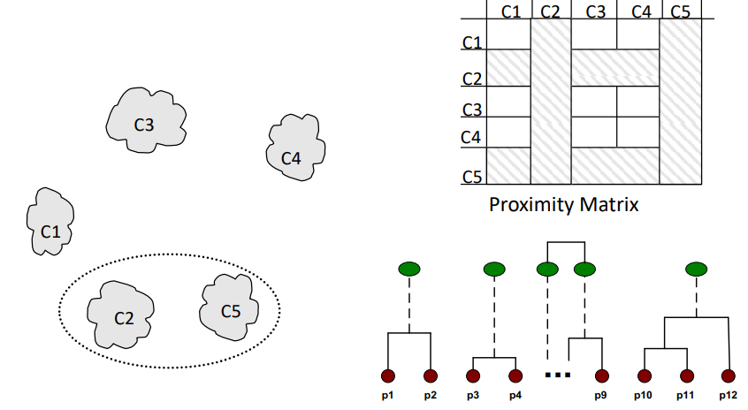

After Merging

• The question is “How do we update the proximity matrix?”

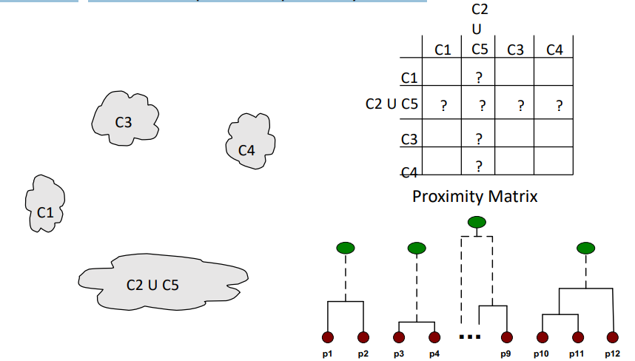

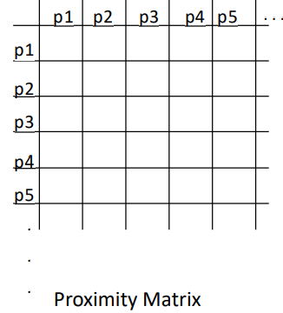How to Define Inter-Cluster Similarity

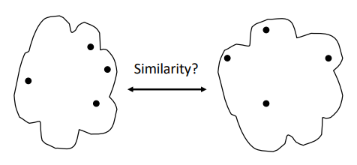

● MIN (Single Link)

● MAX (Complete Link)

● Group Average (Average Link)

● Distance Between Centroids

● Other methods driven by an objective function

– Wardʼs Method uses squared error

How to Define Inter-Cluster Similarity

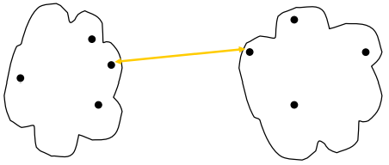

**● MIN (Single Link)**

● MAX (Complete Link)

● Group Average (Average Link)

● Distance Between Centroids

● Other methods driven by an objective function

– Wardʼs Method uses squared error

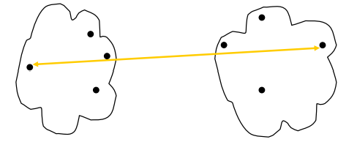

● MIN (Single Link)

**● MAX (Complete Link)**

● Group Average (Average Link)

● Distance Between Centroids

● Other methods driven by an objective function

– Wardʼs Method uses squared error

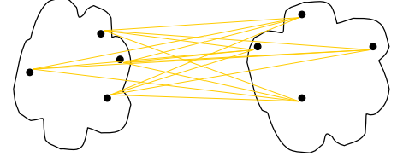

● MIN (Single Link)

● MAX (Complete Link)

**● Group Average (Average Link)**

● Distance Between Centroids

● Other methods driven by an objective function

– Wardʼs Method uses squared error

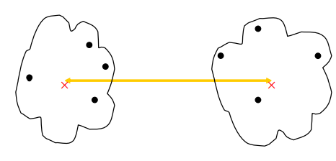

● MIN (Single Link)

● MAX (Complete Link)

● Group Average (Average Link)

**● Distance Between Centroids**

● Other methods driven by an objective function

– Wardʼs Method uses squared error

MIN or Single Link

• Proximity of two clusters is based on the two closest points in the different clusters

• Determined by one pair of points, i.e., by one link in the proximity graph

• Example:

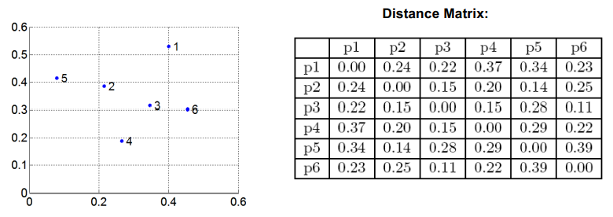

Hierarchical Clustering: MIN

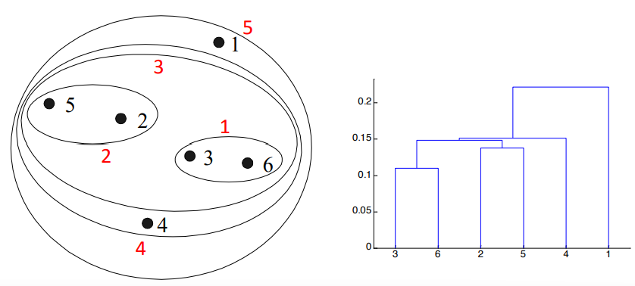

MAX or Complete Linkage

• Proximity of two clusters is based on the two most distant points in the different clusters

• Determined by all pairs of points in the two clusters

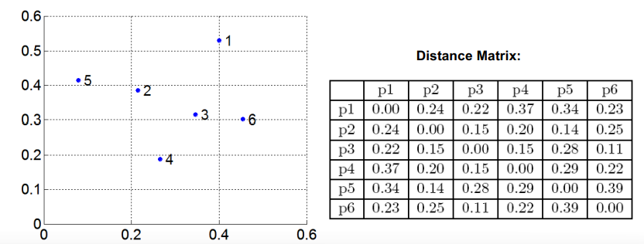

Hierarchical Clustering: MAX

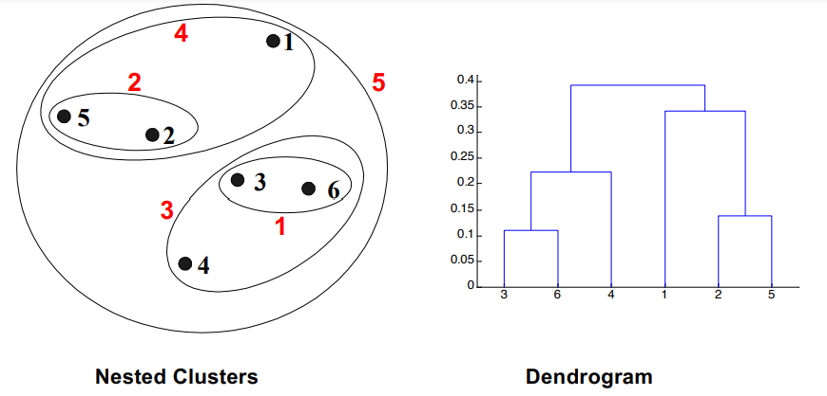

Group Average

• Proximity of two clusters is the average of pairwise proximity between points in the two clusters.

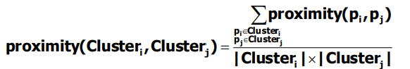

• Need to use average connectivity for scalability since total proximity favors large clusters

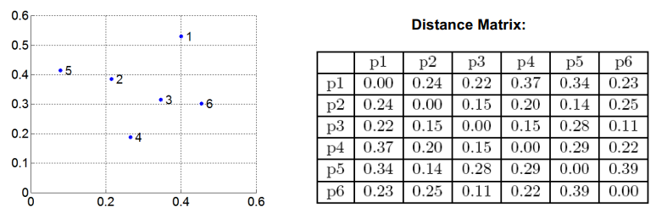

Hierarchical Clustering: Group Average

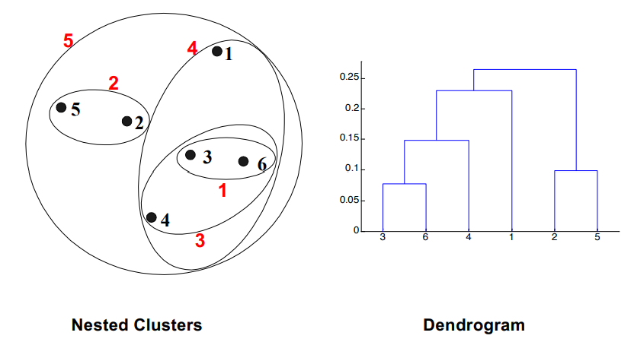

Hierarchical Clustering: Group Average

• Compromise between Single and Complete Link

• Strengths • Less susceptible to noise and outliers

• Limitations • Biased towards globular clusters

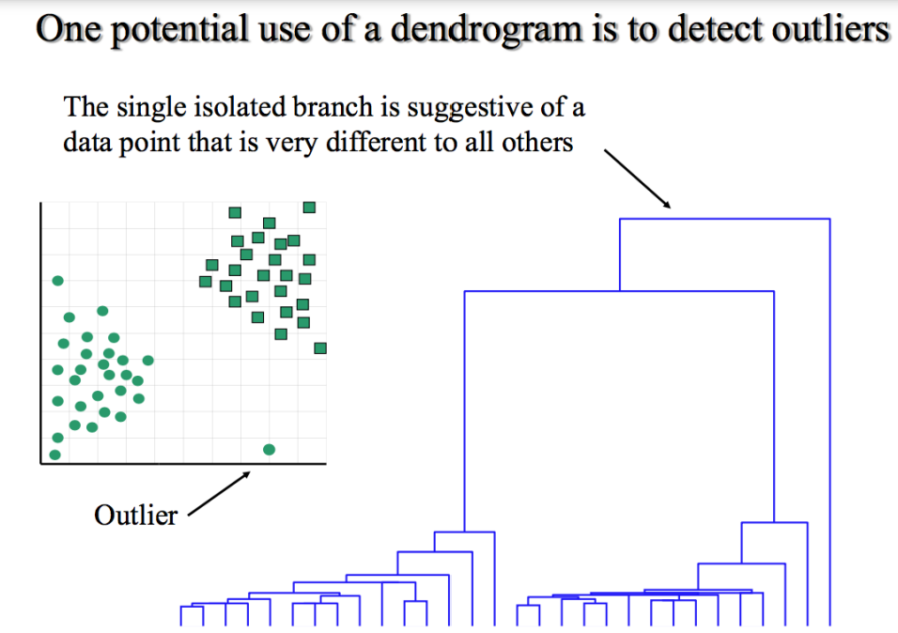

Hierarchical Clustering: Problems and Limitations

• Once a decision is made to combine two clusters, it cannot be undone

• No objective function is directly minimized

• Different schemes have problems with one or more of the following:

• Sensitivity to noise and outliers

• Difficulty handling different sized clusters and convex shapes

• Breaking large clusters

Soft Clustering – Expectation Maximization (EM)

• Clustering typically assumes that each instance is given a "hard" assignment to exactly one cluster.

• Does not allow uncertainty in class membership or for an instance to belong to more than one cluster.

• Problematic because data points that lie roughly midway between cluster centers are assigned to one cluster

**• Soft clustering** gives **probabilities** that an instance belongs to each of a set of clusters.

• Let's see how data is generated.

Gaussian Mixture Models

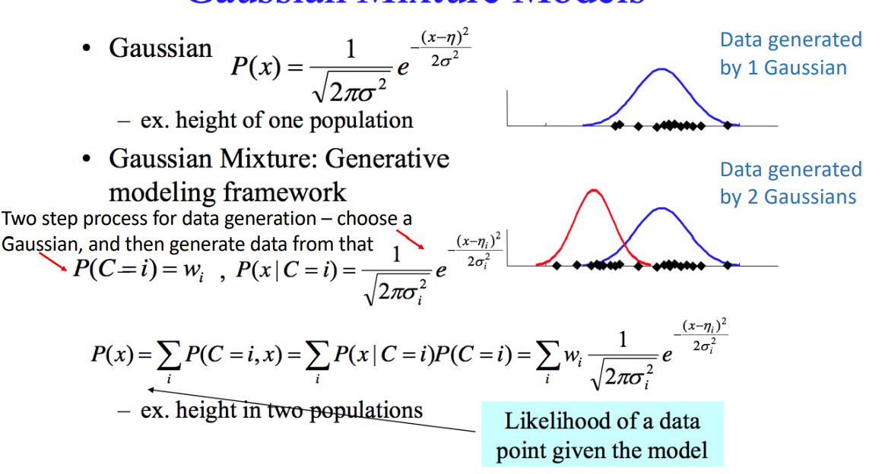

GMM: A generative Model

Problem is that we don't know the probability of each component (wi ) or parameters for each Gaussian. So how do we proceed? Random initialization

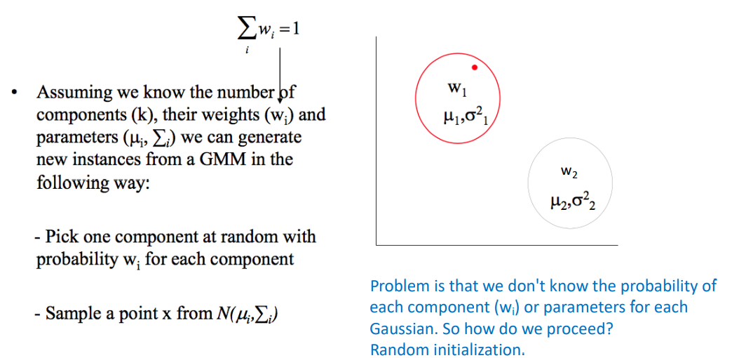

Estimating model parameter

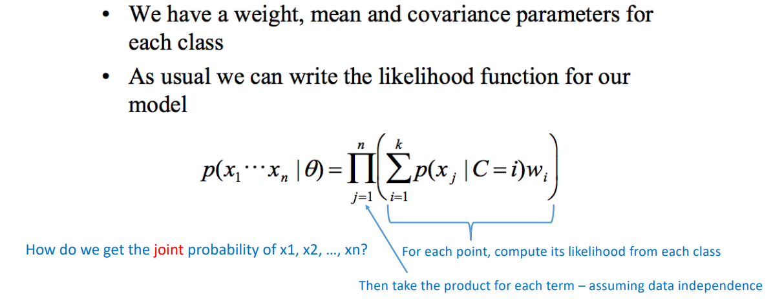

EM algorithm: key Idea

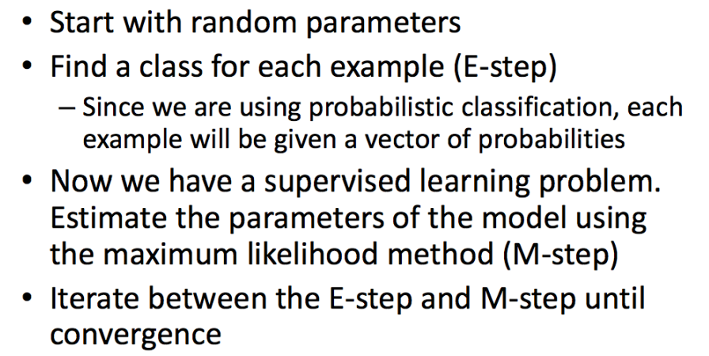

GMM + EM = “Soft K-means”  
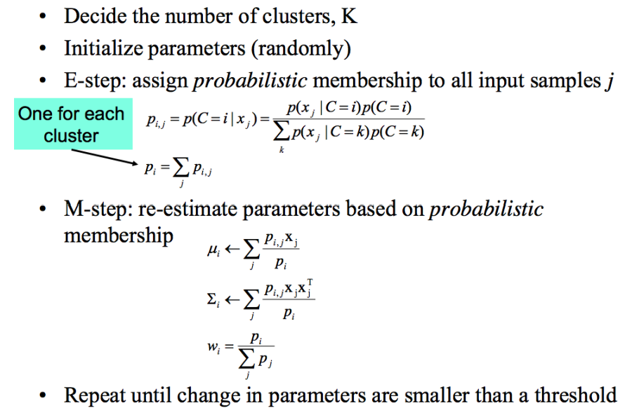

Gaussian Mixture Example: Start

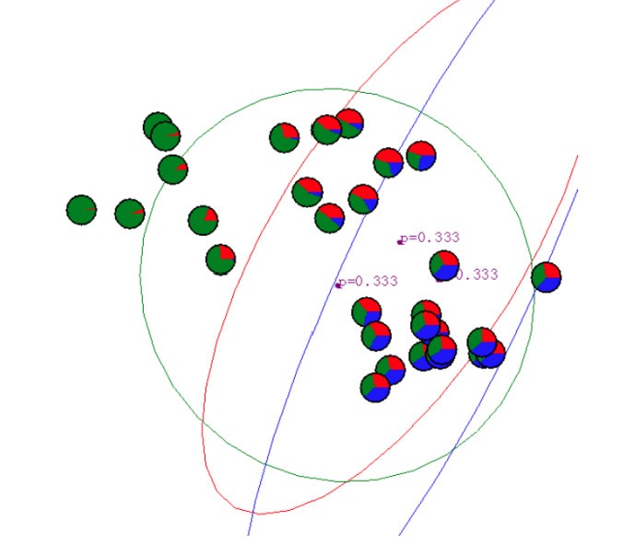

After first iteration

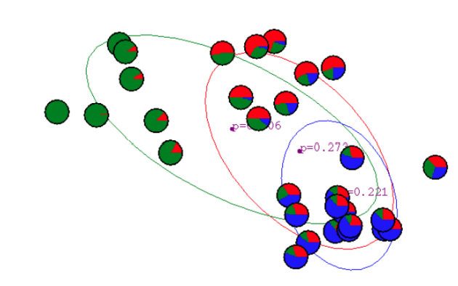

After 2nd iterator

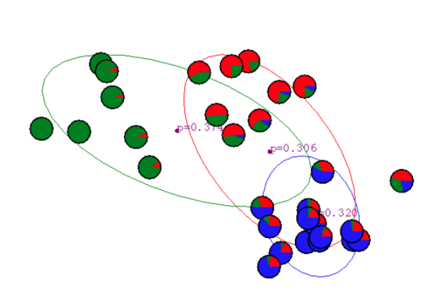

After 3rd iteration

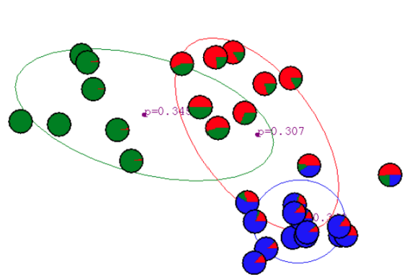

After 4th iteration

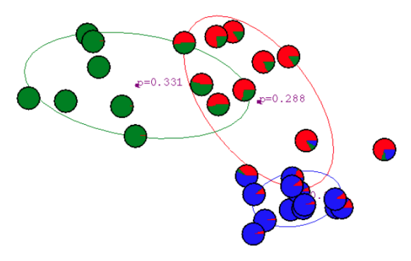

After 5th iteration

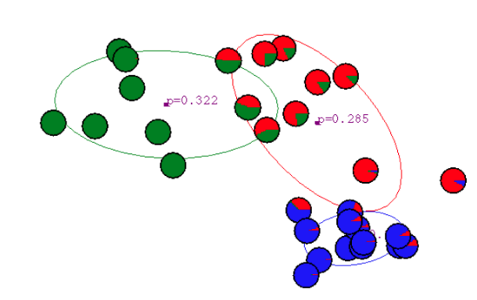

After 6th iteration

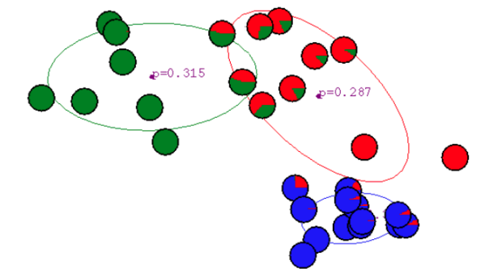

After 20th iteration

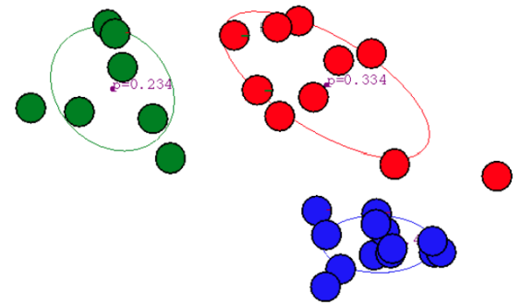

Algorithm: K – means and GMM

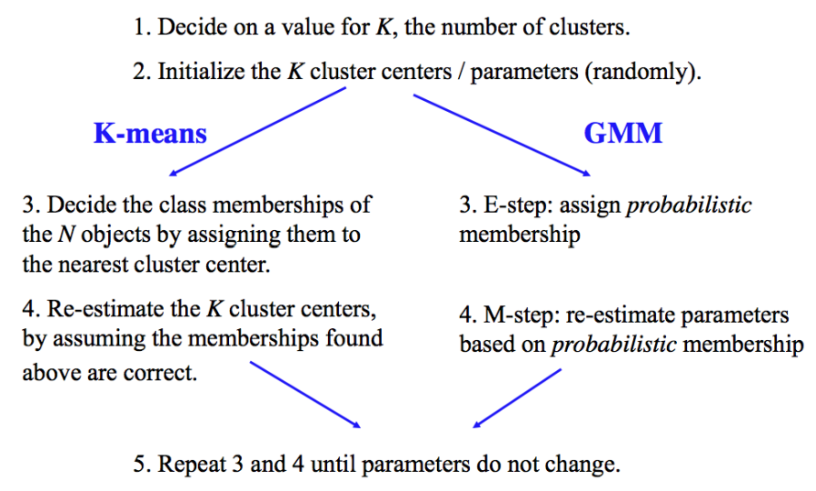

Properties of EM

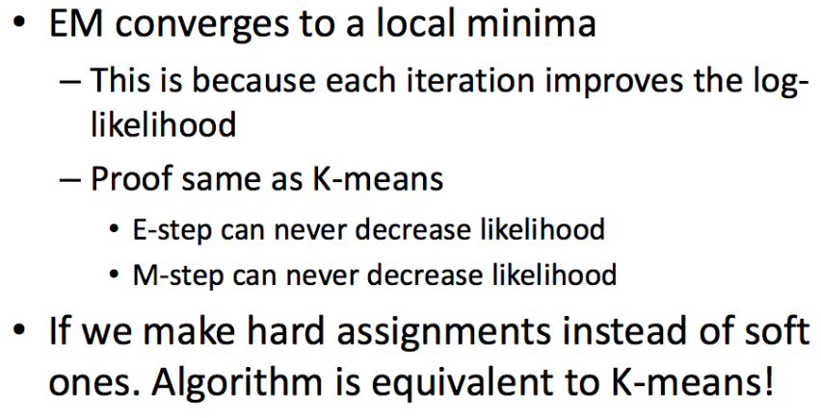

Clustering methods: Comparison

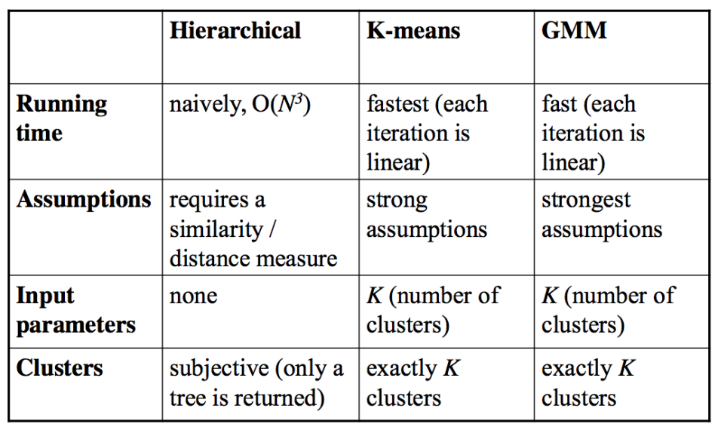

What you should know

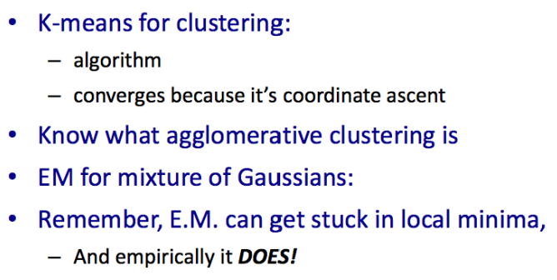

SEP software engineer Program

**Principal Components Analysis (PCA)**

**PCA**

• Not all features (attributes) collected are independent.

• In fact, many attributes are highly correlated e.g. height and weight, total height and head height, attendance and GPA

• We can compact the data by choosing a new attribute that is a linear combination of the correlated factors

Data Compression

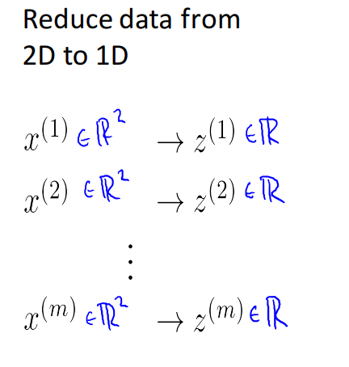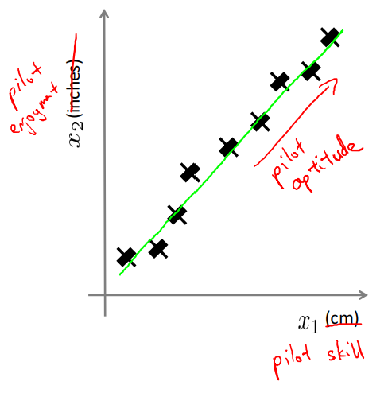

Reduce data from 2D to 1D

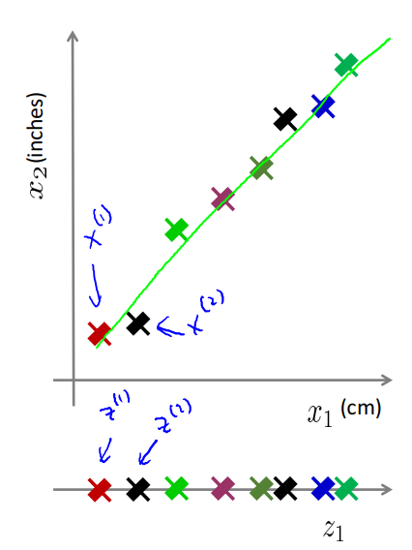

Principle components analysis

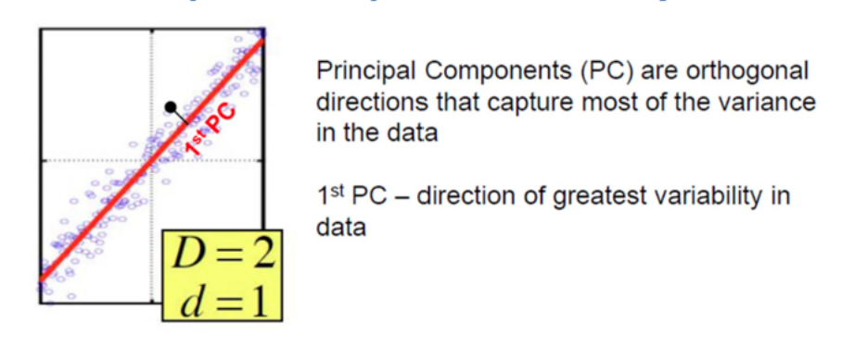

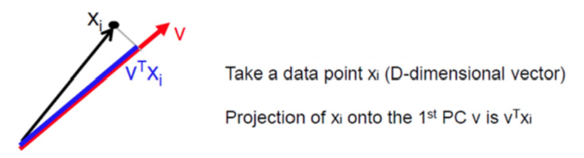

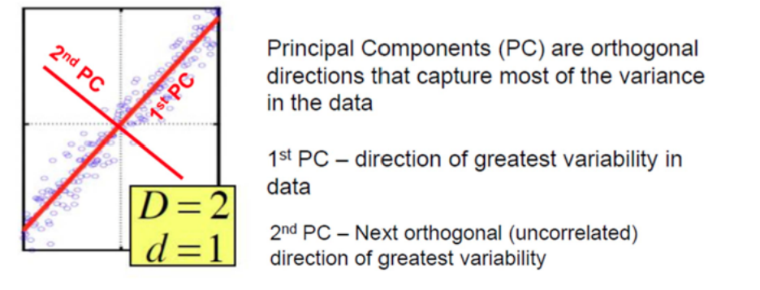

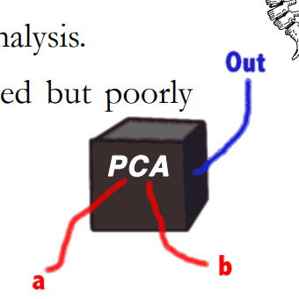PCA is …

• A backbone of modern data analysis.

• A black box that is widely used but poorly understood.

OK … let’s dispel the magic behind this black box

PCA - Overview

• It is a mathematical tool from applied linear algebra.

• It is a simple, non-parametric method of **extracting** relevant information from confusing data sets.

• It provides a roadmap for how to **reduce** a complex data set to a lower dimension.

What do we need under our BELT?!!!

• Basics of statistical measures, e.g. variance and covariance.

• Basics of linear algebra: – Matrices – Vector space – Basis – Eigen vectors and eigen values

Variance

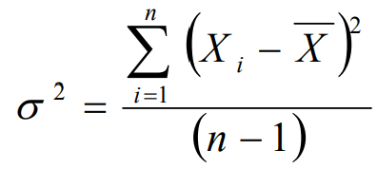• A measure of the spread of the data in a data set with mean 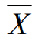

• Variance is claimed to be the original statistical measure of spread of data.

Covariance

• Variance – measure of the deviation from the mean for points in one dimension, e.g., heights

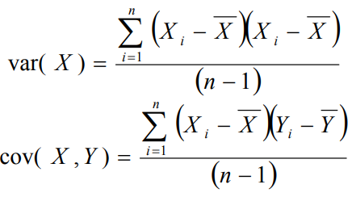• Covariance – a measure of how much **each of the dimensions** varies from the mean **with respect to each other**.

• Covariance is measured between 2 dimensions to see if there is a relationship between the 2 dimensions, e.g., number of hours studied and grade obtained.

• The covariance between one dimension and itself is the variance.

Covariance Should has small ideally = 0

• What is the interpretation of covariance calculations?

• Say you have a 2-dimensional data set

– X: number of hours studied for a subject

– Y: marks obtained in that subject

• And assume the covariance value (between X and Y) is: 104.53

• What does this value mean?

Covariance

• Exact value is not as important as its sign.

• A **positive value** of covariance indicates that **both dimensions increase or decrease together**, e.g., as the number of hours studied increases, the grades in that subject also increase.

• A **negative value** indicates **while one increases the other decreases**, or vice-versa, e.g., active social life vs. performance in ECE Dept.

• If **covariance is zero**: the two dimensions **are independent** of each other, e.g., heights of students vs. grades obtained in a subject.

Covariance

• Why bother with calculating (expensive) covariance when we could just plot the 2 values to see their relationship?

Covariance calculations are used to find relationships between dimensions in high dimensional data sets (usually greater than 3) where visualization is difficult.

Covariance Matrix

• Representing covariance among dimensions as a matrix, e.g., for 3 dimensions:

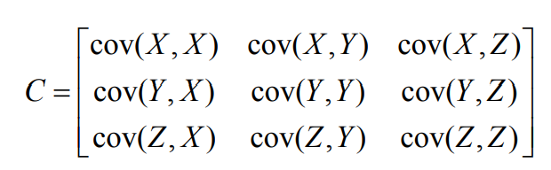

• Properties:

– Diagonal: variances of the variables

– cov(X,Y)=cov( Y,X), hence matrix is symmetrical about the diagonal (upper triangular)

– m-dimensional data will result in mx m covariance matrix

Covariance Matrix

• Covariance matrix C is square and symmetric.

• Our aim is to convert C to a diagonal matrix.

• If we convert given matrix X to be a zero mean one, then we can define C as

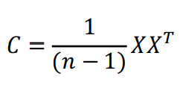

where XT is the transpose of X.

Covariance Matrix

Theorem from Linear Algebra: In linear algebra, a square matrix A is called **diagonalizable** if it is similar to a diagonal matrix, i.e., if there exists an invertible matrix P such that P−1AP is a diagonal matrix. That is, we can discover a diagonal matrix D such that: D = P−1AP.

Covariance Matrix

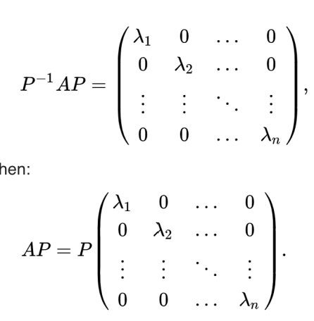

Covariance Matrix

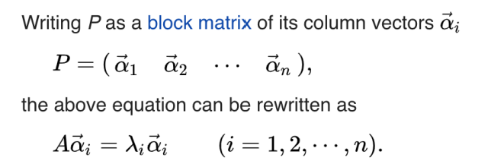

What does this remind us of? Eigenvectors 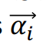 and eigenvalues 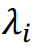

So the column vectors of P are eigenvectors of A, and the corresponding diagonal entry is the corresponding eigenvalue.

**Now … Let’s go back PCA**

Example of a problem

• We collected m parameters about 100 students: – Height – Weight – Hair color – Average grade – …

• We want to find the most important parameters that best describe a student.

• Each student has a vector of data which describes him of length m: – (180,70,’purple’,84,…)

• We have n = 100 such vectors. Let’s put them in one matrix, where each column is one student vector.

• So we have a mxn matrix. This will be the input of our problem.

Which parameters can we ignore?

• **Constant** parameter (number of heads)

– 1,1,…,1.

• Constant parameter with **some noise** - (thickness of hair)

– 0.003, 0.005,0.002,….,0.0008 -> low variance

• Parameter that **is linearly dependent** on other parameters (head size and height)

– Z= aX + bY

Which parameters do we want to keep?

• Parameter that doesn’t depend on others (e.g. eye color), i.e. uncorrelated -> low covariance.

• Parameter that changes a lot (grades) – The opposite of noise – High variance

Covariance Matrix

• Assuming zero mean data (subtract the mean), consider the indexed vectors { x1, x2, …, x m} which are the rows of an mxn matrix X.

• Each row corresponds to all measurements of a particular measurement type or attribute (xi).

• Each column of X corresponds to a set of measurements from particular instance or example.

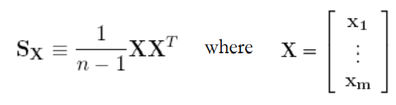• We now arrive at a definition for the covariance matrix SX.

Covariance Matrix

• The ijth element of the variance is the dot product between the vector of the ith measurement type with the vector of the jth measurement type.

– S X is a square symmetric m×m matrix.

– The diagonal terms of S X are the variance of particular measurement types.

– The off-diagonal terms of S X are the covariance between measurement types.

Diagonalize the Covariance Matrix

Our goals are to find the covariance matrix that:

1. Minimizes redundancy, measured by covariance. (off-diagonal), i.e. we would like each variable to co-vary as little as possible with other variables.

2. Maximizes the signal, measured by variance. (the diagonal)

Since covariance is non-negative, the optimized covariance matrix will be a diagonal matrix

Diagonalize the Covariance Matrix PCA Assumptions

• PCA assumes that all basis **vectors {p 1,...,p m }** are orthonormal (i.e. p i · pj = δij).

• Hence, in the language of linear algebra, PCA assumes **P** is an orthonormal matrix.

• Secondly, PCA assumes the directions with the largest variances are the most “important” or in other words, most principal.

• Why are these assumptions easiest?

Solving PCA: Eigen Vectors of Covariance Matrix

• We will derive our first algebraic solution to PCA using linear algebra. This solution is based on an important property **of eigenvector decomposition**.

• Once again, the data set is **X**, an m×n matrix, where m is the number of measurement types and n is the number of data trials.

• The goal is summarized as follows: – Find some orthonormal matrix **P** where **Y = PX** such that is 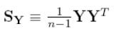 diagonalized. The rows of **P** are the principal components of **X**.

PCA Process – STEP 1

• **Subtract the mean from each of the dimensions**

• This produces a data set whose mean is zero.

• Subtracting the mean makes variance and covariance calculation easier by simplifying their equations.

• The variance and co-variance values are not affected by the mean value.

• Suppose we have two measurement types **X 1** and **X 2**, hence m = 2, and ten samples each, hence n = 10.

Principal Component Analysis (PCA)

Steps in PCA: #1 Calculate Adjusted Data Set

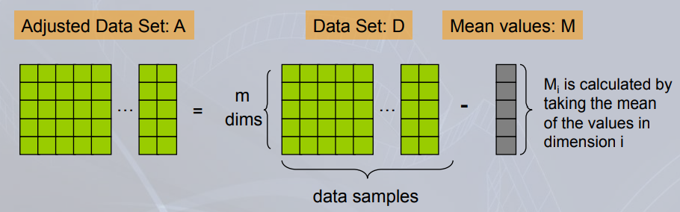

PCA Process – STEP 1

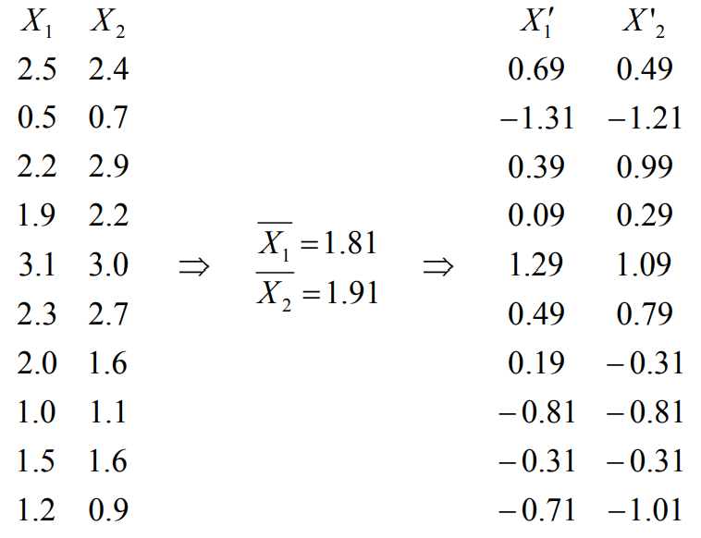

PCA Process – STEP 2

• Calculate the covariance matrix

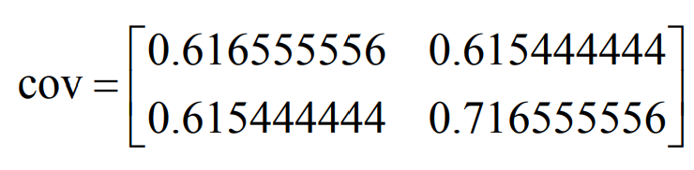

• Since the non-diagonal elements in this covariance matrix are positive, we should expect that both the **X 1** and **X 2** variables increase together.

• Since it is symmetric, we expect the eigenvectors to be orthogonal.

Principal Component Analysis (PCA)

Steps in PCA: #2 Calculate Co-variance matrix, C, from Adjusted Data Set, A

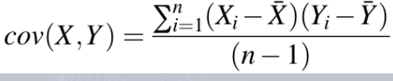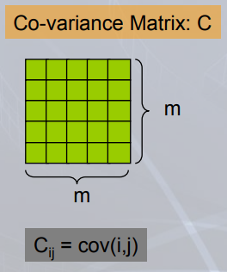

Note: Since the means of the dimensions in the adjusted data set, A, are 0, the covariance matrix can simply be written as: C = (A AT) / (n-1)

PCA Process – STEP 3

• Calculate the eigenvectors and eigenvalues of the covariance matrix

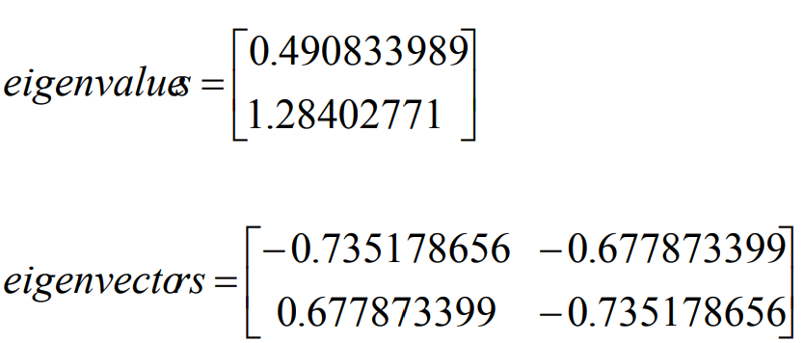

Principal Component Analysis (PCA)

Steps in PCA: #3 Calculate eigenvectors and eigenvalues of C

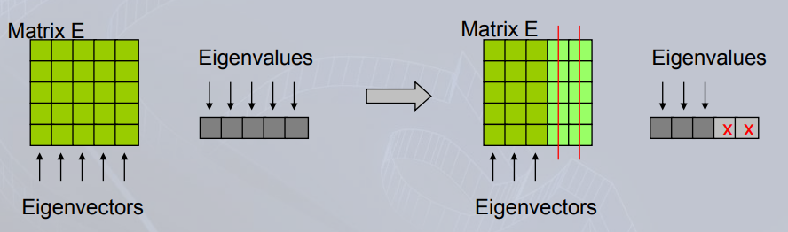

If some eigenvalues are 0 or very small, we can essentially discard those eigenvalues and the corresponding eigenvectors, hence reducing the dimensionality of the new basis.

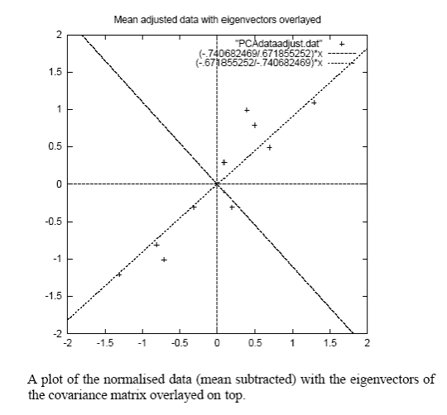PCA Process – STEP 3

Eigenvectors are plotted as diagonal dotted lines on the plot. (note: they are perpendicular to each other).

One of the eigenvectors goes through the middle of the points, like drawing a line of best fit.

The second eigenvector gives us the other, less important, pattern in the data, that all the points follow the main line, but are off to the side of the main line by some amount.

PCA Process – STEP 4

• Reduce dimensionality and form feature vector

The eigenvector with the highest eigenvalue is the principal component of the data set.

In our example, the eigenvector with the largest eigenvalue is the one that points down the middle of the data.

Once eigenvectors are found from the covariance matrix, the next step is to order them by eigenvalue, highest to lowest. This gives the components in order of significance.

PCA Process – STEP 4

Now, if you’d like, you can decide to ignore the components of lesser significance.

You do lose some information, but if the eigenvalues are small, you don’t lose much

• **m** dimensions in your data

• calculate **m** eigenvectors and eigenvalues

• choose only the first r eigenvectors

• final data set has only r dimensions.

**PCA Process – STEP 4**

• When the λi’s are sorted in descending order, the proportion of variance explained by the r principal components is:

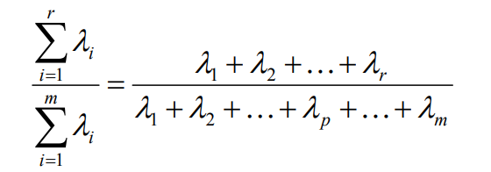

• If the dimensions are highly correlated, there will be a small number of eigenvectors with large eigenvalues and r will be much smaller than m.

• If the dimensions are not correlated, r will be as large as m and PCA does not help

PCA Process – STEP 4

• Feature Vector FeatureVector = (λ1 λ 2 λ 3 … λ r ) (take the eigenvectors to keep from the ordered list of eigenvectors, and form a matrix with these eigenvectors in the columns)

We can either form a feature vector with both of the eigenvectors:

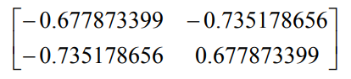

or, we can choose to leave out the smaller, less significant component and only have a single column:

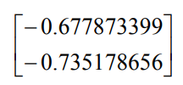

PCA Process – STEP 5

• Derive the new data

**FinalData = RowFeatureVector x RowZeroMeanData**

**RowFeatureVector** is the matrix with the eigenvectors in the columns transposed so that the eigenvectors are now in the rows, with the most significant eigenvector at the top.

**RowZeroMeanData** is the mean-adjusted data transposed, i.e., the data items are in each column, with each row holding a separate dimension.

• **FinalData** is the final data set, with data items in columns, and dimensions along rows.

• What does this give us? The original data solely in terms of the vectors we chose.

• We have changed our data from being in terms of the axes **X 1** and **X 2**, to now be in terms of our 2 eigenvectors.

**PCA Process – STEP 5**

FinalData (transpose: dimensions along columns)

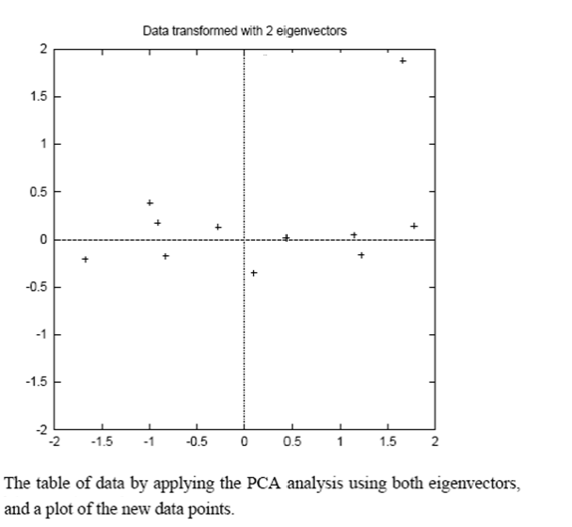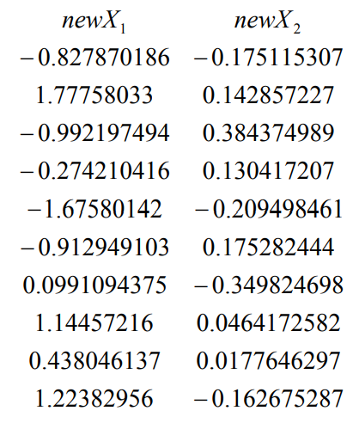

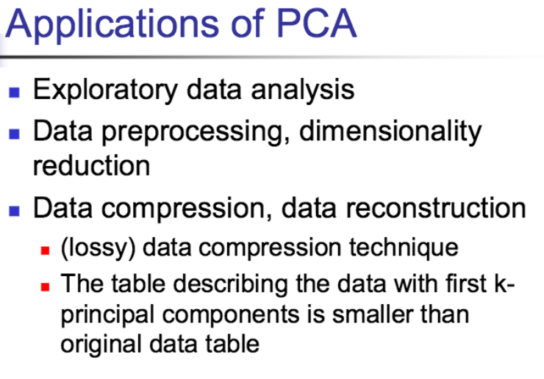

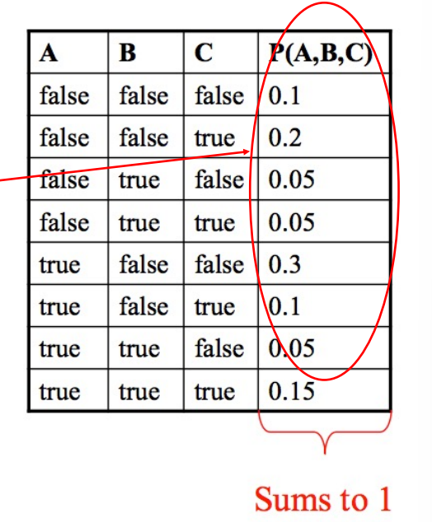**Bayes Net**

Conditional Independence

Joint Probability

• To represent the joint probability of n Booleans, I need a table with **2n** rows filled.

• Need **2n - 1** parameters.

• What if we don't have enough data or resources to estimate that many parameters?

• Variable Independence to the rescue.

Independence

Variables A and B are independent if any of the following hold:

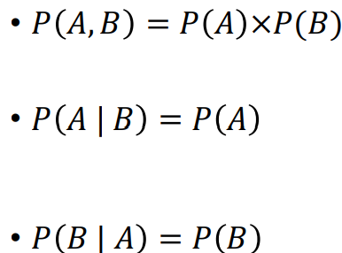

This says that knowing the outcome of A does not tell me anything new about the outcome of B.

Independence

• How does independence help us?

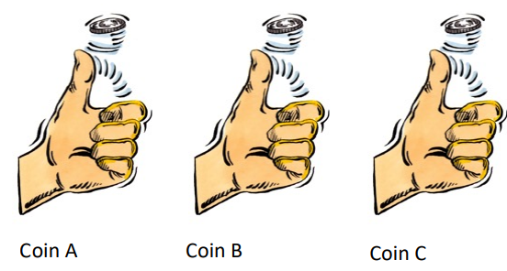• Suppose you flip n coins. If they were **dependent**, you would need a joint distribution. Example: If A = head, B = head, to find probability of C = heads, you would need to look up the table.

If you assume that all the coin throws **are independent**, it makes it very easy.

P(A=H, B=H, C=H) = P(A=H) P(B=H) P(C=H)

**Joint probability is simply product of individual probabilities**.

Independence

• Suppose I have n Boolean events (C1, C2, …, Cn) that are independent, their joint probability can be expressed as: 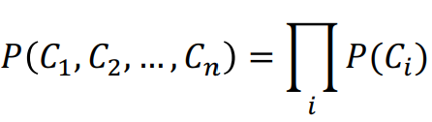

Each Ci has its own table: 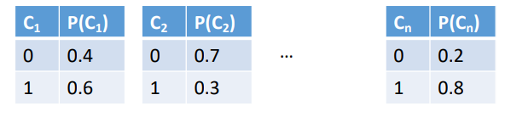

• Total of n tables, 2n entries, and n parameters.

Conditional Independence

Variables A and B are conditionally independent given C, if any of the following hold:

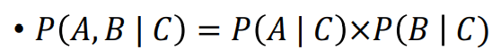

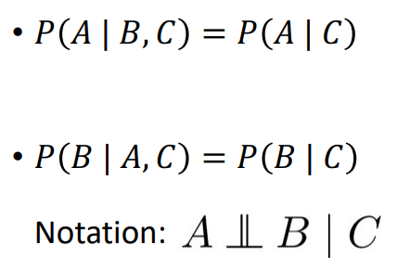

Knowing C tells me everything about B. I don’t gain anything by knowing A (either because A doesn’t influence B or because knowing C provides all the information knowing A would give)

Conditional Independence

• In real life, the scenario is somewhere in between **total dependence** and **total independence**.

• Some variables may be dependent, while others may not be.

• We need a way to represent these relationships.

• This is where Bayesian networks come in.

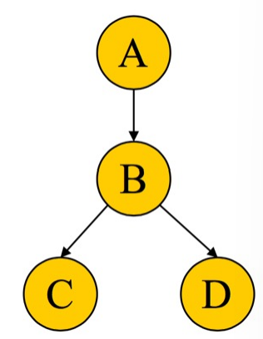Bayesian Network

• A Bayes Net is made up of:

1. A Directed Acyclic Graph (DAG) representing dependencies

2. A set of tables for each node.

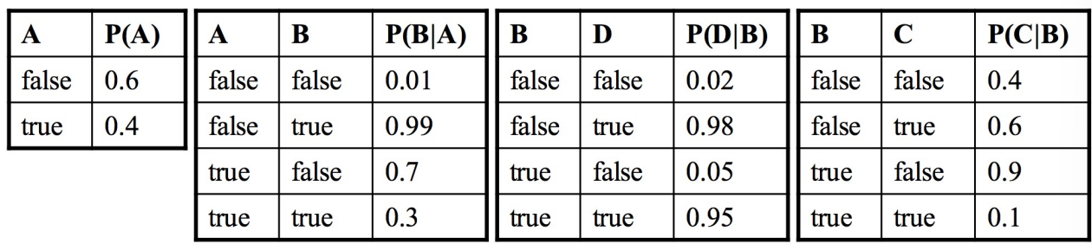

DAG

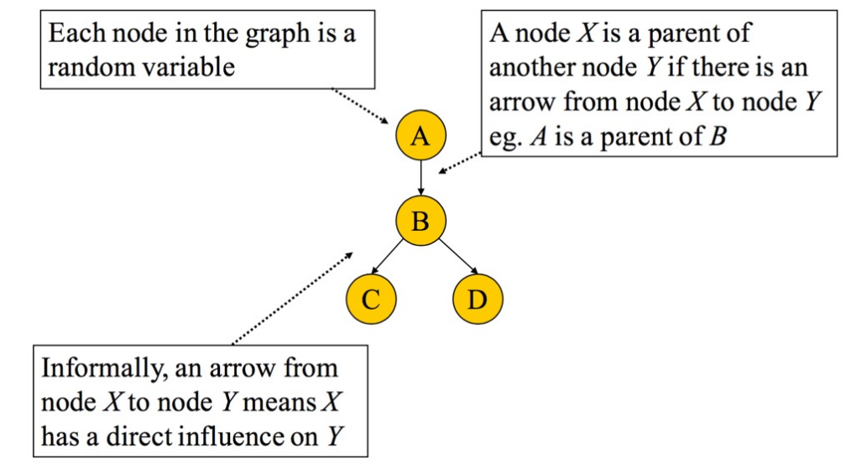

A Set of Tables for Each Node

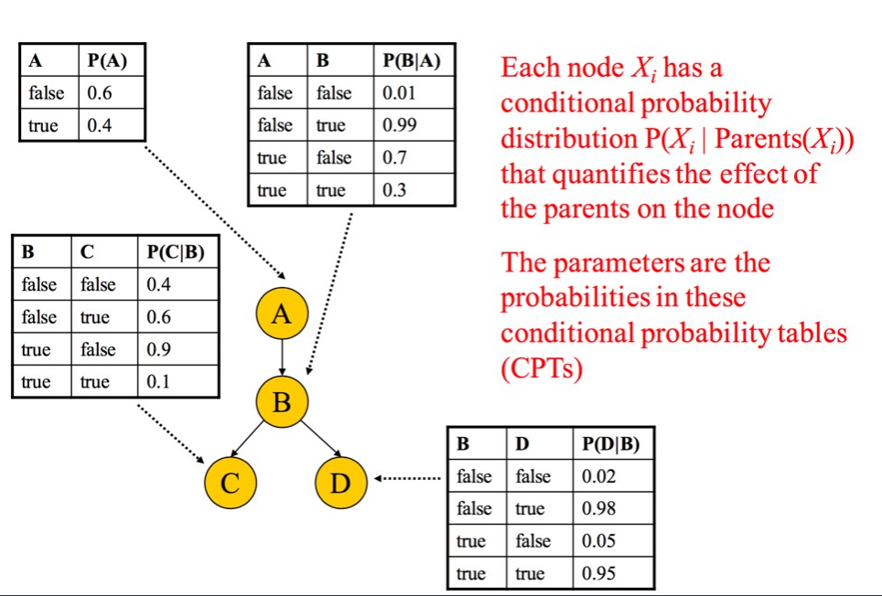

A Set of Tables for Each Node

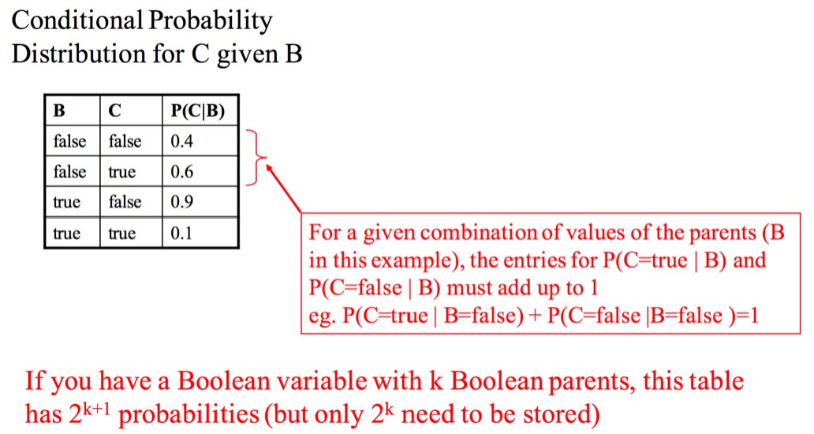

Conditional Independence using Bayes Net

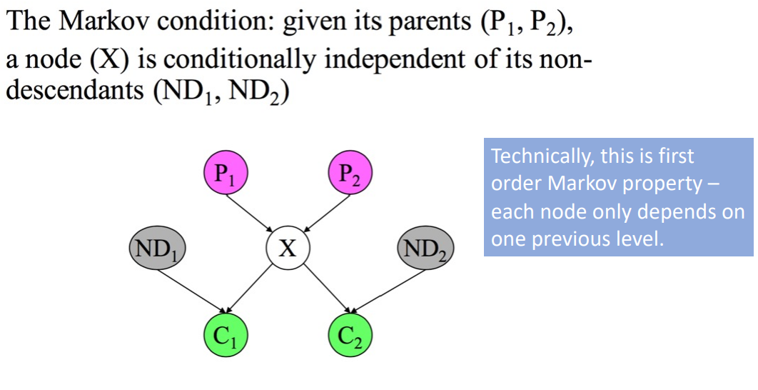

Technically, this is first order Markov property – each node only depends on one previous level.

Joint Probability Distribution

• Using a Bayes Net and Markov condition, we can compute the joint probability distribution over all the variables X1, X2, …, Xn.

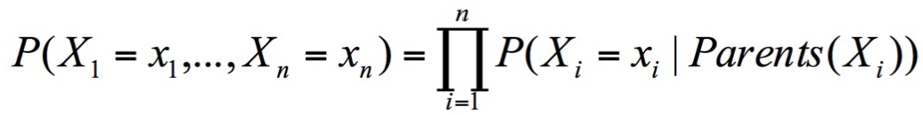

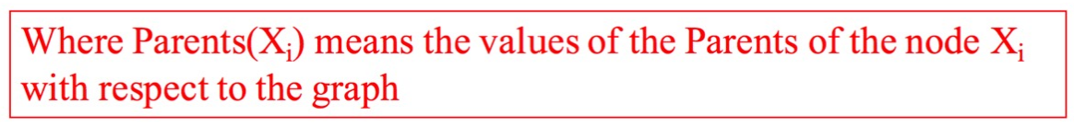

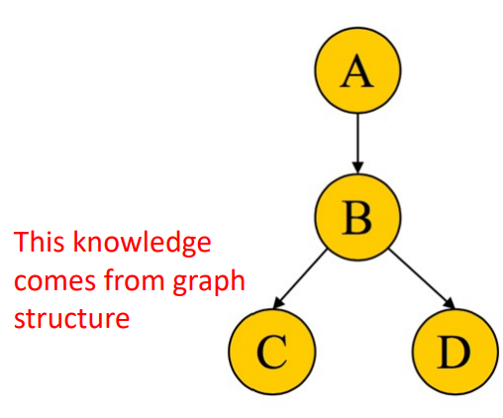Example

• Compute the following joint probability: P(A = true, B = true, C = true, D = true)

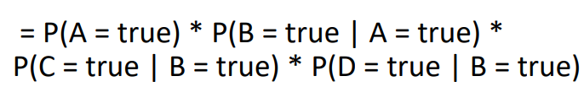

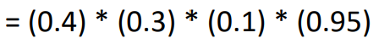

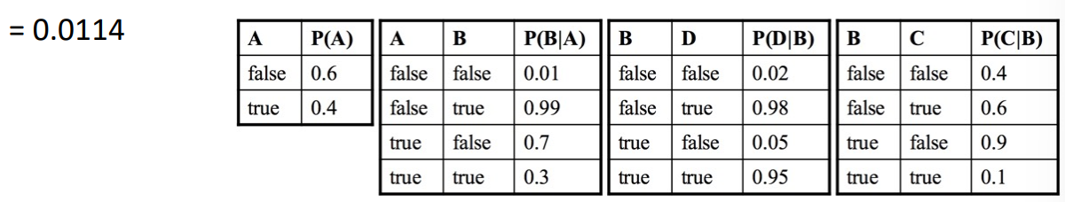

Example

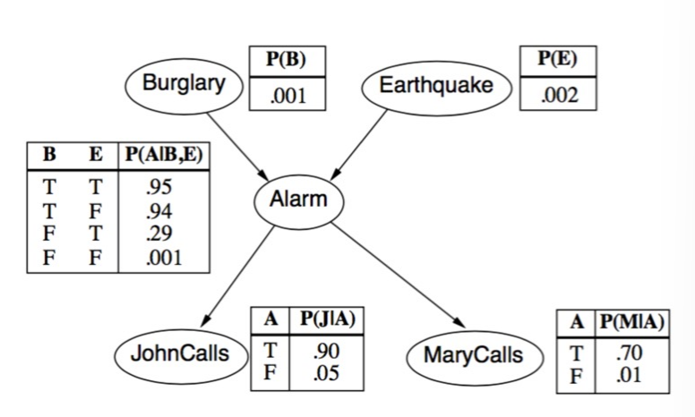• Consider the Bayes Net:

• How many parameters? 10

• Without CI assumption, we would require 25 -1 parameters.

• What’s the joint probability of

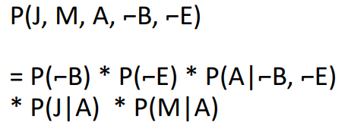

Example:

• Consider the BN:

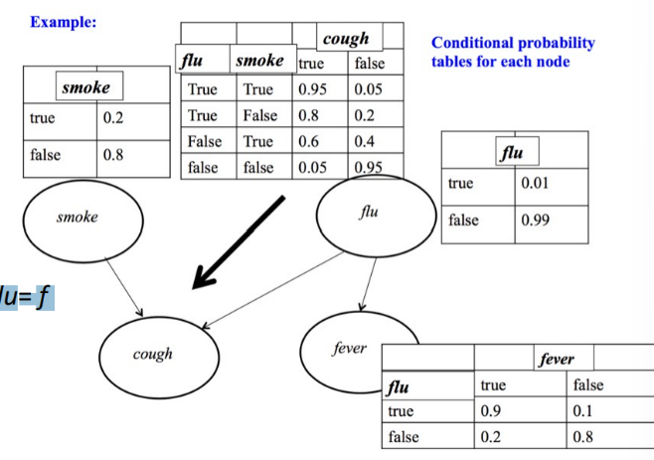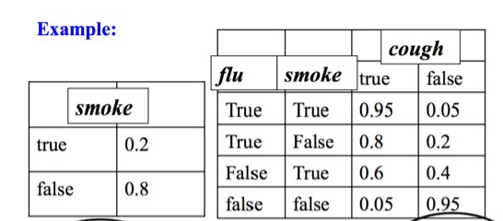

• Use it to evaluate: P(cough=t ∧fever= f ∧flu= f ∧smoke= f)

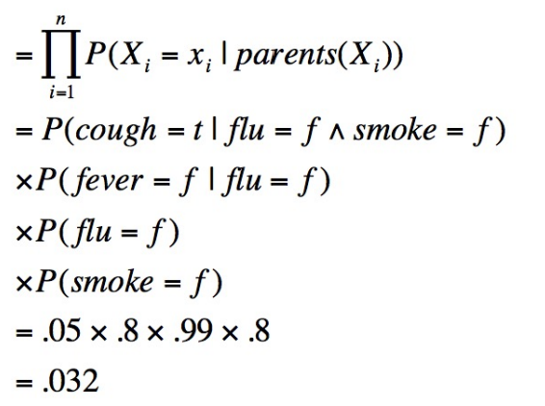

Inference Queries using BN

• The previous 2 were examples of inference queries using BN.

• In general, we can have queries like: P(X | E) where X = query variable, E = evidence variable.

• Another Example:

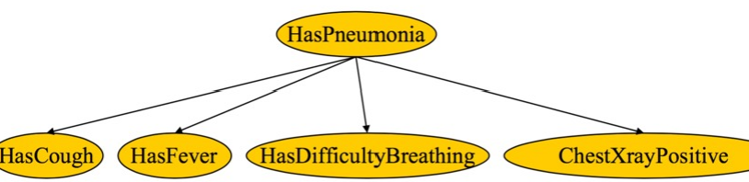

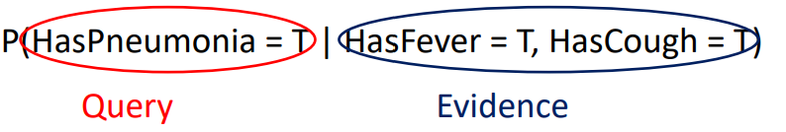

Another Bayesian Belief Network (BBN)

• What's the probability that A is late? What's the probability that B is late?

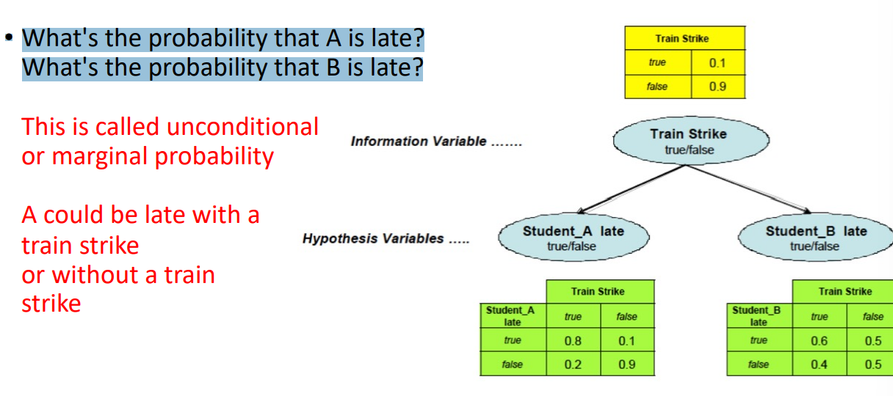

Marginal Probability

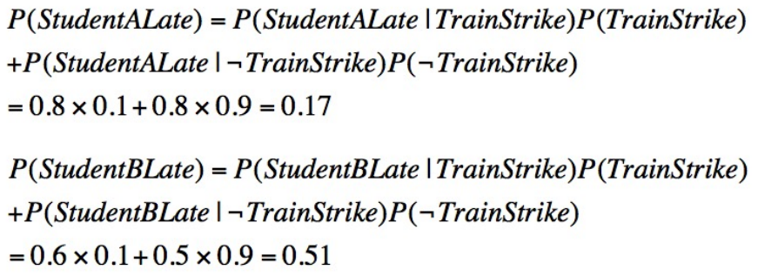

Evidence About Parent Given

• Given that there is a train strike, what's the probability that A is late. P(Student_A late | Train Strike)

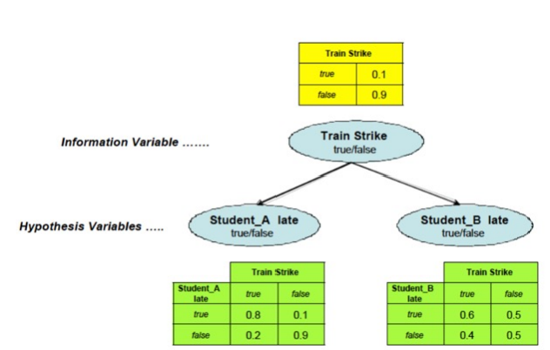• Simple – just look up the table

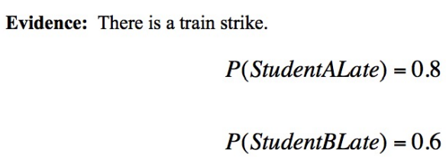

Evidence About Child Node Given

• Suppose we know that student A was late, how does it revise probability of train being late, and student B being late?

• This is idea behind **belief propagation**.

• Evidence: Student A late

Query: Train Strike

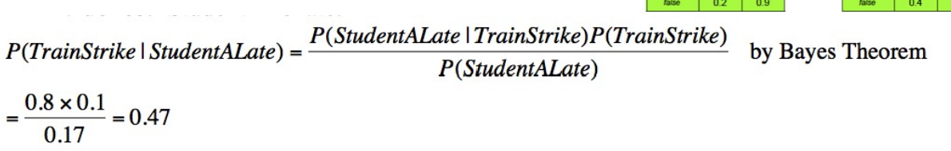

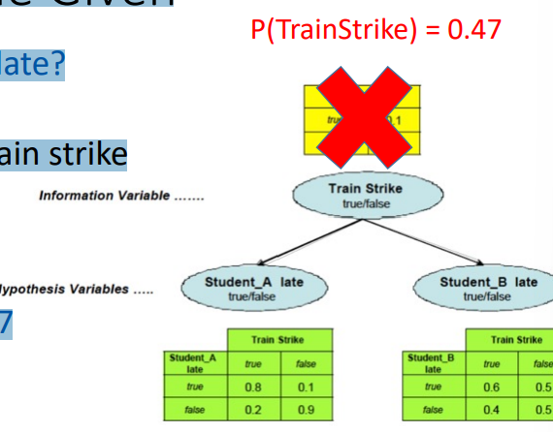Evidence About Child Node Given

• How does it affect probability of B being late?

• We need to use updated probability of train strike

• Evidence: Student A late

Query: Student B late

We saw that updated P(TrainStrike) = 0.47

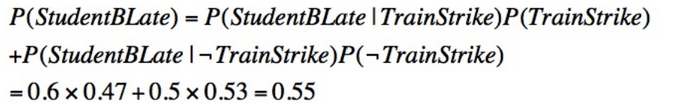

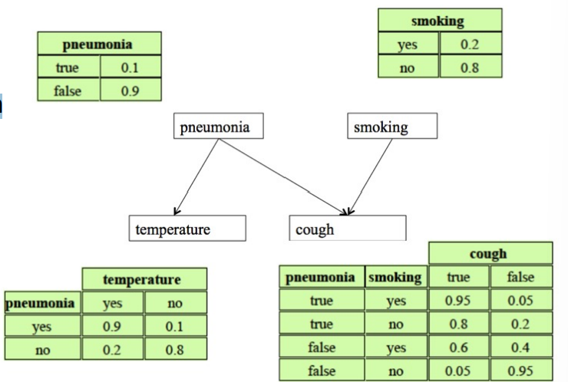Practice Question

• Consider the Bayes Net shown

• Evaluate: P(Cough | Smoking = T)

• How do you proceed? You need to marginalize over pneumonia.

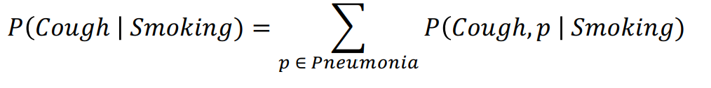

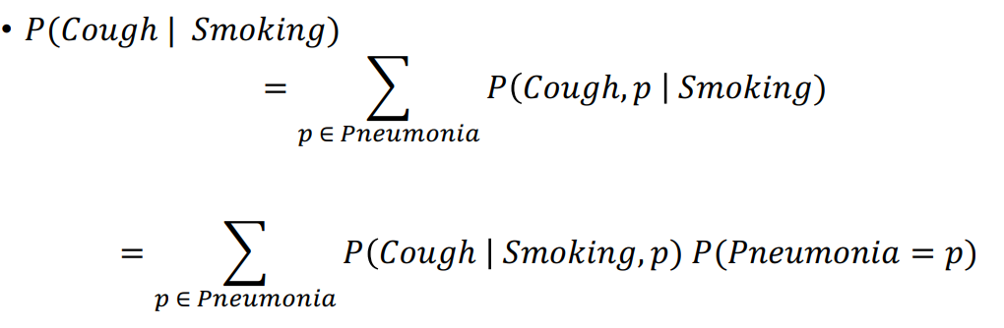

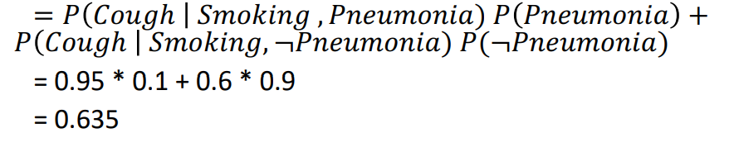

Practice Question

• Consider the Bayes Net shown

• Evaluate: P(Cough | Pneumonia = F)

P(Cough | Smoking = T, Pneumonia = F)

P(Cough)